

Newforma Project Center Basic User Guide



Eleventh Edition

Table of Contents

Overview 1

General Navigation 1

Getting Started Using Newforma Project Center 2

My Project Center 2

Edit My Projects 2

Change the Project Order 4

Getting Started in a Project 5

Project Home 5

Edit Project Home Contents 5

Adding Groups 6

Project Files 9

Search 10

Overview 10

Performing a Search 10

Search Tips 10

Using Search Filters 11

Using the Viewer and Markup 13

Making a PDF 14

Save Markup Session 15

PDF Editor 16

Managing Project Email 17

Filter for Email Messages 17

Change Email Preview 17

File Email Messages to the Project 18

File Email and Keep a Copy in your Inbox 19

Send and File Emails 20

Using the Project Email Activity Center 21

Responding to Project Email Filed in Newforma Project Center 22

Copy Project Email Back to Your Inbox 23

How to Use Newforma® Info Exchange 24

Overview 24

Managing Info Exchange Access with the Project Team 24

Adding Team Members to a Project 26

Transfer Files and Create an Outgoing Transmittal 27

Access and Download File Transfers 31

Send Files from Info Exchange 33

Track your File Transfers 35

Receiving an Info Exchange Transfer from an External Project Team Member 36

Resend a File Transfer 37

Send Related Email 38

Modify Info Exchange settings 38

Repost Expired Content 38

Tracking Transferred Files 40

Viewing the Change Log 40

Creating Shared Folders 42

Uploading Files to Shared Folders on Info Exchange 46

Accessing Info Exchange Remotely 49

Newforma Project Center Help and Support 50

Newforma® Project Center User Guide

Overview

Newforma Project Center (NPC) is a project information management (PIM) solution that creates a more productive environment for project managers and their teams by organizing project information, facilitating information exchange with external team members, and enabling more efficient contract and construction management processes. NPC integrates information from multiple sources, such as CAD, Microsoft® Office, PDF files and email, enabling search, compare, review, mark up, transfer and management of project information more effectively.

NPC organizes and provides context for project information through a suite of tools that all project team members will find useful.

General Navigation

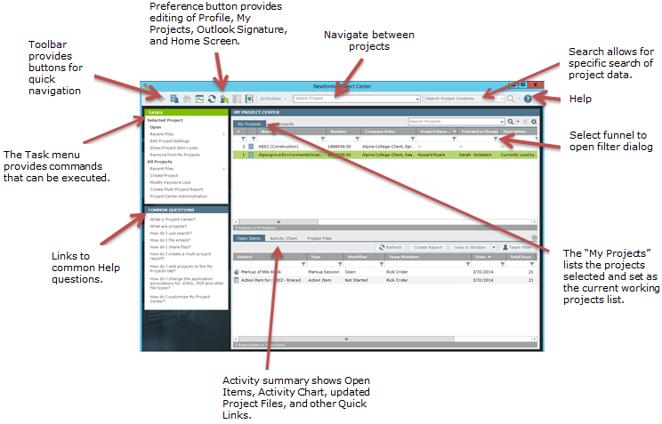

Getting Started Using Newforma Project Center

My Project Center

My Project Center allows users to create a list of frequently used projects on the **My Projects** tab. Users can also see a list of all projects available in Newforma on the **All Projects** tab. My Project Center also includes a Project Activity Summary or dashboard view of action items, submittals, transmittals, Info Exchange, and email for a selected project.

Edit My Projects

Creating the **My Projects** list is one of the first tasks a new user should perform in Newforma. This list not only facilitates accessing frequently used projects, but it will make filing email into Newforma a simple drag and drop activity.

1. Select the **Preferences** icon and select **My Projects...** to access the **Edit My Projects** dialog.

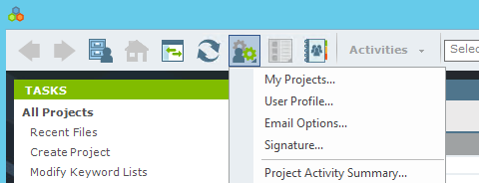

1. In the **Edit My Projects** dialog, click **Add…**. The **All Projects** list appears.

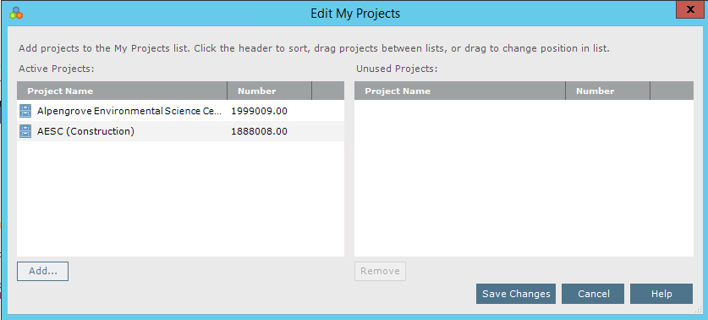

1. Select the checkboxes of the projects to include in the **My Projects** list. Click **OK** to return to the **Edit My Projects** dialog.  
   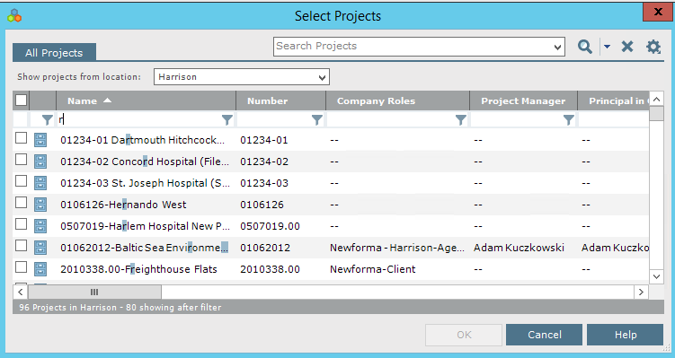
2. Review the selected projects and click **Save Changes**. The selected projects will now appear in the **My Projects** list.  
   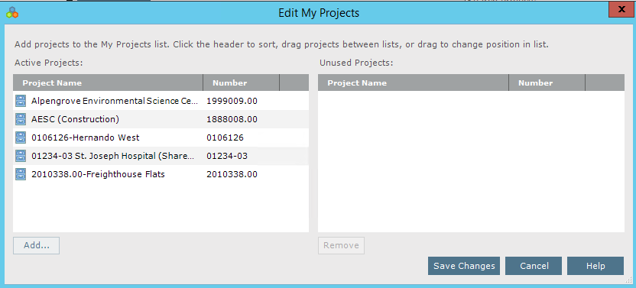

Change the Project Order

1. The order in which the projects appear in **My Projects** can be modified by simply dragging and dropping the projects in the **Active Projects** list in the **Edit My Projects** dialog.  
   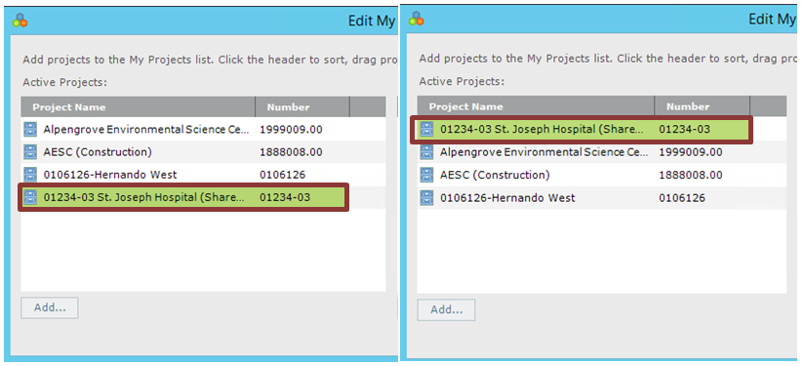
2. Click **Save Changes** in the **Edit My Projects** dialog to save the new project order.

|  |  |
| --- | --- |
| C:\Users\Alison\AppData\Local\Microsoft\Windows\Temporary Internet Files\Content.IE5\3AR54E5N\MC900293188[1].wmf | Once the changes are saved, email folders will be created in Outlook that will appear under the **Newforma Items to File** folder. |

Getting Started in a Project

1. Double click on a My Projects item to open a project.  
   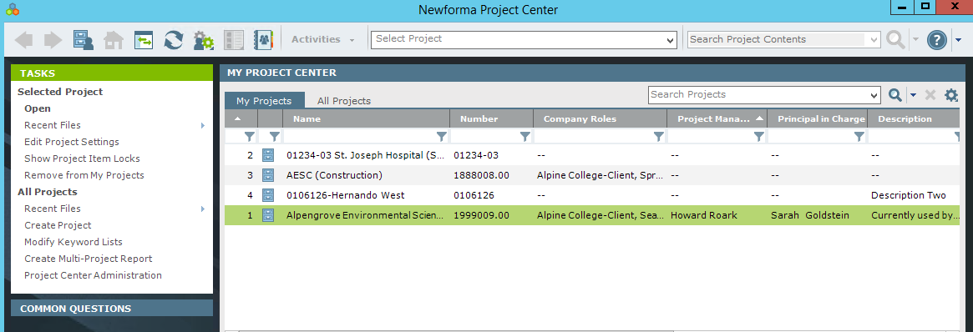

Project Home

A project is the basis for all Activity Centers in Newforma Project Center. After double clicking a project from **My Projects** the **Project Home** screen opens and shows the available Activity Centers for that project. Below is an example:  
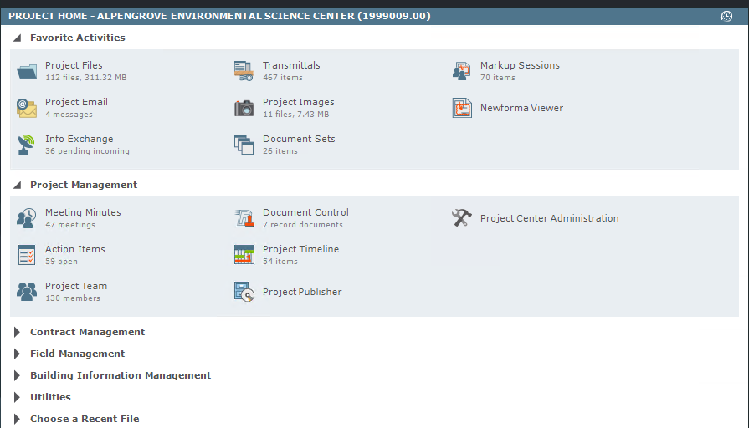

|  |  |
| --- | --- |
| C:\Users\Alison\AppData\Local\Microsoft\Windows\Temporary Internet Files\Content.IE5\3AR54E5N\MC900293188[1].wmf | Global and Project Administrators can set which Activity Centers will be available for each project. |

Edit Project Home Contents

Users can create a list of favorite activity centers for a project to more easily access frequently used activity centers.

1. Click the **Preferences**  button at the top of the screen and select **Project Home Contents**. The **Edit Project Home Contents** dialog appears.
2. To add an activity center to the list of favorites, drag and drop it from the **Hidden Activities** list to the **Favorite Activities** pane.  
   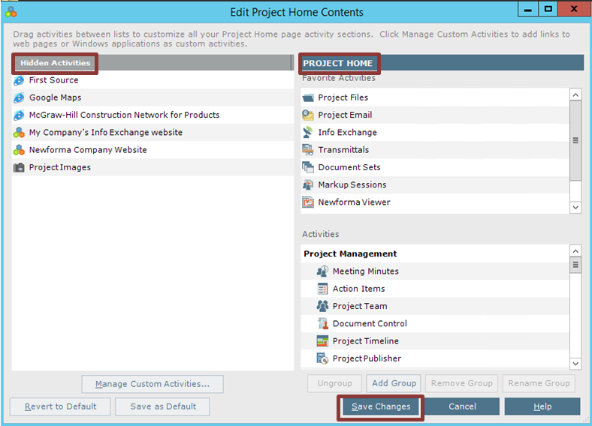
3. Click **Save Changes** to save the updates to the **Favorite Activities** list.

Adding Groups

Add groups to the Project Home page to help organize the available activity centers.

1. Click the **Preferences** button at the top of the screen and select **Project Home Contents**. The **Edit Project Home Contents** dialog appears.
2. Click **Add Group**. A text box appears in the **Activities** pane. Type the name of the new group. Common groups include Project Management, Design and Contract Management.

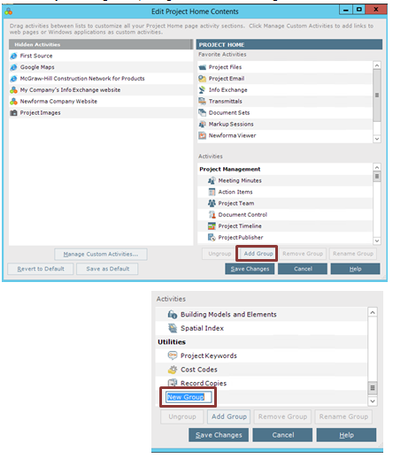

1. The new group appears in the **Activities** list. Drag and drop an activity center onto the appropriate group to add it to the group.  
   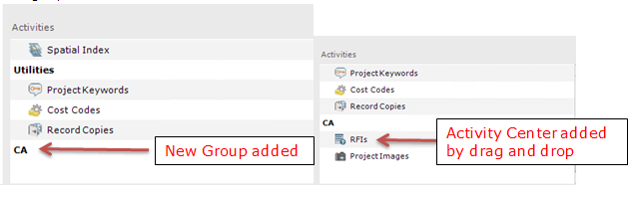
2. Click **Save Changes**. The new groups appear on the **Project Home** page.  
   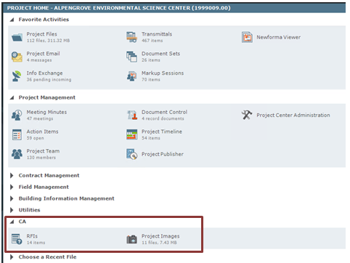

Project Files

Project Center offers different ways to access project files. Locate information by accessing the files from the Project Files activity center.

1. On the **Project Home page**, select the **Project Files** activity center.  
   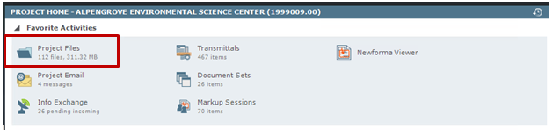
2. The Project Files activity center displays the project information in its directory structure. Use this to access files in the same manner as Windows Explorer.

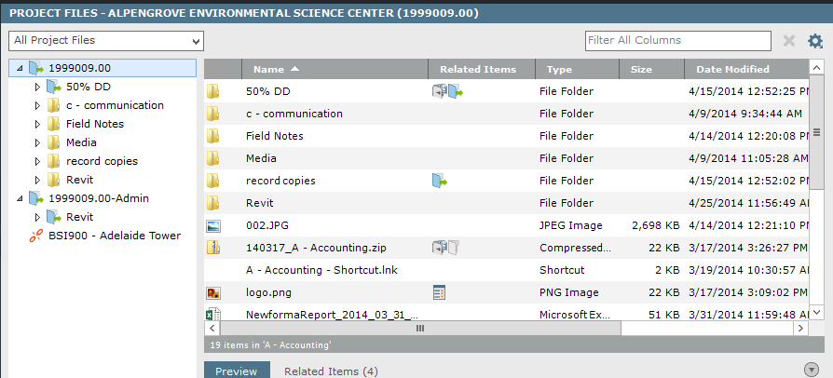

Search

Overview

The Search capability is one of the most powerful Newforma Project Center features. It enables search for text in all folders, files and items (including keywords) in a single project or multiple projects, in project email, in My Projects, in archived projects or even the Learn area of the Newformant Community Website. Also search Google Desktop or a SharePoint site, if these are used. By enabling search across multiple record types simultaneously, the Newforma Project center search saves time finding valuable project information.

Performing a Search

1. Enter the search text in the **Search** field (located in the Toolbar) and click the search button.
2. All instances of the text from all files and items in the project are listed in the Search Results window.  
   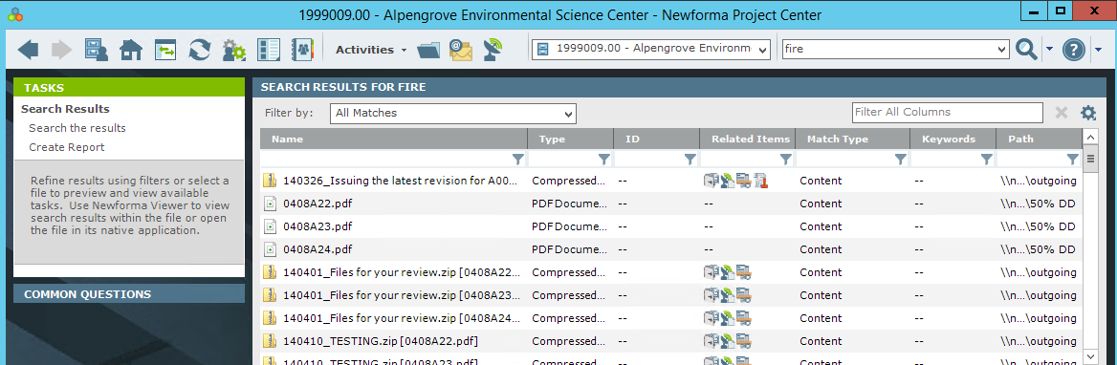

Search Tips

* Newforma Search does not recognize punctuation marks or the following special characters: ! @ # % ^ &. These are ignored, but they will still be found in filenames.
  + For example to search the phrase errors & omissions the ampersand will be ignored. If it is enclosed in quotes, as follows, it will still be ignored: "errors & omissions".
* Wildcards can be used in the search window.
  + For example, searching for DWG files only, enter *.DWG in the search window.
* If looking for a phrase, enter the phrase in quotes such as “concrete slab”.

Using Search Filters

Filter search results by the file type and use the column sorting to help find files.

1. To filter by file type, select the desired option from the Filter by dropdown list.  
   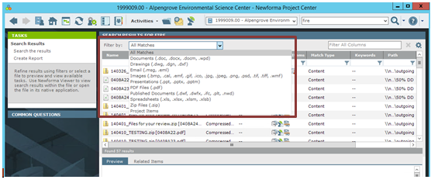
2. Once the file is located, double click on it to open. The Newforma® View will open 2D CAD, PDF and image files automatically. The Find tab of the Drawing Explorer dialog shows where the search criteria are found in the file.  
   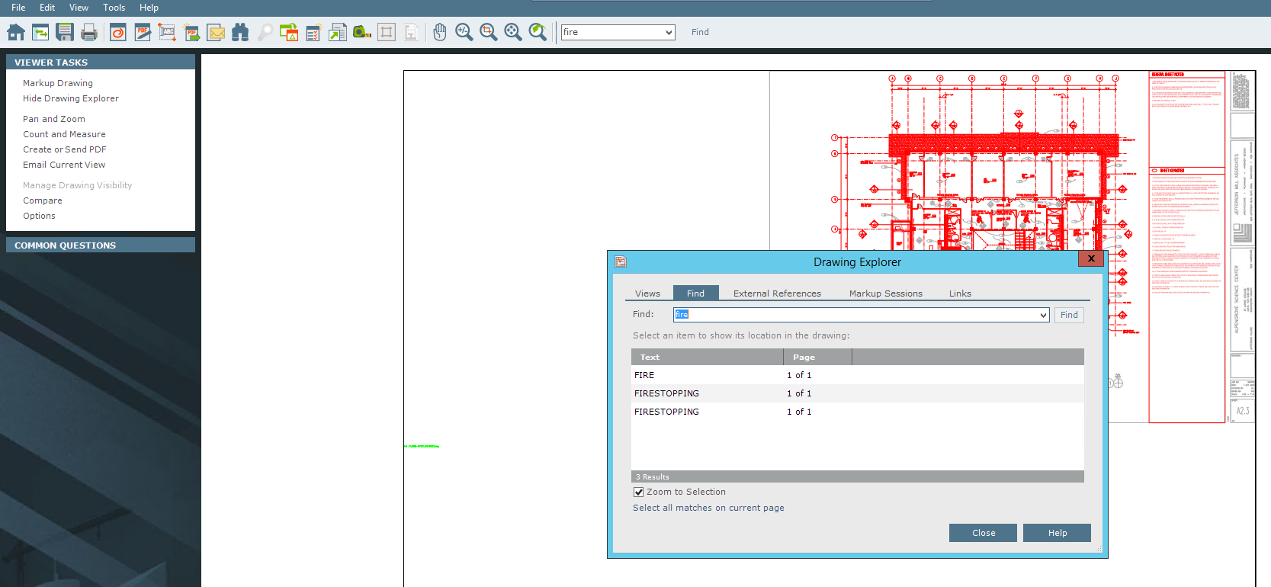
3. When you select a line item on the Find tab, the view zooms into where it appears in the file.  
   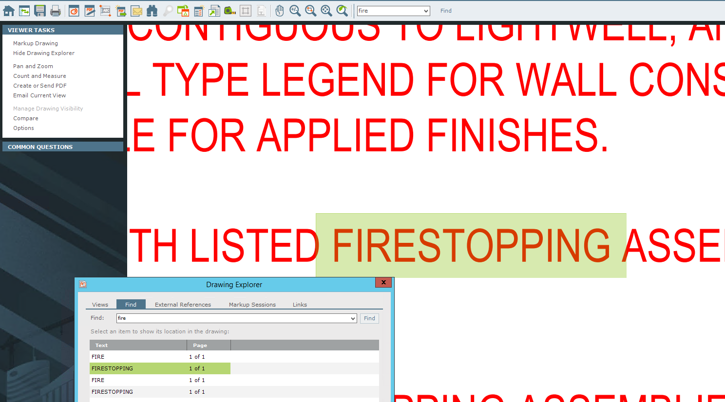

Using the Viewer and Markup

The Newforma Viewer opens 2D CAD files, PDF files and image files.

You can use the icons in the toolbar to zoom into sections of the image and open the Markup tools.

You have a variety of options within the markup tools including pointers, circles, clouds and text.

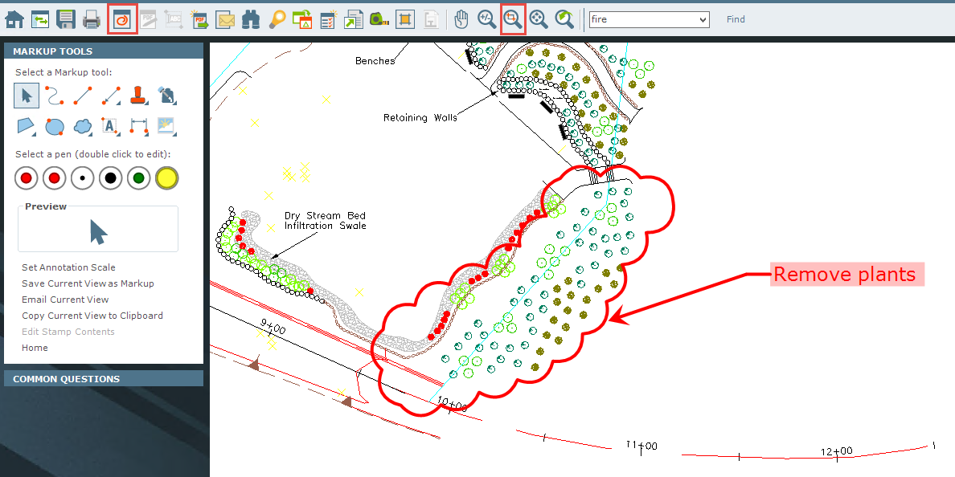

Making a PDF

After markups are complete, saving the file as a new PDF will embed the markups for communication purposes.

1. Click the **PDF** icon in the toolbar. The **PDF Options** pane appears.  
   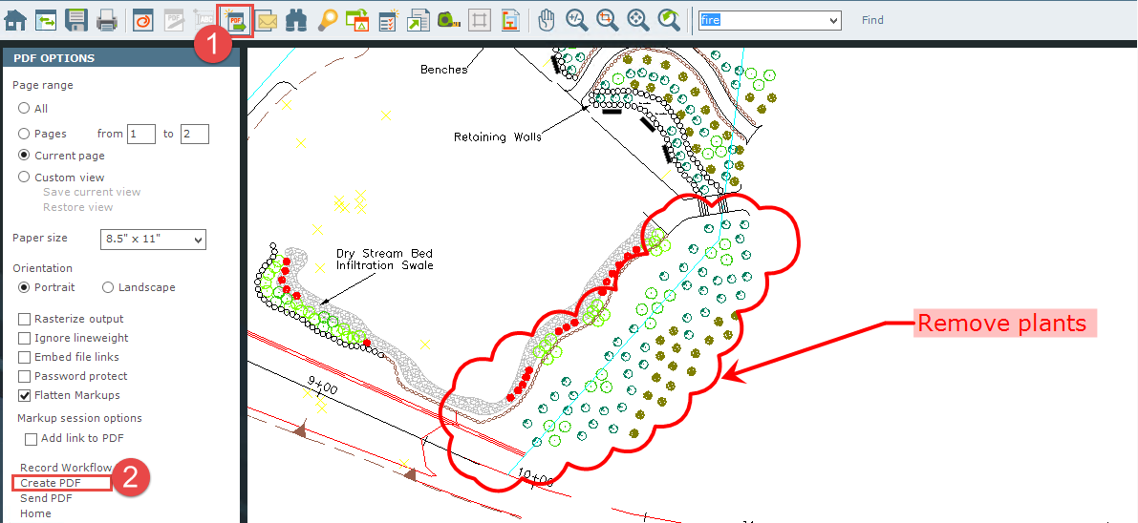
2. Select **Create PDF** to name and save the PDF to a desired location.

Save Markup Session

From the Newforma Viewer, save the current markup as a markup session which will be referenced with this file as a related project item. All markup sessions are tracked in Newforma Project Center and do not change the native file.

1. To save the markup session, click the **Save** icon in the toolbar.  
   
2. The **Save Markup Session As** dialog appears.Enter a name for the markup and click **OK** to save the markup to the project.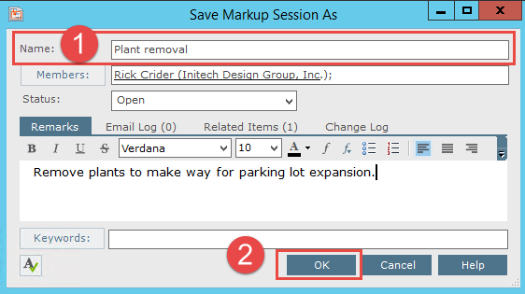

|  |  |
| --- | --- |
| C:\Users\Alison\AppData\Local\Microsoft\Windows\Temporary Internet Files\Content.IE5\3AR54E5N\MC900293188[1].wmf | Saving the markup session will not change the native file. |

1. When this file is opened from Newforma Project Center, the markup will be listed on the **Markup Sessions** tab in the **Drawing Explorer** dialog along with any others related to this file. Select the checkbox for each markup to be shown on the file.

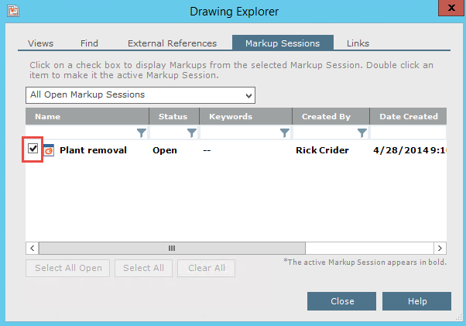

PDF Editor

When opening a PDF file in the Newforma Viewer use the PDF Editor to delete pages, add pages, reorder pages and import markups. These markups do not have to originate in Newforma. They can be done by outside consultants in applications such as such as Adobe or Bluebeam.

1. After opening a PDF in the Newforma viewer, select the **PDF Editor** buttonfrom the tool bar.The **PDF Page Editor** opens and displays the pages of the selected PDF file.  
   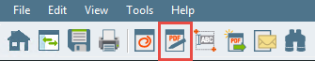
2. Drag and drop pages to change the order. To remove a page, select it and click **Delete**.

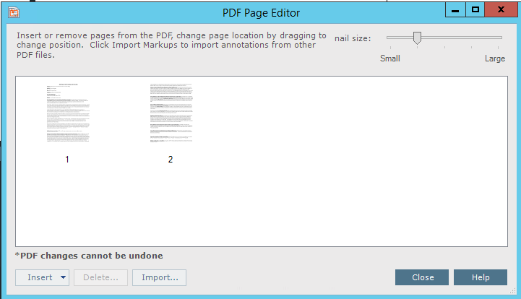

Managing Project Email

Filter for Email Messages

When you do a general project search, the **Search Results** display all project information including project email and attachments.

1. To filter results to only display email, select **Email (.msg, .eml)** from the **Filter by** dropdown list. The **Search Results** update to only display project email that matches the search criteria.  
   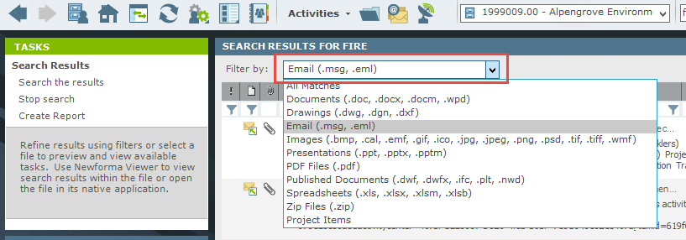

Change Email Preview

1. To adjust the preview of the email in the **Search Results**, click the **View** icon in the toolbar.  
   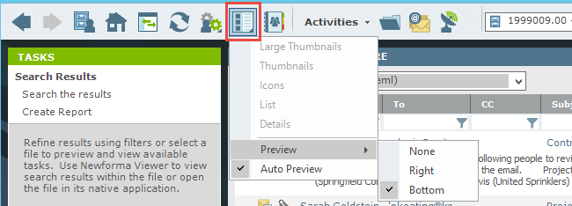
2. Select **Preview**, then the desired preview position from the menu.

File Email Messages to the Project

1. To file an email into a project, open the email client (i.e., Outlook).
2. Drag and drop emails into the correct project folder under **Newforma-Items to File** in the email client. By default, the email is removed from the Inbox.  
   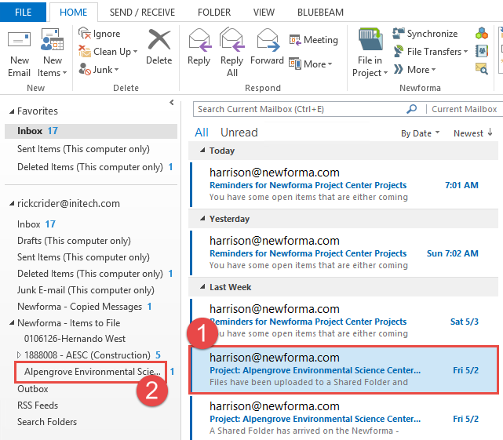

File Email and Keep a Copy in your Inbox

1. To keep a copy of the email in the Inbox, select the Email and then select the File in Project folder icon. Indicate the project destination in the dialog box that appears.  
   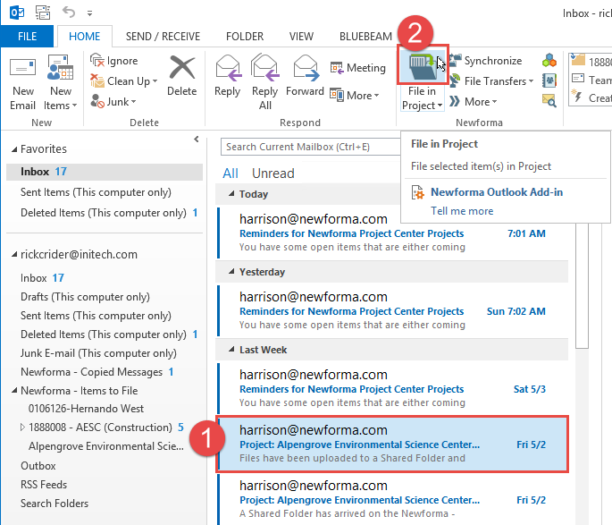
2. Select the project and then OK.

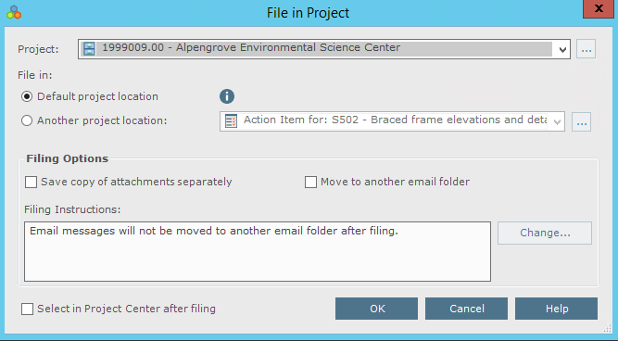

1. A copy of the email is placed in the Newforma project folder and the email remains in your Inbox.

Send and File Emails

1. To file an email to a project at the same time it is sent, click **Send and File in Project** in the ribbon bar when sending, forwarding, or replying to an email. The select a project dialog appears.

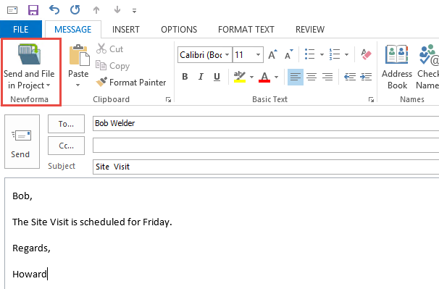

1. Select the project from the recently used list or browse out to select from any project in Newforma.



Using the Project Email Activity Center

In the Project Email activity center all the email filed to that project is seen, regardless of who filed the original item.

1. To view only the emails in which you were involved, click the **People** icon. To toggle back to viewing all emails, click the **People** icon again.  
   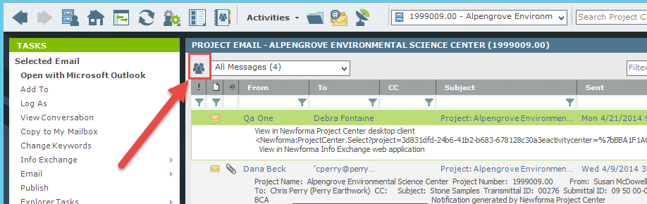

|  |  |
| --- | --- |
| C:\Users\Alison\AppData\Local\Microsoft\Windows\Temporary Internet Files\Content.IE5\3AR54E5N\MC900293188[1].wmf | A single person on the icon means only your email are shown. Multiple people in the icon means that all messages related to the project are shown. |

1. To further narrow the results, enter values in one or more column’s search filters to help locate the desired email.  
   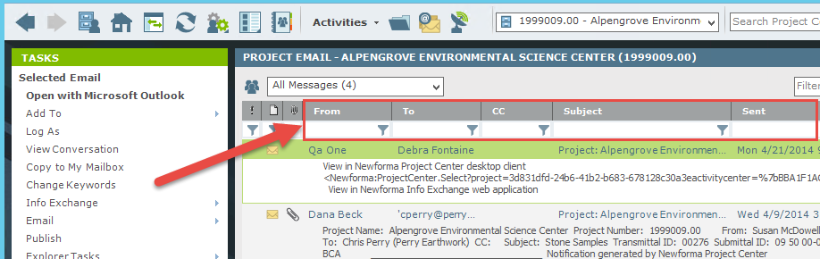

Responding to Project Email Filed in Newforma Project Center

1. To respond or forward any project email in the Email activity center, double-click on the message. The message opens in Outlook.  
   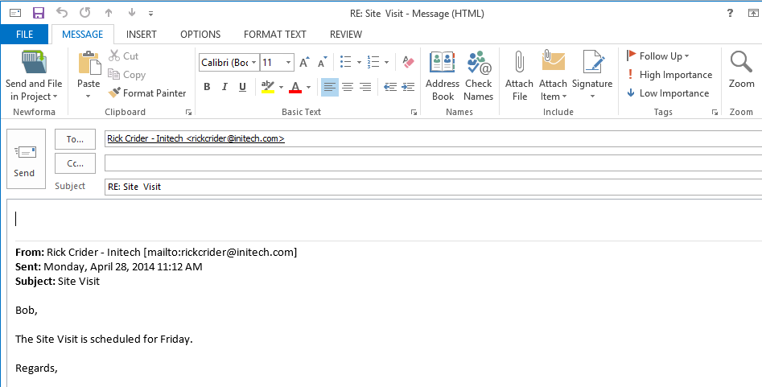

|  |  |
| --- | --- |
| C:\Users\Alison\AppData\Local\Microsoft\Windows\Temporary Internet Files\Content.IE5\3AR54E5N\MC900293188[1].wmf | Respond to or forward an email stored in a project even if you were not part of the original email transaction. |

1. Once the email is open in Outlook, use the **Send and File in Project** button if the email is related to a project.

Copy Project Email Back to Your Inbox

There may be times such as leaving the office that a copy of an email stored in a project needs to be back in the Outlook Inbox for easy reference in the field. Newforma Project Center provides a way to do so quickly.

1. Highlight the email(s) to be copied back to the Inbox in the Project Email activity center. Select **Copy to My Mailbox** from the **Tasks** pane.  
   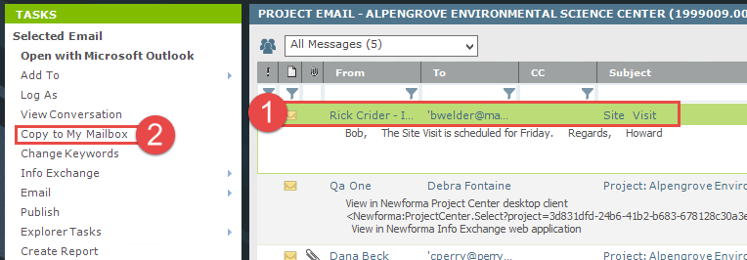
2. The email is copied to the Outlook Inbox and appears in the **Newforma-Copied Messages** folder.  
   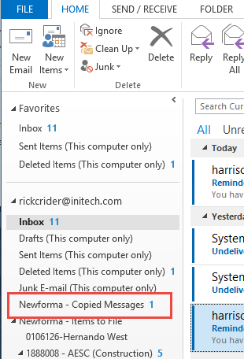

How to Use Newforma® Info Exchange

Overview

Newforma Info Exchange is a project website that facilitates the transfer of files without the limitations of email or FTP. It also allows both internal and external project members (with permission) to access select project data from the website with any web-enabled device. The Info Exchange activity center is used to create and manage all file transfers sent via Info Exchange; however, Info Exchange transfers can be created directly from many of the other Activity Centers such as Project Files and Project Email.

Managing Info Exchange Access with the Project Team

In order for an external contact to both receive and send transmissions via Info Exchange, he/she must be a member of the project team and have Info Exchange access. These permissions are given in the Project Team activity center and are set per project.

1. To give a user access, select the desired contact in the Project Team activity center and click **Modify** in the **Tasks** pane.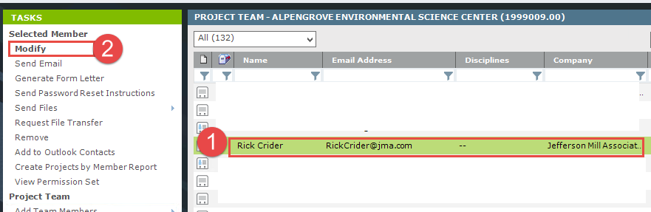
2. The Modify Project Team Member dialog appears. Select the **Project Roles and Permissions** tab. Select the **Allow web access to this Project on your Info Exchange server** checkbox in the **Newforma Info Exchange Options** section of the dialog. This is a per project setting. If it is the first time access has been given to this user on any project, Newforma will send the user an email with login credentials and directions.

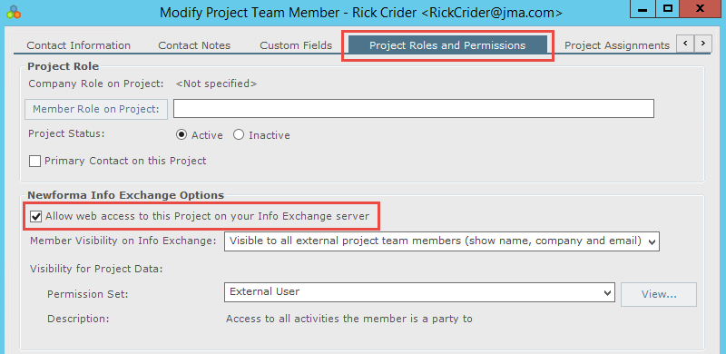

1. If a user needs his/her login credentials sent again, highlight the Project Team member and use the **Send Password Reset Instructions** option in the **Tasks** pane.  
   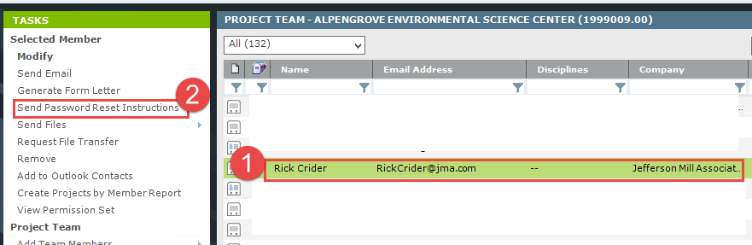

Adding Team Members to a Project

If the contact is currently not in the project team you will need to add them to the project.

1. Select **Add Team Members** from the **Tasks** pane.  
   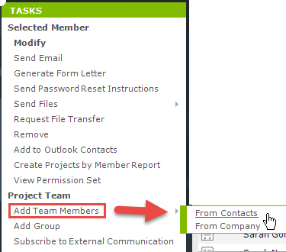
2. The **Choose New Team Members from Global Contact List** dialog appears. Fill in the checkbox for each of the contacts you wish to add as project team members and click **OK**.  
   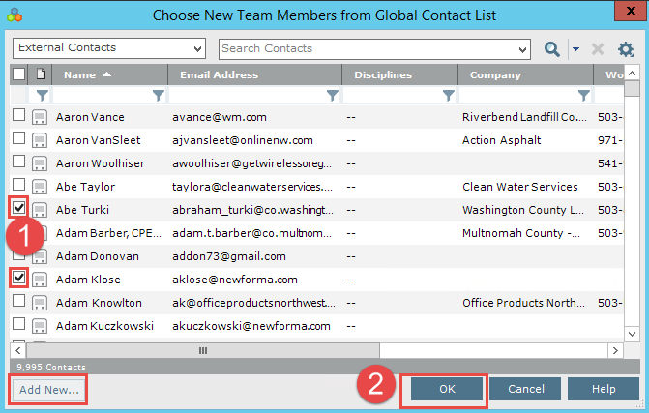

|  |  |
| --- | --- |
| C:\Users\Alison\AppData\Local\Microsoft\Windows\Temporary Internet Files\Content.IE5\3AR54E5N\MC900293188[1].wmf | If the contact is not already in the list, you can select Add New… to add the contact or drag and drop the contact from your Outlook Contact list. |

Transfer Files and Create an Outgoing Transmittal

1. To initiate the file transfer in the Info Exchange activity center, select **Create File Transfer** from the **Tasks** pane. In the **Transfer Files to Info Exchange** dialog, select the **Yes, fill out and record a Project Transmittal** option and click **OK**.  
   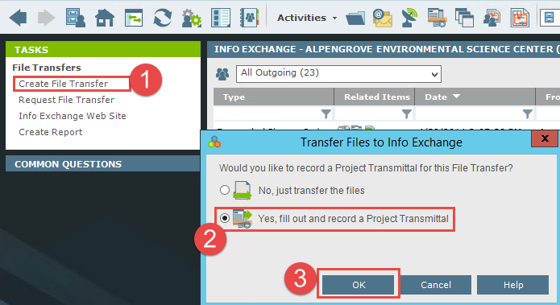

|  |  |
| --- | --- |
| C:\Users\Alison\AppData\Local\Microsoft\Windows\Temporary Internet Files\Content.IE5\3AR54E5N\MC900293188[1].wmf | This process can be initiated from other Activity Centers by highlighting the files or folders to transfer and selecting **Info Exchange** in the **Tasks** pane. |

1. The Transfer Files and Create an Outgoing Transmittal form appears. Fill in the transmittal information as needed. The following table provides information on the function of each field in the form. Use the **Associated Files** tab to add files or folders of documents that you want to send.

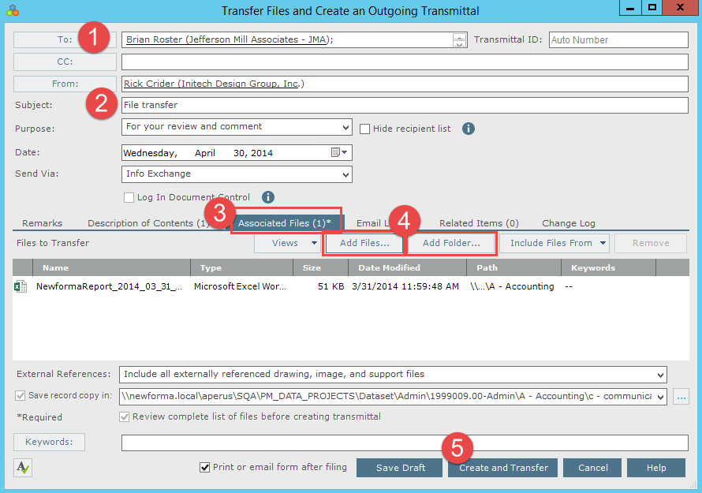

|  |  |
| --- | --- |
| **To** | Click to open the [**Choose a Project Team Member** dialog](http://help.newforma.com/robohelp/robo/server/general/projects/Project%20Center%20Seventh%20Edition%20Help/Dialog_Boxes_1/Select_Project_Team_Members_dialog_box.htm) to select the [project team](http://help.newforma.com/robohelp/robo/server/general/projects/Project%20Center%20Seventh%20Edition%20Help/Topics_1/Project_Team_Overview.htm) members who will receive the files. Email addresses can be typed directly in this field.  If email addresses of contacts are not project team members, they will not have the ability to partially download files on Info Exchange. |
| **CC** | Click to open the **Choose a Project Team Member** dialog to select additional recipients. Email addresses can be typed directly in this field.  Contacts in the **CC** field will receive a link to download the files, but will not be sent reminders. |
| **From** | Click to open the [**Choose a Project Team Member** dialog](http://help.newforma.com/robohelp/robo/server/general/projects/Project%20Center%20Seventh%20Edition%20Help/Dialog_Boxes_1/Choose_a_Contact_dialog_box.htm) to select the project team member who is transferring the files. The current user is the default. Email addresses can be typed directly in this field. |
| **Subject** | Enter a subject for the file transfer. |
| **Purpose** | Select the purpose of the file transfer from the drop-down list. |
| **Date** | The date the files were transferred. The current date is entered by default, but the date can be edited if needed. |
| **Transmittal ID** | Project Center automatically creates an ID number for the transmittal. Edit the ID number if needed. |
| **Send Via** | The files are transferred via Info Exchange by default, but other options are available. |
| **Keywords** | Click to open the [**Choose Keywords** dialog box](http://help.newforma.com/robohelp/robo/server/general/projects/Project%20Center%20Seventh%20Edition%20Help/Dialog_Boxes_1/Choose_Keywords_dialog_box.htm) to select keywords. In Project Center, keywords are words you can add to items to use for filtering. When you add keywords, they appear in the Keywords column of the corresponding Project Center activity center. You can then filter the list of items using the keywords to quickly find the items you are looking for. |
|  | Click to spell check the fields in this window. If any mistakes are found, the Spelling dialog box opens with spelling suggestions. |
| **Print or Email Form After Filing** | Mark this checkbox to open the [Transmittal form](http://help.newforma.com/robohelp/robo/server/general/projects/Project%20Center%20Seventh%20Edition%20Help/Dialog_Boxes_1/Transmittal_Form_dialog_box.htm) for review and to print immediately after filing the transmittal, or send a report in an email message in Microsoft Outlook to the contacts in the **To** field.  The files in the Transmittal form are grouped first by folder, and then listed alphabetically. |
| **Save Draft** | Click to save a draft of the transmittal. It will appear in the Draft Log of the [Project Transmittals activity center](http://help.newforma.com/robohelp/robo/server/general/projects/Project%20Center%20Seventh%20Edition%20Help/Main_Windows/Project_Transmittals_window.htm). The files will not be sent. |
| **Create and Transfer / Create and Send / Create Transmittal** | The button that appears is based on the transfer method selected in the **Send Via** field. When Info Exchange is selected, **Create and Transfer** appears.  Click to open the [**Transfer to Info Exchange Options** dialog box](http://help.newforma.com/robohelp/robo/server/general/projects/Project%20Center%20Seventh%20Edition%20Help/Dialog_Boxes_1/Publish_to_Info_Exchange_dialog_box.htm) to edit the settings for the file transfer and transfer it to your Newforma Info Exchange Server. |

1. When you are done filling in the transmittal information, click **Create and Transfer**. The **Transfer to Info Exchange Options** dialog appears. Update the options as needed and click **OK** to create the transfer. The following table provides information on the function of each field in the form.  
   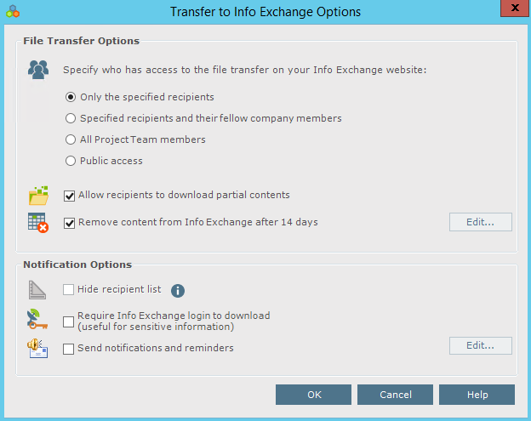

|  |  |
| --- | --- |
| C:\Users\Alison\AppData\Local\Microsoft\Windows\Temporary Internet Files\Content.IE5\3AR54E5N\MC900293188[1].wmf | When you click **OK**, the file transfer is logged in the All Outgoing log of the [Info Exchange activity center](http://help.newforma.com/robohelp/robo/server/general/projects/Project%20Center%20Seventh%20Edition%20Help/Main_Windows/File_Sharing_window.htm), and the transmittal is filed in the All Sent log of the Project Transmittals activity center. |

|  |  |
| --- | --- |
| **Specify who has access to the file transfer on the Info Exchange website** | Choose **Only the specified recipients** to allow only the members selected in the **To** or **CC** fields to download the files included in the transfer.  Choose **Specified recipients and their fellow company members** to allow access only to the recipients and members of their companies (as listed in the Company column of the Project Team window).  Choose **All Project Team members** to allow all recipients and anyone on the internal or external project team to download the files.  Choose **Public access** to allow anyone on the internet to access the file transfer by logging on to the Info Exchange website using the anonymous password. |
| **Allow recipients to download partial contents** | Allows the recipients to download the files incrementally instead of all at once. |
| **Remove content from Info Exchange** | Deletes the uploaded files off the web site after the designated number of days. The log of the transmission and the record copies of the sent files remain. Recipients will not be able to download files after the expiration date. You can use the **Repost** option in the **Tasks** pane in the Info Exchange activity center to allow access to the information again. |
| **Hide recipient list** | Hides the list of recipients, which allows you to send bid documents to multiple bidders without the bidders being able to identify the other recipients. If this option is not checked, then the email notifications and transmittals will contain the To and CC contacts. |
| **Require Info Exchange login** **to download** | Enables the sender to require the recipient to login to Info Exchange to download the files. The recipient does not receive a direct download link in the email message. If this is unchecked, then the recipient receives a link in the notification email and will be able to download the files without logging into the website. |
| **Send notifications and reminders** | Select if you want to send notifications and reminders pertaining to this transfer. |

1. Pop up messages appear when the Info Exchange server has started and completed the transmission.

Access and Download File Transfers

Once a file transfer is completed, recipients can access and download the files.

1. External team members receive a notification email when a file transfer is available. If they are not required to login, they can click the link to download the files and follow the browser download options.  
   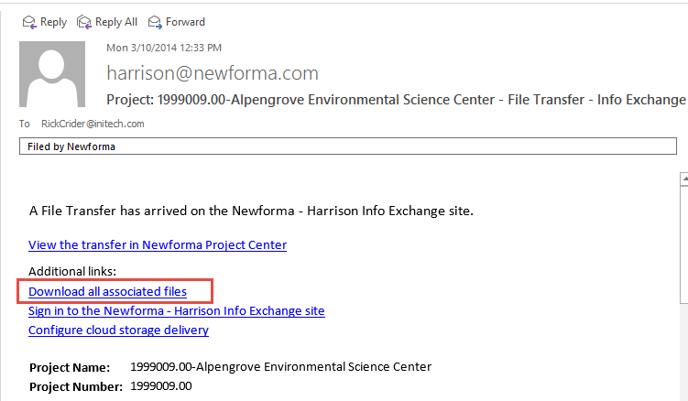
2. The second link requires that the user be a team member with access to Info Exchange. Selecting this option enables the recipient to create file transfers for the sender and other team members. Clicking the link opens the **Sign in to Newforma Info Exchange** dialog. Enter your username and password and click **Sign In**.  
   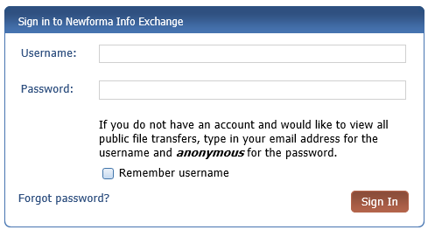

|  |  |
| --- | --- |
| C:\Users\Alison\AppData\Local\Microsoft\Windows\Temporary Internet Files\Content.IE5\3AR54E5N\MC900293188[1].wmf | See the “Managing Info Exchange Access with the Project Team” and “Adding Team Members to a Project” sections above for additional information on team member permissions. |

1. After logging in, Info Exchange opens automatically to the new file transfer. Select **Download All Contents** to download all files or select which files to download (if available) and click **Download Selected Contents**. Select to **Open** or **Save** the files at the bottom of the screen.  
   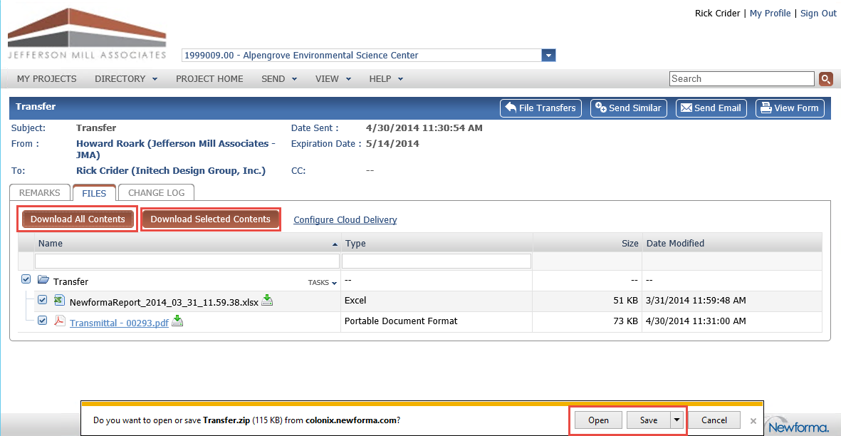

Send Files from Info Exchange

You can use Info Exchange to securely send file transfers of all sizes to project team members and track when the files were received.

1. Log into the Info Exchange web site and select the project.  
   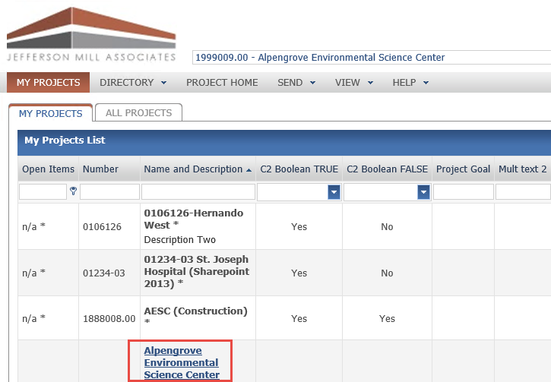
2. Select **Send, Files** from the **Shortcuts**.

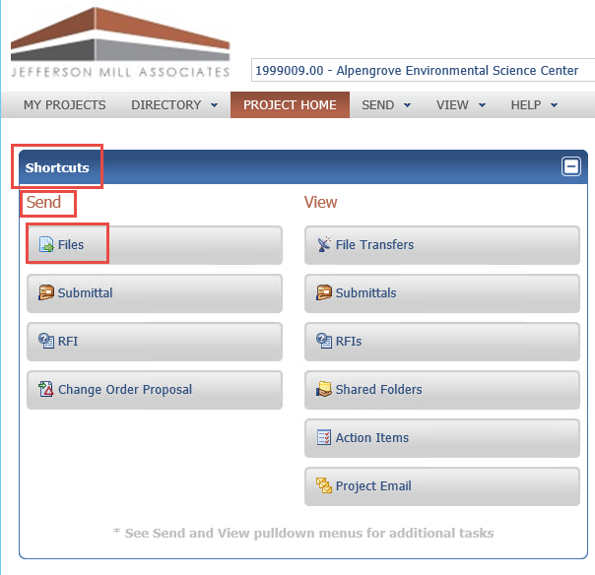

1. Fill in the transmittal information including recipients from the project team.  
   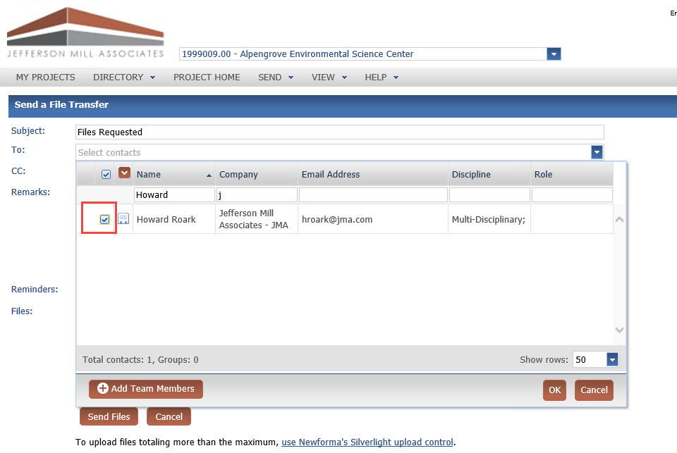
2. Select the Add Files icon to add files or folders of files to send. Click **Send Files** to complete transfer.  
   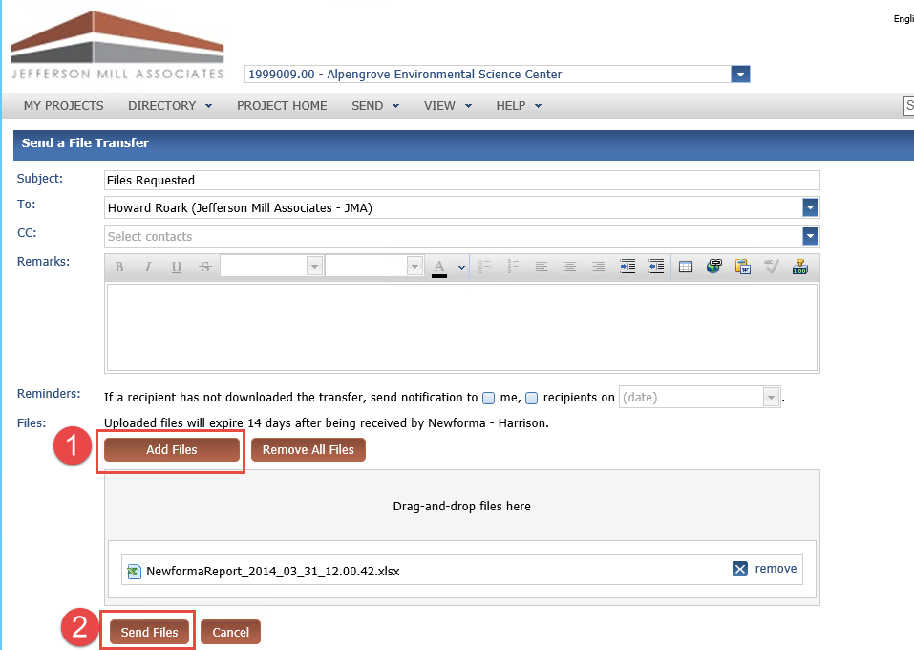

Track your File Transfers

1. To track your file transfers, select **View, File Transfers** from the toolbar or from **Shortcuts**.  
   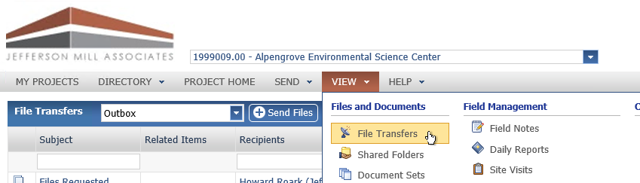
2. On the **File Transfers** screen, select the transfer you would like to track.  
   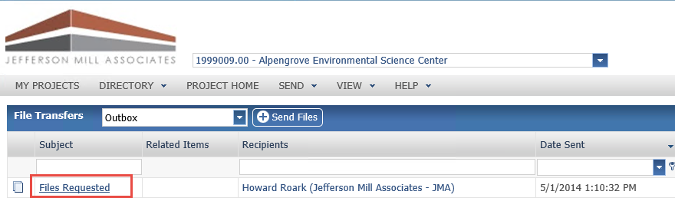
3. Select the **Change Log** tab on the **Transfer** screen to see all actions relating to the transfer.  
   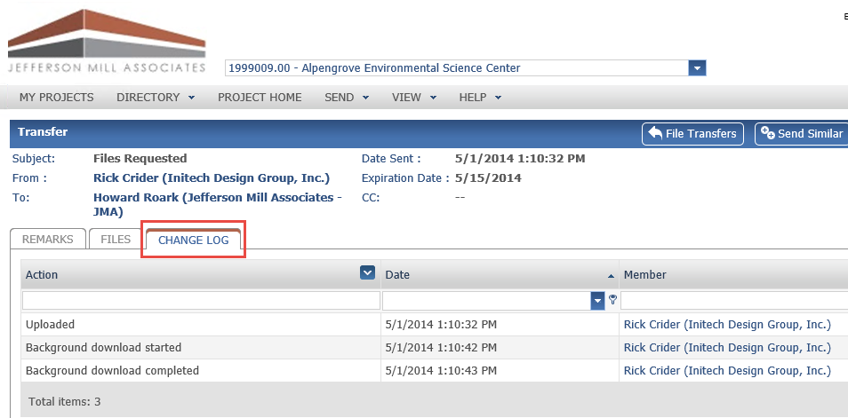

Receiving an Info Exchange Transfer from an External Project Team Member

It is possible for external team members with the proper permissions to send Info Exchange file transfers. As a recipient view the information directly in Newforma Project Center.

1. As a recipient of a transfer a notification email is sent notifying of the transfer. Click the link in the email to view the transfer in the Info Exchange activity center.  
   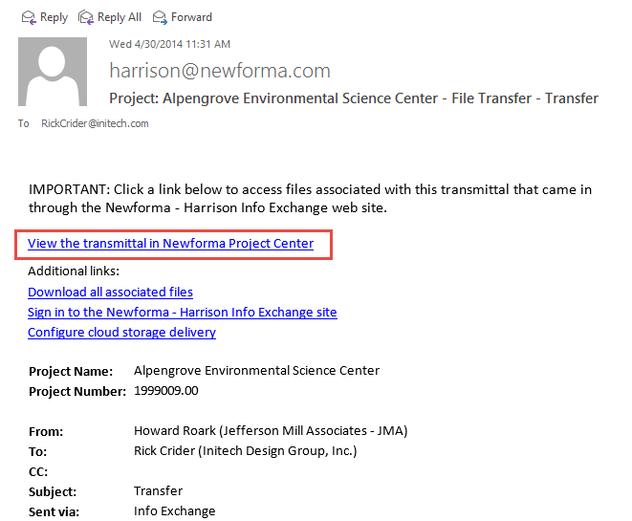
2. Once in the Info Exchange activity center, you can select **Acknowledge Receipt** from the **Tasks** list to acknowledge the receipt of the transfer. The example below shows that the file has already been received. Depending on the system setting the file may need to be received first.  
   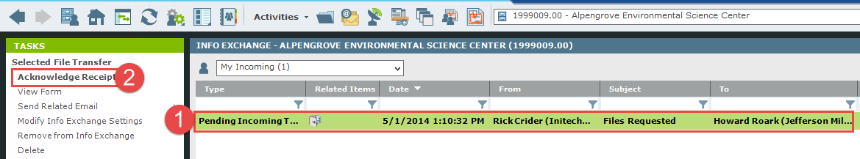
3. Select the Next action.

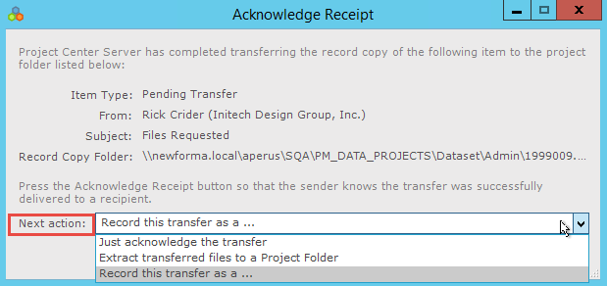

Next action options:

|  |  |
| --- | --- |
| **Just acknowledge the transfer** | This option will update the Change Log showing receipt of the file. |
| **Extract transferred files to a Project folder** | This option extracts the received files out of the zip file and prompts for the destination folder. |
| **Record this transfer as a . . .** | This option allows you to log this information into another project item. |

Resend a File Transfer

If the transmission needs to be sent again, you can use the **Resend** option.

1. To resend a transfer, select it in the list of transfers in the Info Exchange activity center.
2. Select **Resend** in the **Tasks** list and select **via Info Exchange** or **via Email** from the popup menu.  
   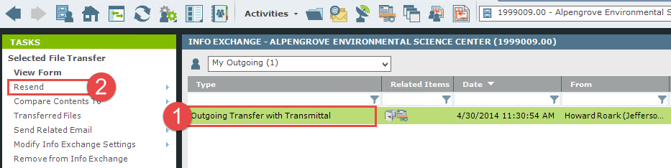

Send Related Email

From Info Exchange, you can send an email that relates to the transfer package to project participants.

1. Select the transfer from the list of transfers.
2. Select **Send Related Email** from the **Tasks** list. Select **To Sender**, **To Recipients** or **To All Participants** from the fly out menu.   
   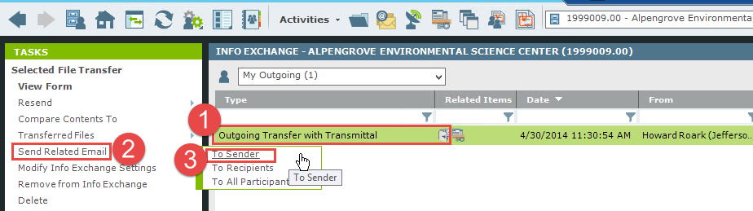

Modify Info Exchange settings

You can modify Info Exchange settings on a transmission and resend.

1. To modify settings, select the transmission in the Info Exchange activity center list.
2. Select **Modify Info Exchange Settings** from the **Tasks** list, then select the desired action from the popup menu and update as needed.  
   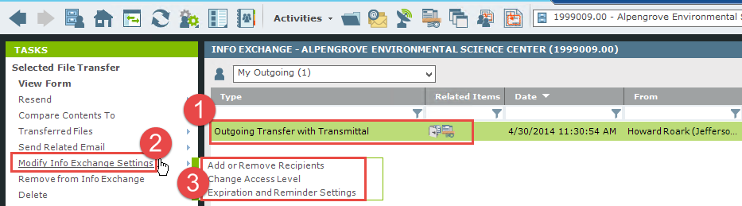

Repost Expired Content

In order to prevent outdated information from remaining on Info Exchange web site, all transmissions should be given an expiration date. There may be situations in which the recipients did not have an opportunity to download the files by the expiration date. If this occurs, the creator of the transmission can repost it.

1. Select the expired transmission in the Info Exchange activity center.
2. Select **Repost Expired Content** from the **Tasks** list.  
   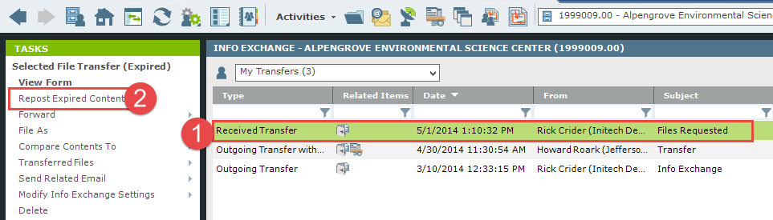

Tracking Transferred Files

The Info Exchange activity center tracks who transferred files and who downloaded (or partially downloaded) the files with a date and time stamp.

1. To view the activity for a transfer, select the transfer in the Info Exchange activity center.
2. Select the **Transferred Files** tab to view the record copy of the files that were transferred. These files can be viewed or saved to a new location if desired.  
   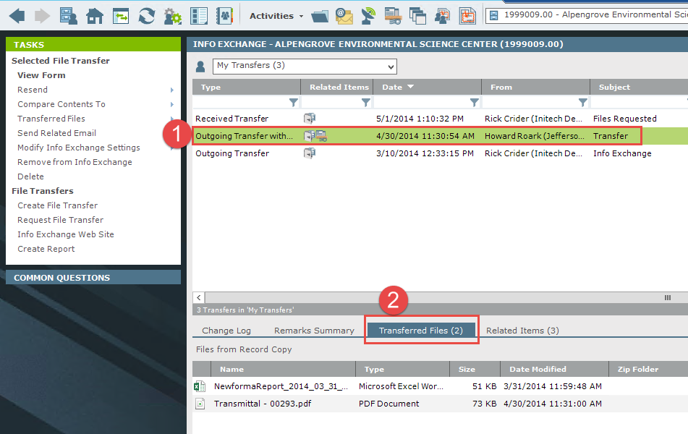

Viewing the Change Log

The **Change Log** tab displays which files each recipient downloaded.

1. To view the change log for a transfer, select the transfer in the Info Exchange activity center.
2. Select the **Change Log** tab. If the **Event Type** column lists **Partial Download**, simply click on that event to see exactly which files were downloaded.  
   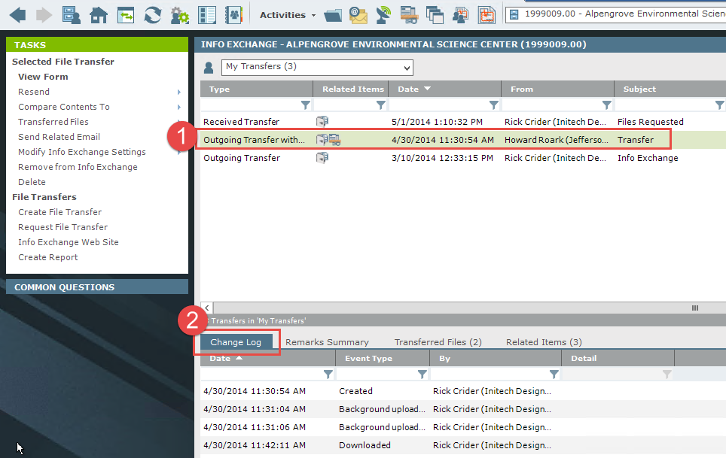

Creating Shared Folders

Creating shared folders will synchronize the content with Info Exchange website both manually and automatically. This allows users to access the most up to date information on Info Exchange simply by selecting the files saved in an Info Exchange shared folder. Internal and external users can also upload files to these folders from the Info Exchange web site.

For example, to update a set of Design Documents that go out to the client every Tuesday, create a shared folder that is set to automatically synchronize every Tuesday at the same time and save the new version of the documents in the folder. Notifications to recipients to remind them of the updates may also be sent.

1. To create a shared Info Exchange folder, go to the Project Files activity center and select the folder to be shared. Select **Info Exchange** from the **Tasks** pane, then **Create Shared Folder** from the popup menu.  
   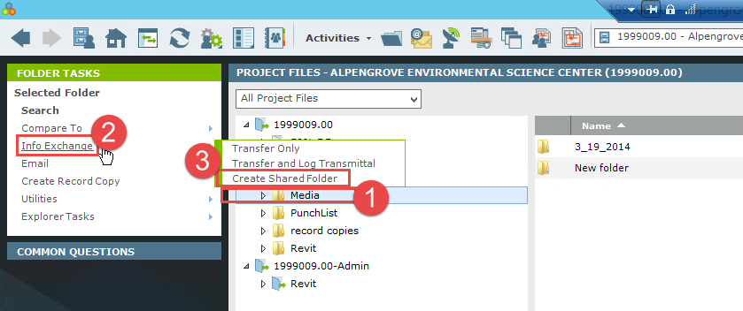
2. The **Create Shared Folder** dialog appears. Enter those who should have access to the information in the folder in the **To** and **CC** fields. Enter a name for the folder.

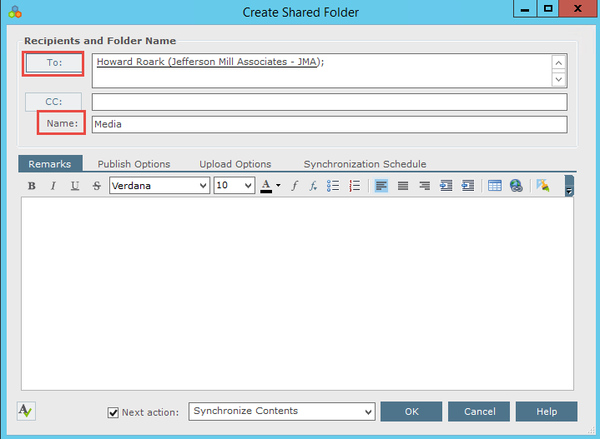

1. Select the **Publish Options** tab and choose the appropriate setting from the **Files to Publish** dropdown. Set whether or not to include external references with the synchronized files in the **External References** field. To save record copies of all synchronized files, select the **Save a record copy of the published files** checkbox and enter a location for the record copies in the **Record copy folder** field. Recipients can be notified when the contents of the folder are updated, select the **Notify each recipient** checkbox.  
   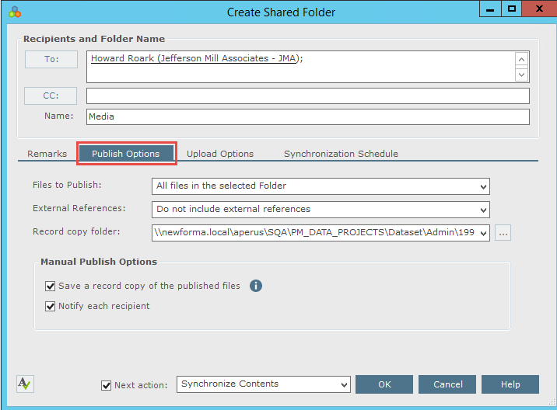
2. Select the **Upload Options** tab. The options on this tab allow you to control whether or not users can upload files to the shared Info Exchange folder. To allow users to upload files to the folder, select the **Allow Info Exchange Users to upload files** checkbox. This activates the rest of the fields on the tab.

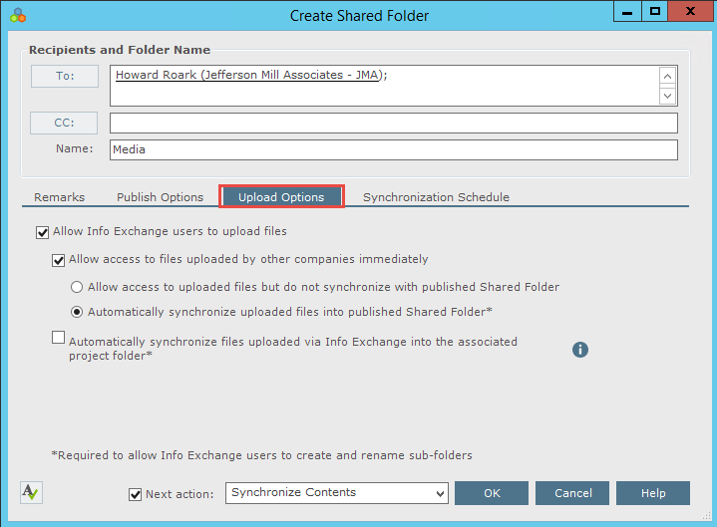

1. To make files uploaded by external users immediately available on Info Exchange, select the **Allow access to files uploaded by other companies immediately** checkbox. Select the **Automatically synchronize uploaded files into published Shared Folder** option for the uploaded files to appear in Info Exchange as well as in the shared folder (which is a shared folder on your network). To prevent the files from synchronizing with the shared folder, select the **Allow access to uploaded files but do not synchronize with published Shared Folder** option.
2. Select the **Automatically synchronize files uploaded via Info Exchange into the associated project folder** option for new files uploaded to the shared folder via Info Exchange to automatically synchronize with the associated project folder.
3. Select the **Synchronization Schedule** tab to set the synchronization schedule options for the shared folder. Create either a singular or recurring synchronization.
4. Select the dropdown next to the **New Time** button to select the time range.

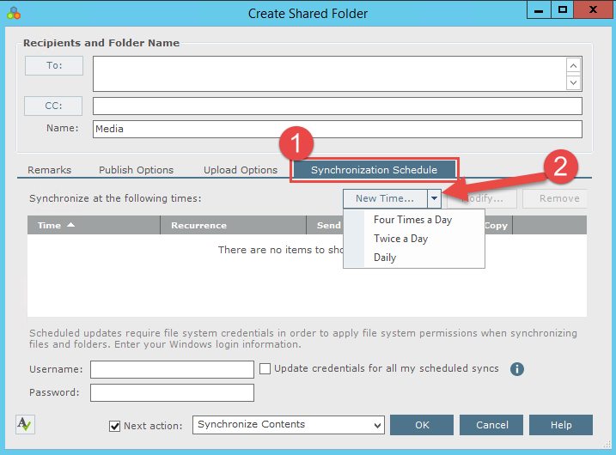

1. The **Synchronize at the following times:** section of the dialog updates. To modify any time item, select the desired time and select the **Modify** button. Select the options for record copies and notification as desired and click **OK** to schedule the synchronization.

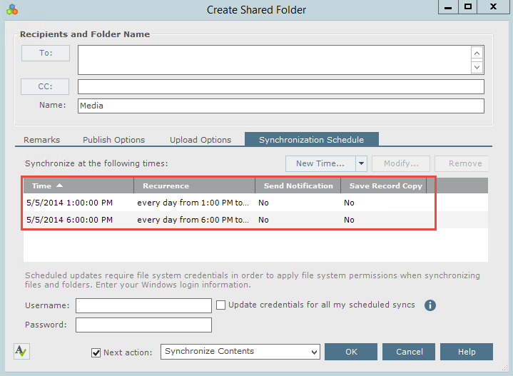

1. To create a recurring synchronization of the folder, select **New Time** and then the **Recurring icon** next to the subject.  
   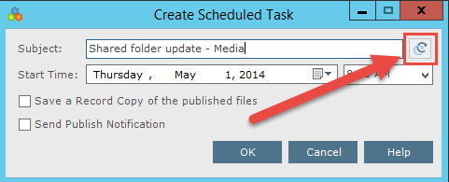
2. The Calendar Item Recurrence dialog appears. Select the desired recurrence values as needed and select OK to save the settings.  
   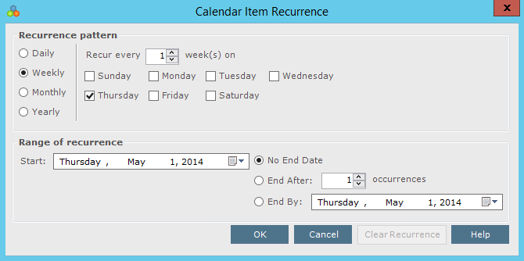

|  |  |
| --- | --- |
| C:\Users\Alison\AppData\Local\Microsoft\Windows\Temporary Internet Files\Content.IE5\3AR54E5N\MC900293188[1].wmf | Only new or updated files will be synchronized. |

Uploading Files to Shared Folders on Info Exchange

Internal and external users can also upload information to shared folders on Info Exchange.

1. Log into Info Exchange and select the **Shared Folders** option in the **Shortcuts** menu.  
   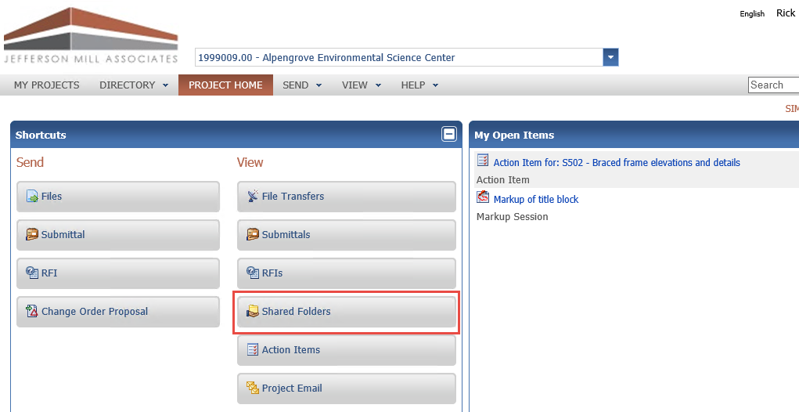
2. The **Shared Folders** list appears. Select the folder to upload files.  
   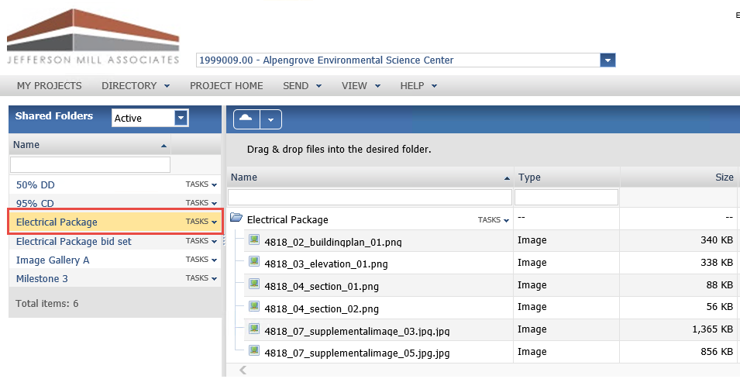
3. The contents of the selected folder are displayed. Click the **TASKS** dropdown next to the shared folder name and select **Upload Files** in the dropdown list.  
   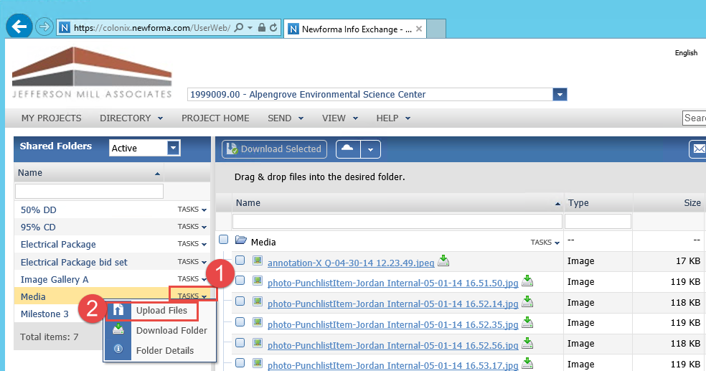
4. The **Upload Files** dialog appears. Complete the transmittal information and select the files to upload. Click **Upload** to upload the files.  
   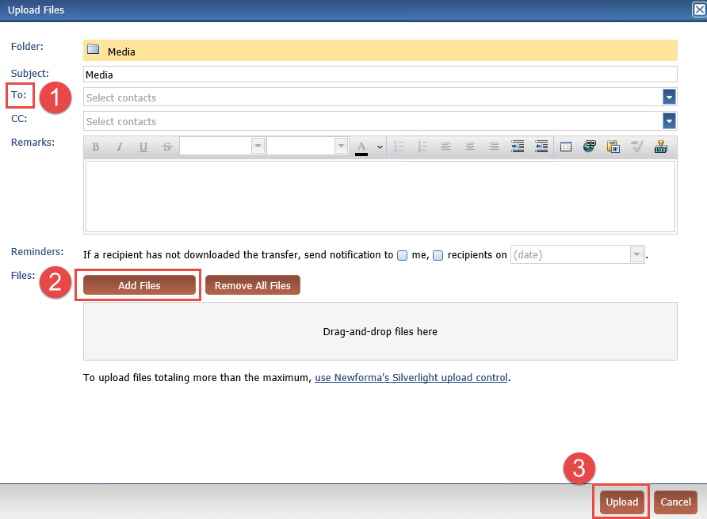
5. Select the **TASKS** dropdown next to the shared folder name and select Folder **Details.** The Folder Details window opens. Select the **Change Log** tab to track the upload.  
   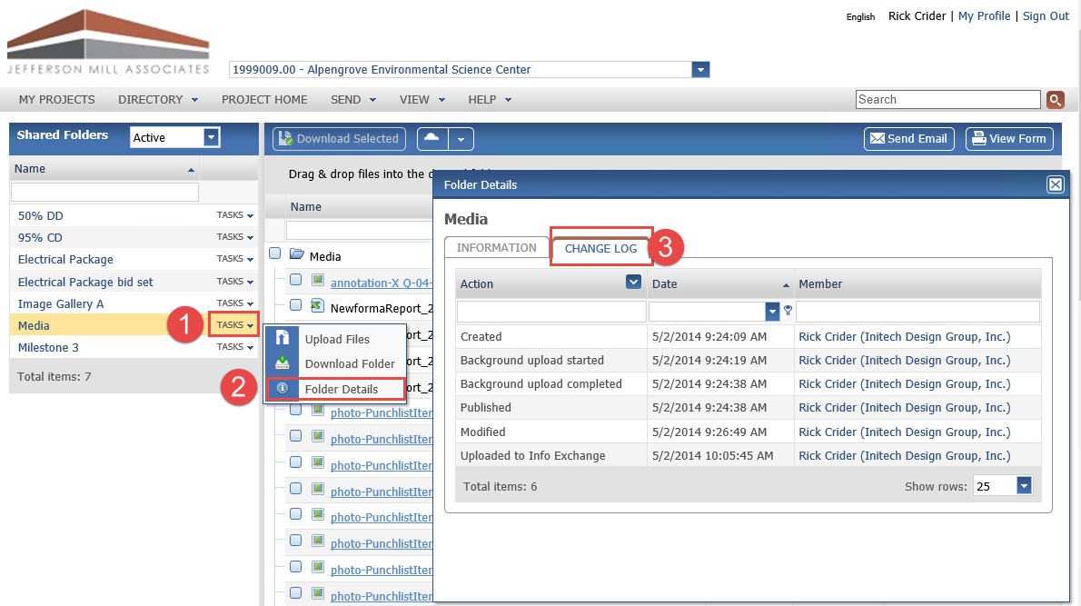

Accessing Info Exchange Remotely

Access Info Exchange web site from any laptop, iPad®, Android™ tablet or other device with an internet connection.

1. To access Info Exchange remotely, launch a web browser and go to the Info Exchange web site. Use the **Search** window to search all items that can be accessed on Info Exchange.

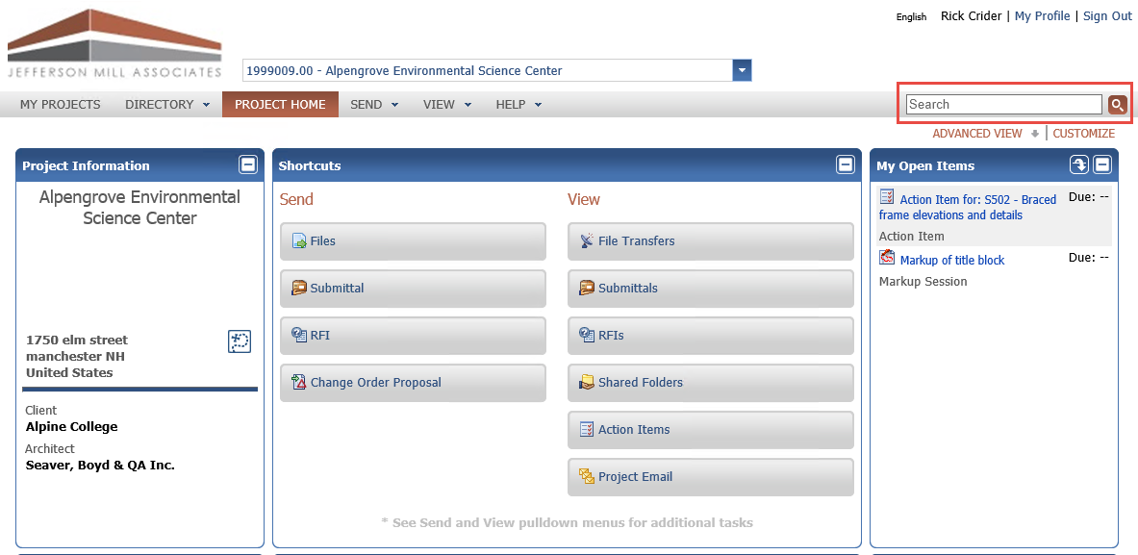

1. View the status of RFIs, Submittals and other contract management project items by selecting them from the **Contract Management** section of the **View** menu.  
   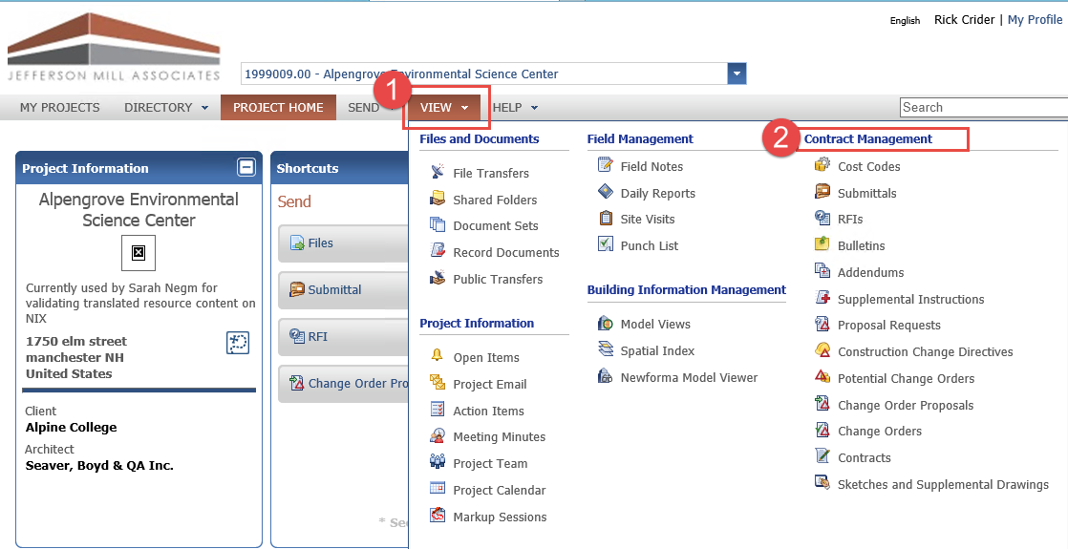

|  |  |
| --- | --- |
| C:\Users\Alison\AppData\Local\Microsoft\Windows\Temporary Internet Files\Content.IE5\3AR54E5N\MC900293188[1].wmf | Note: Global and project administrators control what Activity Centers are visible online through Info Exchange for both internal and external project team members. |

Newforma Project Center Help and Support

The question mark at the top right of the Project Center screen is the Newforma Project Center Help. The help defaults to the currently selected Activity Center. The help includes both overview and detailed information. There are also sections on Tips and Tricks and Frequently Asked Questions.  
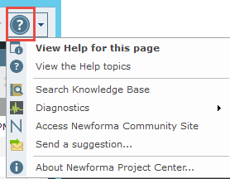

Clicking the drop down menu to the right of the question mark allows users to access Video Tutorials, search the Knowledge Base, and access the Newforma Community Site (www.Newformant.com).

Email any questions to services@newforma.com. For technical support, please contact support@newforma.com.