

AEC PROJECT INFORMATION MANAGEMENT

Newforma-to-Newforma® User Guide

9th Edition

Table of Contents

Overview 1

Connected File Transfers 2

Initiating a Connected File Transfer 2

Receiving a Connected File Transfer 3

Connected Shared Folder Overview 5

Initiating a Connected Folder 5

Publish Options Tab 7

Upload Options Tab 8

Synchronization Schedule Tab 9

Transfer a Connected Shared Folder 11

Receiving a Connected Shared Folder 12

Acknowledging and Managing Connected Shared Folders 12

Manually Synchronize a Connected Shared Folder 15

Approaches to Using Connected Shared Folders 16

The ‘Separate Inbox/Outbox’ Approach 16

The “Single Drop-box” Approach 17

Connected Workflow 19

Initiating a Connected Workflow Item 19

Receiving a Connected Incoming RFI 21

Responding to a Connected RFI 23

Receiving a Connected RFI Response 24

Connecting Expected Submittals 26

Company A Creates an Expected Submittal 26

Company B Imports Expected Submittals 27

Summary 28

Additional Information 28

Appendix I: Enabling Newforma-to-Newforma 29

Appendix II: Connecting to Another Company 30

Initiating a Connection (Company A) 30

Confirming a Connection (Company B) 32

Appendix III: Connecting to a Project 34

Initiating a Connection (Company A) 34

Confirming a Connection (Company B) 36

Appendix IV: Troubleshooting 37

The Sender is not on the Recipient’s Project Team 37

The Sender does not have Sufficient Permission Set Privileges 37

Automatic Download is not Enabled for the Project 38

The Connection is No Longer Set Up 38

Incorrect Project Association 38

Appendix V: Connected Workflow Data Mapping 39

Submittals (Forward For Review – Log a Received) 39

RFIs (Forward For Review – Log a Received) 40

Change Order Proposals (Forward For Review – Log a Received) 41

Supplemental Instructions (Forward For Review – Log a Received) 42

Addendums (Forward For Review – Log a Received) 42

Change Orders (Forward For Review – Log a Received) 43

Proposal Requests (Forward For Review – Log a Received) 43

Construction Change Directives (Forward For Review – Log a Received) 44

Bulletins (Forward For Review – Log a Received) 45

Respond and Close and Record Reviewer Response (All CM workflow activity centers) 46

Action Values for CM Respond and Close and Record Reviewer Response Activities 46

Newforma-to-Newforma® User Guide

Overview

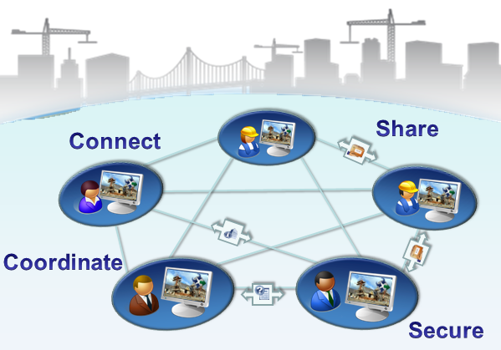Newforma-to-Newforma® (N2N) seamlessly connects companies using Newforma® Project Center to streamline the coordination and exchange of critical project information. By utilizing a direct, secure communication channel between servers within each company’s corporate firewall, Newforma-to-Newforma enables a fully integrated and transparent mode of project delivery without compromising control of proprietary project information.

This user’s guide describes the setup and recommended best practice use cases associated with Newforma-to-Newforma. The appendices of this user guide walk Project Center administrators through the one-time connection process that allows mutually consenting Newforma customers to securely connect their Newforma® Info Exchange servers. With this background server-to-server connection in place, the guide describes the following three use cases enabled by Newforma-to-Newforma:

* Send file transfers directly to the recipient’s incoming Info Exchange log, completely eliminating download delays.
* Synchronize selected project folders on a scheduled basis, ensuring that distributed design and construction teams remain coordinated.
* Seamlessly exchange RFI, Submittal and other workflow actions, eliminating the need to copy and paste meta-data or download related files.

|  |  |
| --- | --- |
| C:\Users\Alison\AppData\Local\Microsoft\Windows\Temporary Internet Files\Content.IE5\3AR54E5N\MC900293188[1].wmf | Note: There are certain pre-conditions in the setup of the project and configuration of project team members that must be met in order for connected delivery of project items to work. Project Center administrators should consult the Troubleshooting appendix of this manual for more details. |

Connected File Transfers

Newforma to Newforma automates the transfer of files between connected companies, completely eliminating the need for file transfer recipients to login and download file transfers from the sender’s Info Exchange server. Instead, incoming file transfers from connected companies are automatically downloaded by the recipient’s Newforma Project Center server directly into the recipient’s incoming Info Exchange log.

Initiating a Connected File Transfer

Sending a connected file transfer is just like sending any other file transfer in Newforma Project Center using Info Exchange. If one or more recipients are connected project team members, the **Enable Connected Project delivery** option will be enabled in the **Transfer to Info Exchange Options** dialog box.

1. Select **Enable Connected Project delivery** to send the transfer via connected delivery to the connected companies listed in the **Delivering to:** field of the **Transfer to Info Exchange Options** dialog box.  
   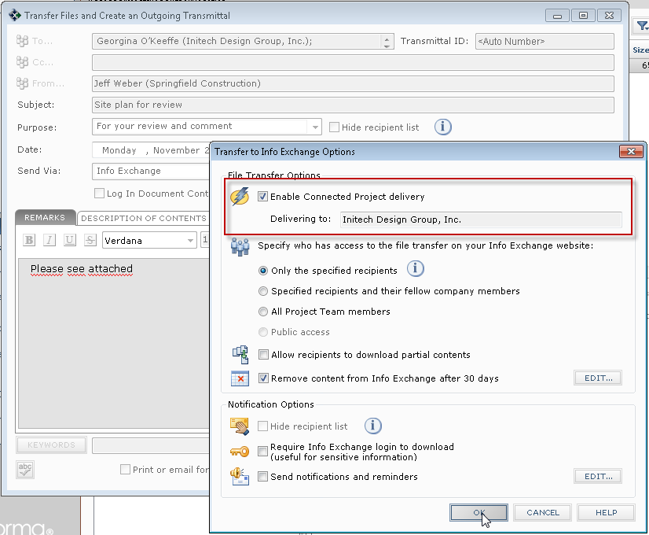
2. Click **OK** in the **Transfer to Info Exchange Options** dialog and in any following dialogs as needed to complete the transaction. The file transfer is uploaded to the sender’s Info Exchange server, and notifications are sent to all the recipients, just as with a normal file transfer.
3. Once the files are available for download from the sender’s Info Exchange server, the sender’s Newforma server notifies the recipient’s Newforma server of the connected file transfer. This prompts the recipient’s Newforma server to login and automatically download the file contents of the file transfer into the recipient’s Newforma Info Exchange activity center. The download appears in the Info Exchange activity center as a pending, incoming file transfer.

Receiving a Connected File Transfer

Once the file transfer is complete, the recipient receives an email notification in the same manner as other file transfer recipients. As the recipient, you can use the links in the notification email to access the files.

1. Click the first embedded link in the notification email to open the incoming file transfer within the associated project in Project Center.  
   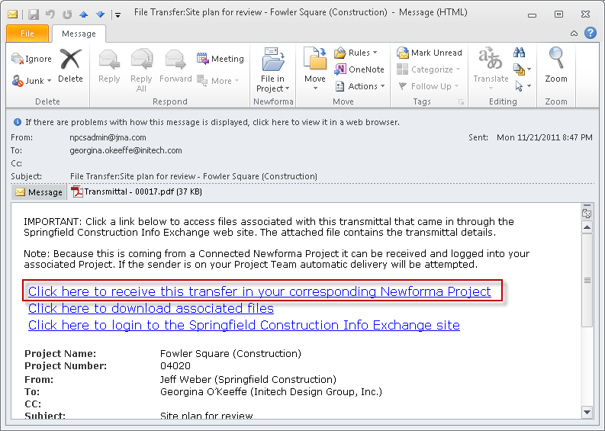

|  |  |
| --- | --- |
| C:\Users\Alison\AppData\Local\Microsoft\Windows\Temporary Internet Files\Content.IE5\3AR54E5N\MC900293188[1].wmf | The other links to download the files and to login to the sender’s Info Exchange site are still available in case the recipient does not have access to Project Center. |

1. The connected transfer is displayed in its pending state in the Info Exchange log. The files have already been downloaded into the project. Click on **Acknowledge Receipt** in the **Tasks** pane to notify the sender that the transfer was successful.  
   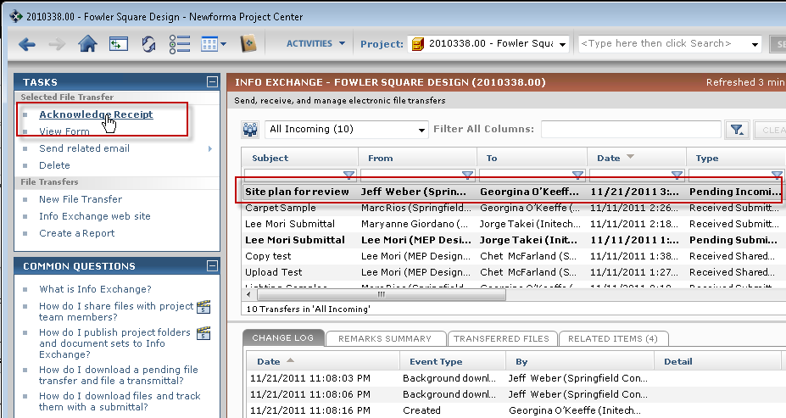
2. The **Acknowledge Receipt** dialog appears.  
   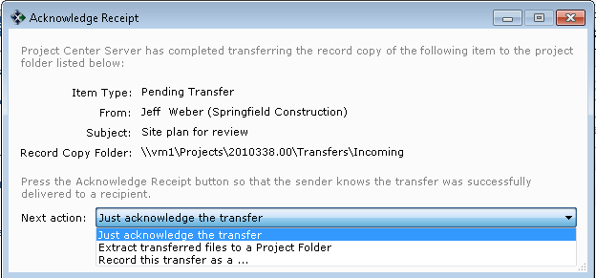
3. Select the appropriate next action:
   1. **Just acknowledge the transfer** will show the sender that you received the files.
   2. **Extract transferred files to a Project Folder** will extract the files from the zip file and allow you to select where you want the files to be saved.
   3. **Record the this transfer as a . . .** will allow you to record the transfer as another Newforma item such as an incoming transmittal, RFI, Submittal or other Contract Management workflow item.

Connected Shared Folder Overview

Newforma to Newforma allows shared folders to be connected, eliminating the need to log into the Info Exchange website to download or upload files into the shared folder.

**Please reference the section of this document on Approaches to Using Connected Shared Folders on page 16 for suggestions and best practices in using this feature.**

Initiating a Connected Folder

Before initiating a connected folder, the project team representatives from each company should define the purpose and process for each connected folder. Also, to avoid any permanent loss of data, avoid sharing and connecting ‘live’ working folders. Instead, define an ‘Outgoing’ or project ‘Dropbox’ folder used for exchange and coordination with external team members.

|  |  |
| --- | --- |
| C:\Users\Alison\AppData\Local\Microsoft\Windows\Temporary Internet Files\Content.IE5\3AR54E5N\MC900293188[1].wmf | For fully connected delivery to succeed, the initiator of a connected transfer or workflow action needs to be on the recipient’s project team. This is because the sender needs project member credentials in order to log into the recipient’s Info Exchange to upload the workflow item. |

The easiest way to create a connected folder is to use the Create Shared Folder option for a project within Project Center.

1. Navigate to the project that contains the folder for which you want to create a connected folder.
2. View the project files and select the desired folder within the project. Right click on the folder and select **Info Exchange**, then **Create Shared Folder** from the popup menu.  
   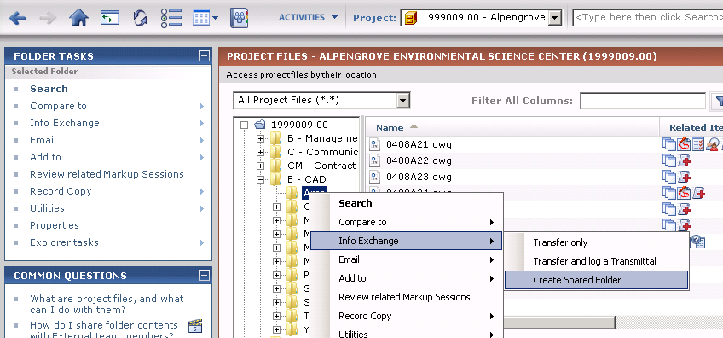

|  |  |
| --- | --- |
| C:\Users\Alison\AppData\Local\Microsoft\Windows\Temporary Internet Files\Content.IE5\3AR54E5N\MC900293188[1].wmf | All sub-folders of the selected folder are included in the connected folder. This includes empty sub-folders. |

1. The **Create Shared Folder** dialog appears.  
   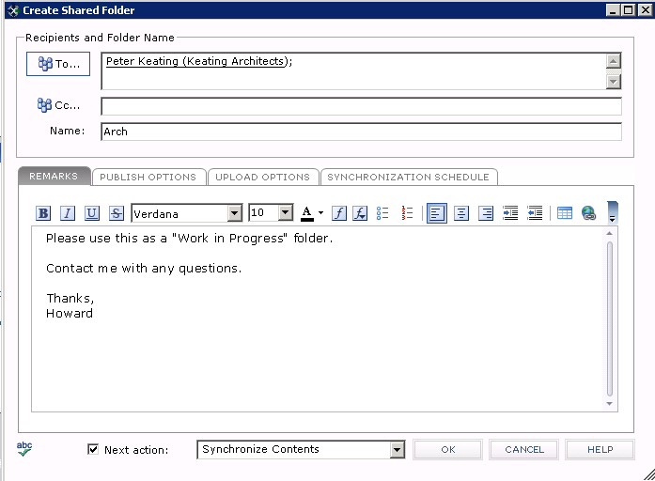
2. Complete the **To…**, **CC…**, and **Name** fields as necessary. Enter any remarks on the **Remarks** tab. The following table explains the purpose of each field:

|  |  |
| --- | --- |
| To… | The To... field contains the team members with whom you want to share the folder. These team members will receive email notifications of any future updates to the folder. If reminders are configured, they will also receive reminder emails if they do not download the updated files. |
| CC… | The primary difference between the CC…and To… fields is that team members in the CC… field will NOT receive reminders if reminders are enabled for the folder. |
| Name | The Name field defaults to the folder name. You can change the name to more accurately describe the purpose of the shared folder (i.e., MEP Coordination, Shop Drawings, CAD Backgrounds, Presentations, etc.) |
| Remarks | The Remarks tab is used to provide more instructive information about the shared folder, its intended use, etc. |

Publish Options Tab

The **Publish Options** tab in the **Create Shared Folder** dialog establishes the publish preferences for the initial transfer of the connected folder, as well as all subsequent synchronization updates.  
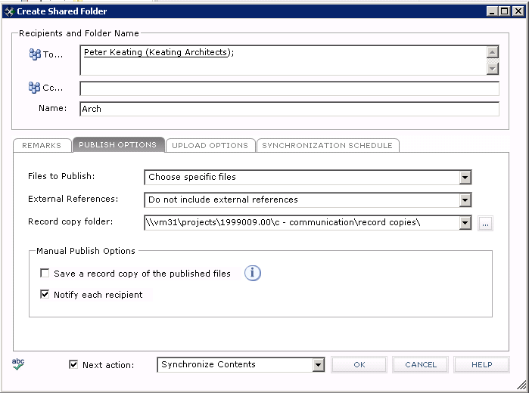

The following table explains the purpose of each field on the **Publish Options** tab:

|  |  |
| --- | --- |
| Files to Publish | Specify whether selected files or all files within the folder will be published. |
| External References | Select an option if external references will be automatically found and sent with the files being shared. |
| Record Copy Folder | Folder in which to store record copies. |
| Manual Publish Options | Sets the parameters for manually published updates. The following options are available:   * Save a record copy of the published files. Enable or disable saving a record copies. Since these folders are typically used for coordination and will be updated frequently, record copies are optional and frequently disabled to save disk space. * Notify each recipient. Enable or disable recipient notification. If the connected folders are going to be updated frequently, the sender might want to disable email notifications to limit the proliferation of email.   These settings apply only to manually published updates. There are separate settings for scheduled updates that can be set on the Synchronization Schedule tab of the Create Shared Folder dialog. |

Upload Options Tab

Connected folders can also be accessed via the sender’s Project Center Web page on their Info Exchange server. The **Upload Options** tab in the **Create Shared Folder** dialog is used to allow Info Exchange users to upload files into the connected folder. The primary use case for this option is to allow external team members that do not yet have Project Center to upload their design and construction files.  
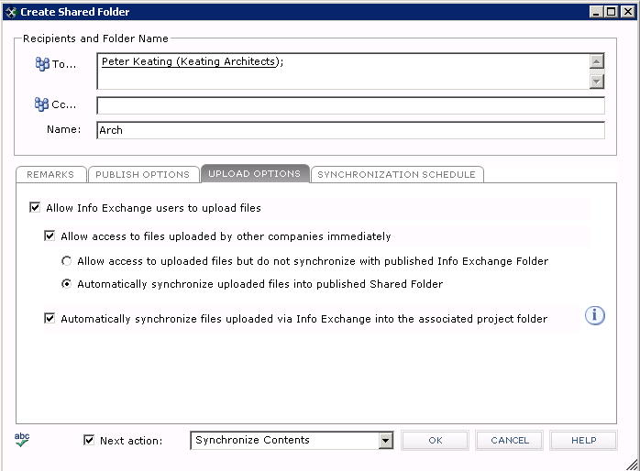

The following table explains the purpose of each field on the **Upload Options** tab:

|  |  |
| --- | --- |
| Allow Info Exchange users to upload files | If this option is not selected, Info Exchange users can only download files from the connected folder and the rest of the Upload Options are grayed out. If this option is selected, the additional options below are enabled. |
| Allow access to files uploaded by other companies immediately | Allow users to upload to shared folders. There are two possible settings for this option when selected:   * Allow access to uploaded files but do not synchronize with published Shared Folder. When this option is selected files from external users would be available to others on Info exchange immediately after they are uploaded. * Automatically synchronize uploaded files into published Shared Folder. When this option is selected uploaded data is both on Info Exchange and also synchronized with the Folder (which is a shared folder on your network). |
| Automatically synchronize files uploaded via Info Exchange into the associated project folder | If the last option on this tab is checked, any new files uploaded to this folder via Info Exchange would automatically synchronize with the folder in your project files. |

Synchronization Schedule Tab

A connected folder can be manually synchronized at any time. The **Synchronization Schedule** tab in the **Create Shared Folder** dialog allows users to schedule synchronization events to occur automatically, either by entering specific dates and times, or by configuring folder synchronization to recur daily, weekly or monthly.

1. To set up a sync event, click **New Time…** at the top of the **Synchronization Schedule** tab. Click on the **Recurring** icon to set up a recurrence schedule.   
   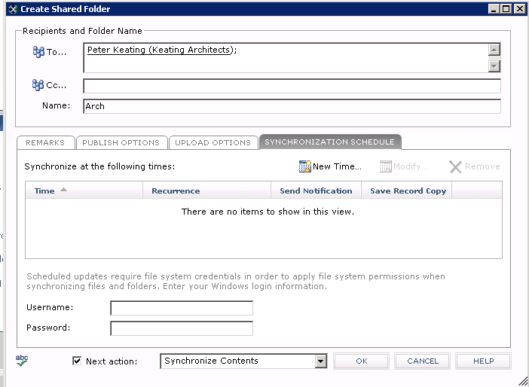

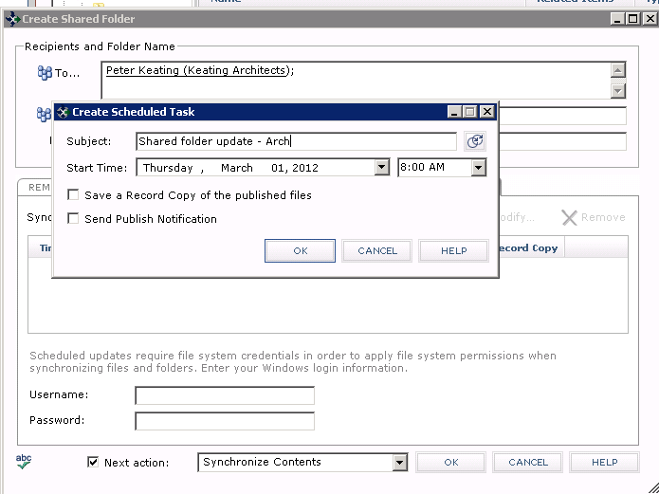

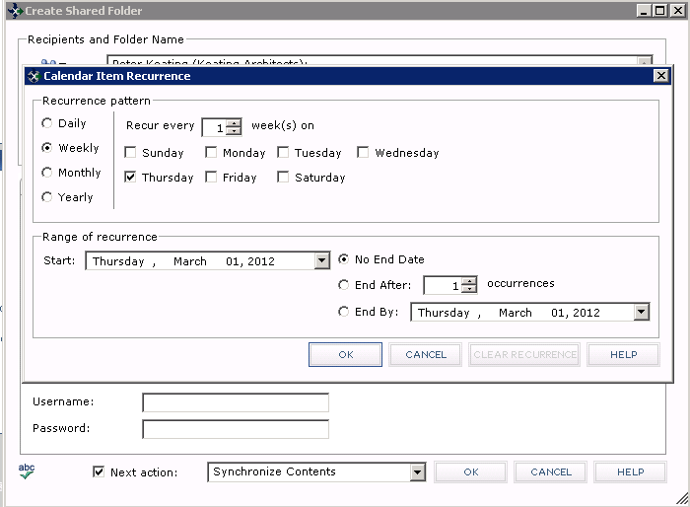

|  |  |
| --- | --- |
| C:\Users\Alison\AppData\Local\Microsoft\Windows\Temporary Internet Files\Content.IE5\3AR54E5N\MC900293188[1].wmf | Notifications and record copies can be configured per scheduled event. |
| C:\Users\Alison\AppData\Local\Microsoft\Windows\Temporary Internet Files\Content.IE5\3AR54E5N\MC900293188[1].wmf | To schedule future updates, the sender must enter their Windows credentials. This prevents the user from sharing or accessing files or sub-folders within the shared folder that the user does not have permission to view. |

1. After setting the options in each tab of the **Create Shared Folder** dialog, select **Synchronize Contents** in the **Next Actions** dropdown list at the bottom of the dialog. Click **OK** to proceed to the next step.

Transfer a Connected Shared Folder

The next dialog allows you to configure the standard Info Exchange options.

1. If one of the recipients is with a connected company and the current project has been connected, the **Enable Connected Project delivery** check box is enabled. Check it to enable connected delivery of the connected folder.  
   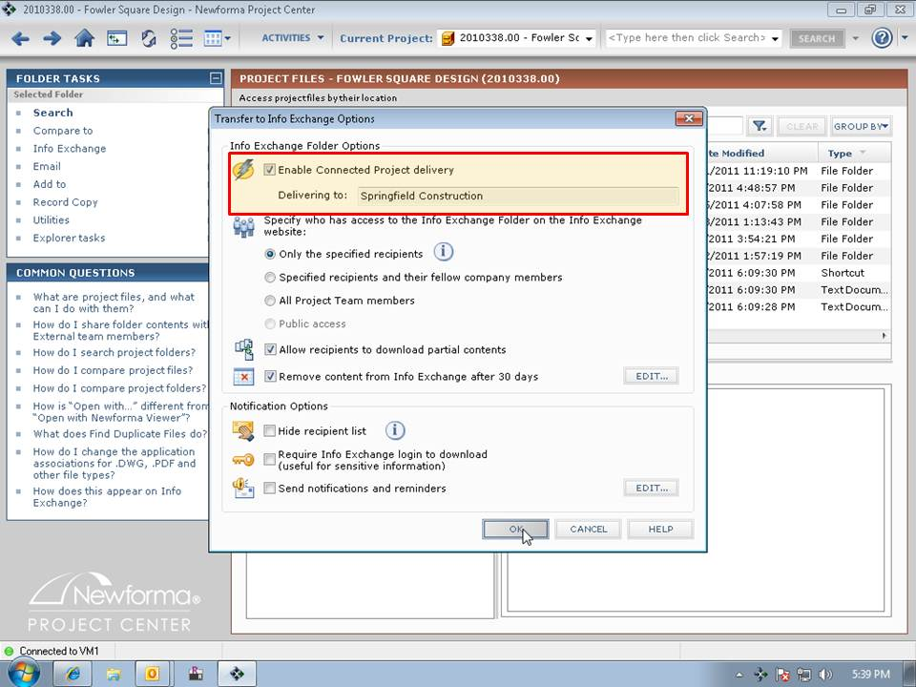
2. Click **OK** and follow the prompts in the ensuing transfer-related dialogs to complete the initial transfer.

Receiving a Connected Shared Folder

When a connected folder is sent using connected delivery, the underlying Newforma-to-Newforma connection notifies the server at Company B to automatically download the folder from Company A’s Info Exchange server.

|  |  |
| --- | --- |
| C:\Users\Alison\AppData\Local\Microsoft\Windows\Temporary Internet Files\Content.IE5\3AR54E5N\MC900293188[1].wmf | The recipient is still notified of the connected folder via email, but the link takes the recipient directly to the pending folder within the recipient’s project in Newforma Project Center. |

The very first time a new connected folder is received, it is downloaded as a pending connected folder and displayed in the Info Exchange activity center within the recipient’s project in Newforma Project Center. The contents of the connected folder are temporarily stored in a zip file.

Acknowledging and Managing Connected Shared Folders

1. To access and manage a pending connected shared folder, select the folder in the Info Exchange activity center, then select **Acknowledge Receipt** from the **Tasks** list.  
   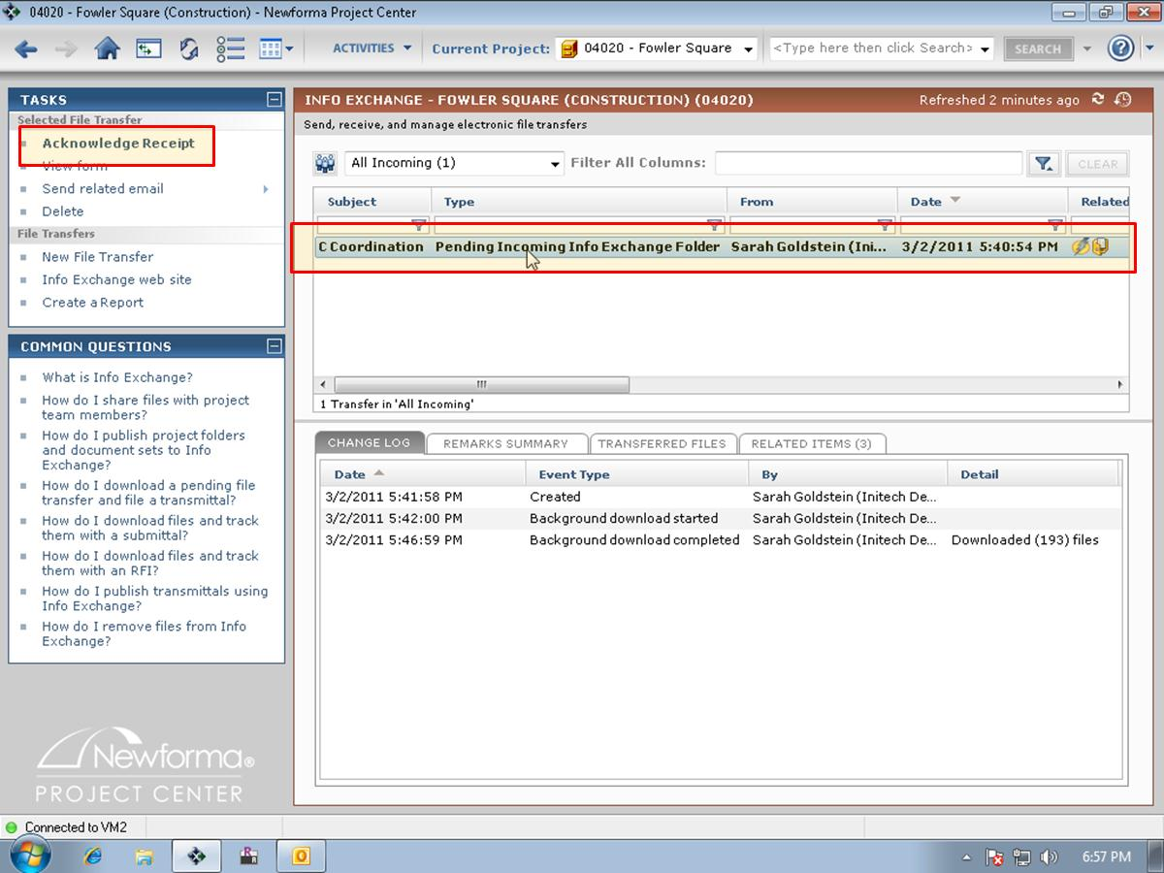
2. The **Acknowledge Receipt** dialog appears. Select **Manage Connected Folder Settings** in the **Next action** dialog. Click **Acknowledge Receipt** to notify the sender’s Project Center server that the connected transfer was successful.  
   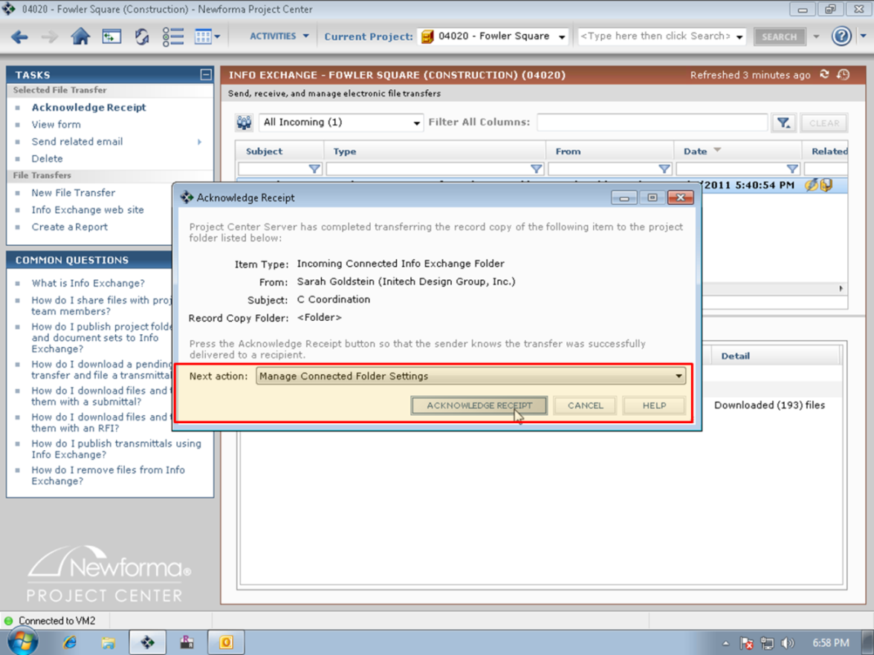
3. The **Manage Connected Incoming Shared Folder** dialog appears. This dialog allows you to configure the behavior for future updates of this connected folder from the sender at Company A. In the **Extraction Folder** field, browse to the local folder within Company B’s version of the project to which you want to extract the contents of the connected folder from Company A. Click **OK** to save the changes.  
   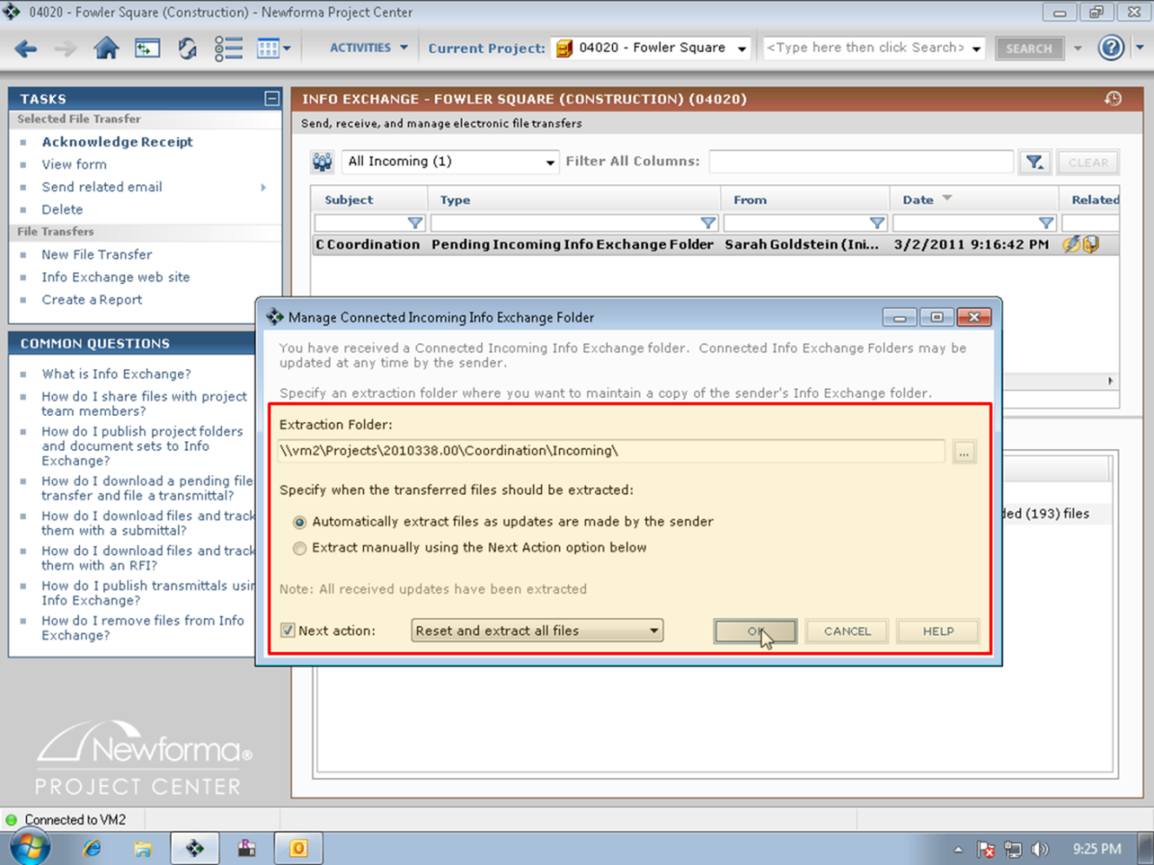

|  |  |
| --- | --- |
| C:\Users\Alison\AppData\Local\Microsoft\Windows\Temporary Internet Files\Content.IE5\3AR54E5N\MC900293188[1].wmf | There is also an option to extract future updates automatically or manually. If automatic extraction is selected, both new files and more recent versions of existing files are automatically extracted into the folder location designated in the recipient’s project. |
| C:\Users\Alison\AppData\Local\Microsoft\Windows\Temporary Internet Files\Content.IE5\3AR54E5N\MC900293188[1].wmf | If a matching file name exists in the local folder, the extraction function will overwrite the existing file if its file date is *older* than the incoming file. If the matching file in the designated extraction folder is *newer*, the incoming file will NOT overwrite it. |

Manually Synchronize a Connected Shared Folder

The sender of a connected Shared folder can manually initiate the synchronization of their local version of the folder in their project with the shared version of the folder in the connected company’s project as well as the sender’s Newforma Project Center Web site at any time.

1. To initiate synchronization, click on the desired folder in the Project Files activity center in Newforma Project Center. Select the **Synchronize Contents** task either by right-clicking on the folder and selecting it from the popup menu or by selecting it from the **Tasks** list.  
   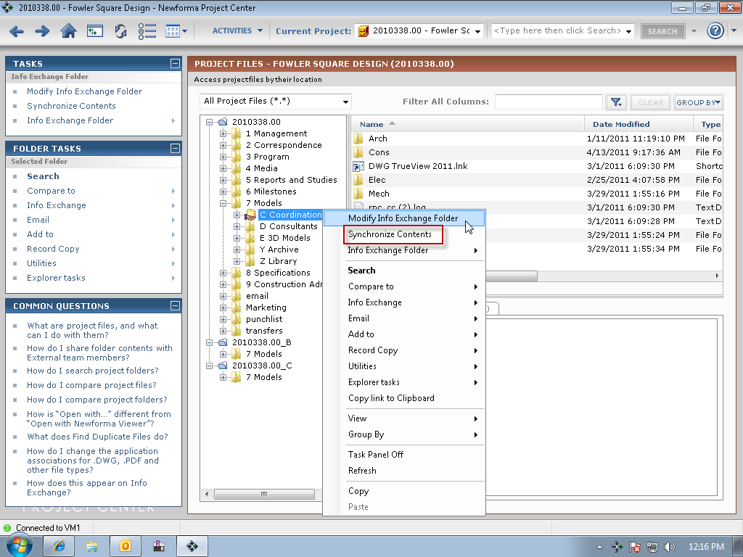
2. The contents of the connected shared folder on the sender’s Project Center Web site are updated. The recipient’s connected Newforma Project Center server downloads the updated connected Shared folder into its project. If the option to Automatically Extract Contents has been selected by the recipient, any new or updated files are automatically extracted into the recipient’s version of the connected folder on their file server.

Approaches to Using Connected Shared Folders

This section explores two best practices that connected Newforma customers have implemented for effective use of connected shared folders:

* The ‘Separate Inbox/Outbox’ approach
* The ‘Single Drop-box’ approach

The ‘Separate Inbox/Outbox’ Approach

With this approach, each company designates separate folders for incoming and outgoing files, as illustrated below:  
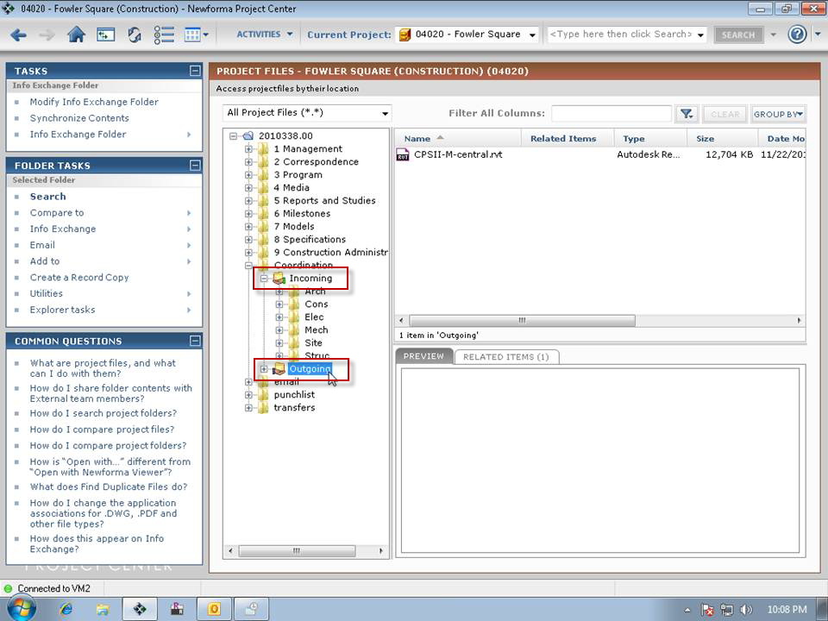

The **Outgoing** folder is used to copy files that are ready to be shared with external team members. A *completely separate* **Incoming** folder is used to locate the latest files that have been shared by another company. For many project teams, this convention is well understood and N2N can be used to eliminate all the manual steps involved in routing updated files to the appropriate location.

The advantage to this approach is there is no risk that the outgoing files that you share will be overwritten by files that are shared back to you. This approach is vital if both companies will be taking turns editing the same files. The disadvantage of this approach is there could be many incoming connected shared folders to manage on a typical project. For example, if there are multiple companies sharing files, it may be necessary to manage multiple **Incoming** folders (i.e. Incoming from Structural, Incoming form Mech, Incoming from GC, etc.).

The “Single Drop-box” Approach

In this approach, a single folder within the project is used for both sharing of outgoing connected shared folders and extraction of incoming connected shared folders. In essence, the recipient at Company B re-publishes the “incoming” connected folder from Company A back to Company A. Company A then receives the return folder from Company B and extracts it into their version of the folder. This scenario is illustrated below:  
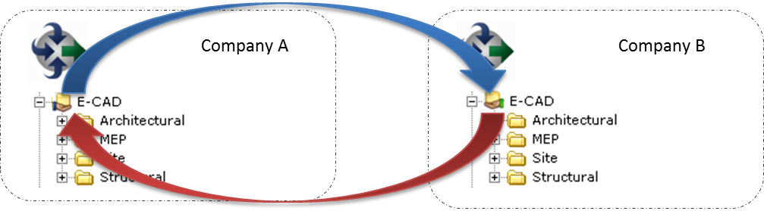

This creates a single connected shared folder for sending and receiving files among connected companies that is extremely easy to maintain. This works best when the connected companies have a clear understanding of which company “owns” each file or sub-folder within the connected shared folder.

For example, in the case of a Revit or CAD dataset where design files are coordinated using external references or linked models, and the individual files that make up the coordinated set are typically owned, edited and updated by one company, this approach works very well.

The illustration below demonstrates how nesting of connected Shared folders could be utilized when a Design or GC firm coordinates with their Sub-Consultants or Sub-Contractors:  
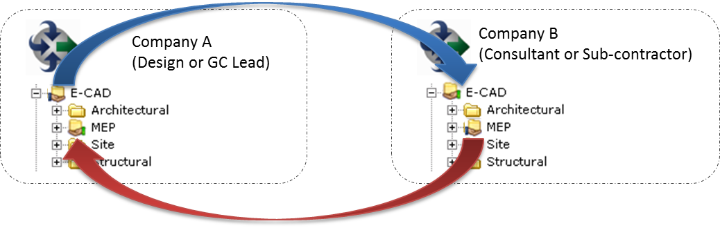

In this case, Company B only shares back the folder containing the files that they “own”. This approach scales well to a situation which might include three or more participants in a coordinated design or construction scenario:  
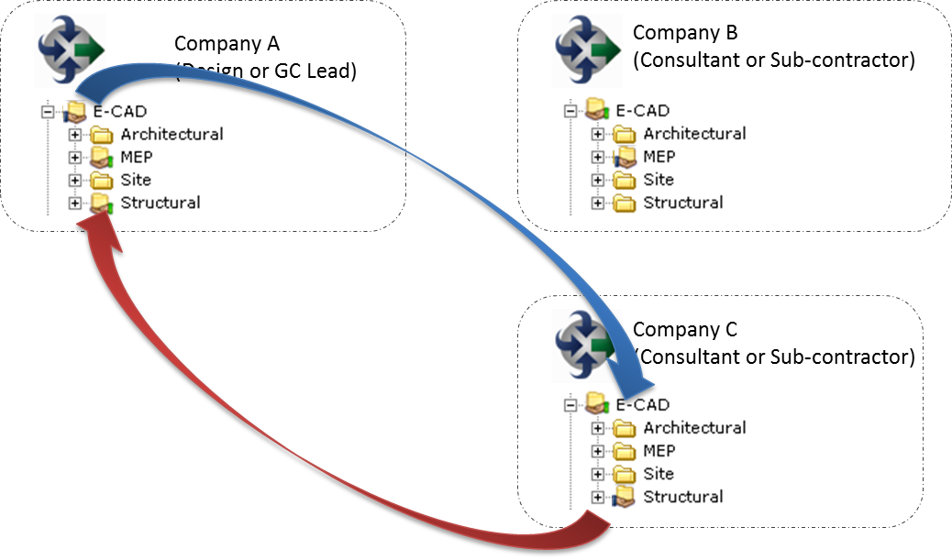

In this scenario, the design or construction lead, or Company A, ‘owns’ the distribution of the ‘coordinated set’ of design and construction files, while each sub-consultant and sub-contractor ‘owns’ their individual company’s specified scope of work.

As mentioned above, this works best when the connected companies have a clear understanding of which company “owns” each file or sub-folder within the connected Shared folder.

This approach does NOT work well if the ownership of individual files is not clear. If there are individual files which the involved companies will ever be concurrently or even sequentially editing and sharing, then this approach is not advised because the connected Shared folder will only retain the file with the newest file date, overwriting any previously updated versions of the file from other companies.

|  |  |
| --- | --- |
| C:\Users\Alison\AppData\Local\Microsoft\Windows\Temporary Internet Files\Content.IE5\3AR54E5N\MC900431585[1].png | When using this “Drop-box” approach, Newforma strongly recommends that the single, designated folders for incoming and outgoing folders NOT function as production folders in either company. |

Connected Workflow

Newforma-to-Newforma simplifies the exchange and coordination of RFIs, submittals and other contract and construction document workflows between construction and design companies using Newforma Project Center. It does so by automatically creating pending incoming items or workflow actions within the recipient company’s corresponding log when initiated by a Newforma-to-Newforma-connected sender. Additionally, any files associated with these transactions are automatically downloaded by the recipient’s server, completely eliminating the need for the recipient to login to the sender’s Newforma Project Center Web server to download files or copy and paste information from their notifications and forms into their Newforma Project Center environment.

Initiating a Connected Workflow Item

Connected workflow imposes minimal changes to the current process within Newforma. RFIs, submittals and other Newforma Contract Management items are initiated and sent (‘Forwarded’ or ‘Responded to’) in the same way as when connected workflow is not enabled.

1. To begin the process, the initiator at Company A creates the item within Newforma Project Center and forwards it to one or more recipients for them to review and respond. In the example below, the project team member at Company A has created an RFI and needs to forward it for review to a connected team member.  
   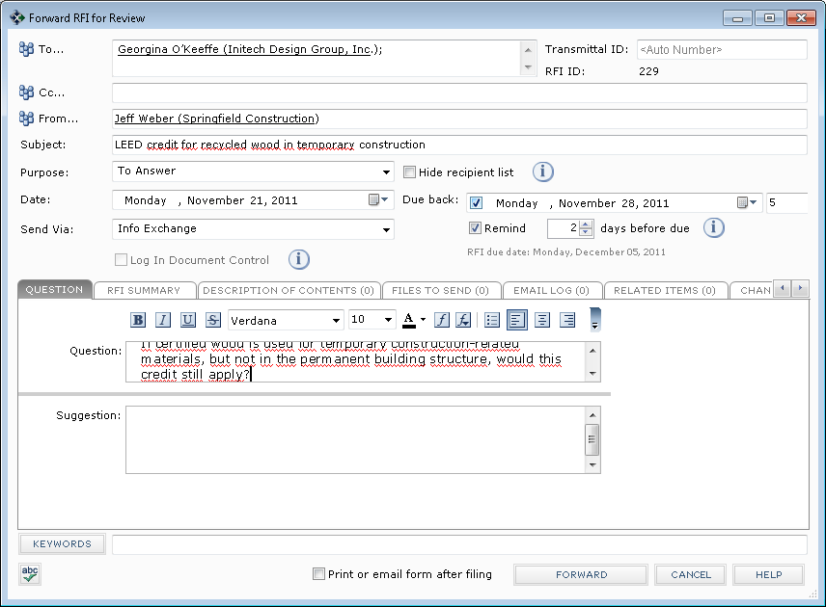
2. If files have NOT been attached to the RFI, the user clicks **Forward** to complete the transaction. The RFI is automatically transferred to the connected recipient as described below.
3. If files HAVE been attached to the RFI on the **Files to Send** tab, the **Transfer to Info Exchange Options** dialog box appears when the user clicks **Forward**. The **Enable Connected Project delivery** option is automatically enabled. To confirm connected delivery of the file contents associated with the RFI, the user ensures that the **Enable Connected Project delivery** check box is selected. The user clicks **OK** to complete the transaction.  
   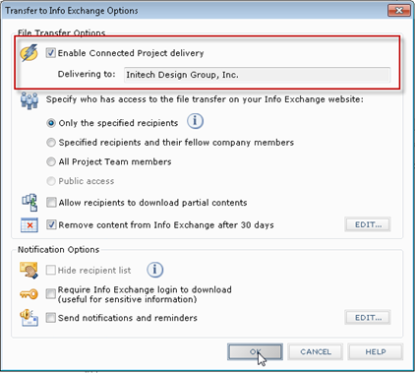
4. Once the transaction is completed and any associated files have been posted to the sender’s Info Exchange server, the recipient(s) of the forwarded RFI receives an email notification, just as with an “un-connected” workflow event.
5. In the case of this connected recipient, the sender’s Newforma server also notifies the recipient’s Newforma server of the connected RFI and associated files. The sender’s server does this by logging into the recipient’s Info Exchange server using the sender’s Info Exchange credentials. The recipient’s Newforma server then downloads the forwarded RFI and its file contents into the recipient’s Newforma RFI activity center as a pending, incoming RFI.

|  |  |
| --- | --- |
| C:\Users\Alison\AppData\Local\Microsoft\Windows\Temporary Internet Files\Content.IE5\3AR54E5N\MC900431585[1].png | For fully connected delivery, the initiator of a connected transfer or workflow action needs to be on the recipient’s project team and needs access to the recipient’s Info Exchange server on the connected project. |

Receiving a Connected Incoming RFI

1. When the RFI arrives, the recipient receives an email notification, just like any other file transfer recipient.  
   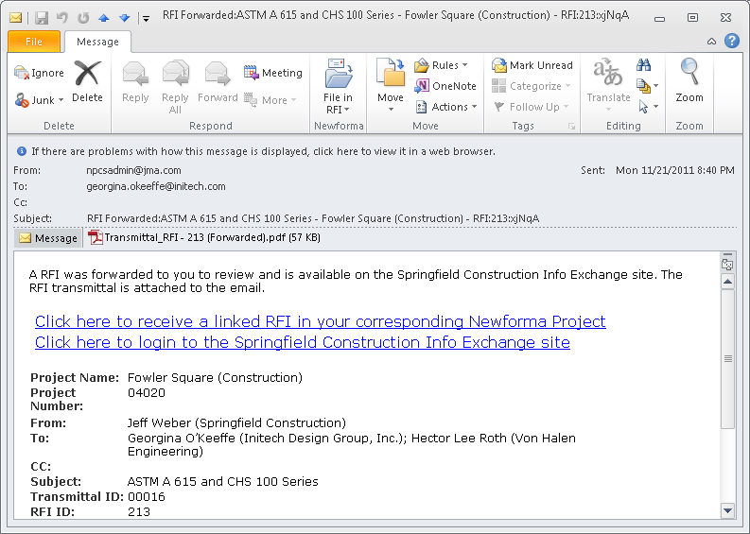
2. Clicking on the first embedded link opens the RFI activity center within the recipient’s Newforma Project Center environment, where the incoming RFI has been logged as a pending RFI.  
   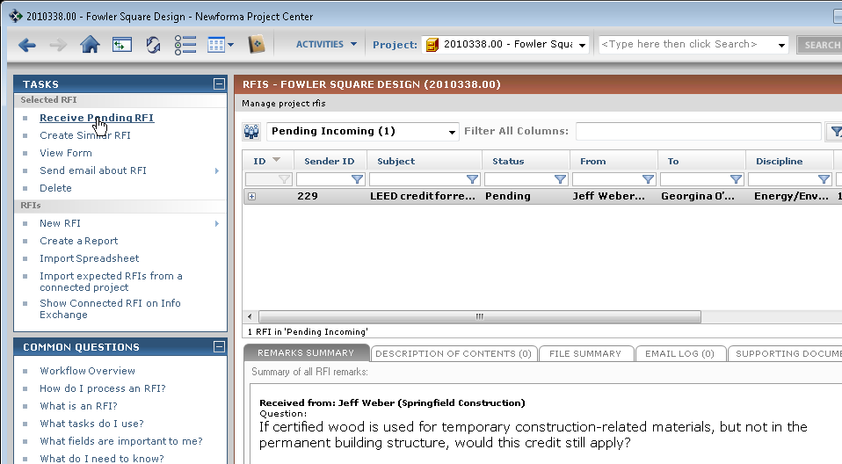
3. All of the data about the RFI, including any attached files, is automatically logged with the incoming RFI. Double click the RFI or highlight it and select **Receive Pending RFI** in the **Tasks** list to complete the process. The **Log a Received RFI** dialog appears. Modify or supplement any of the information provided by the sender as needed.  
   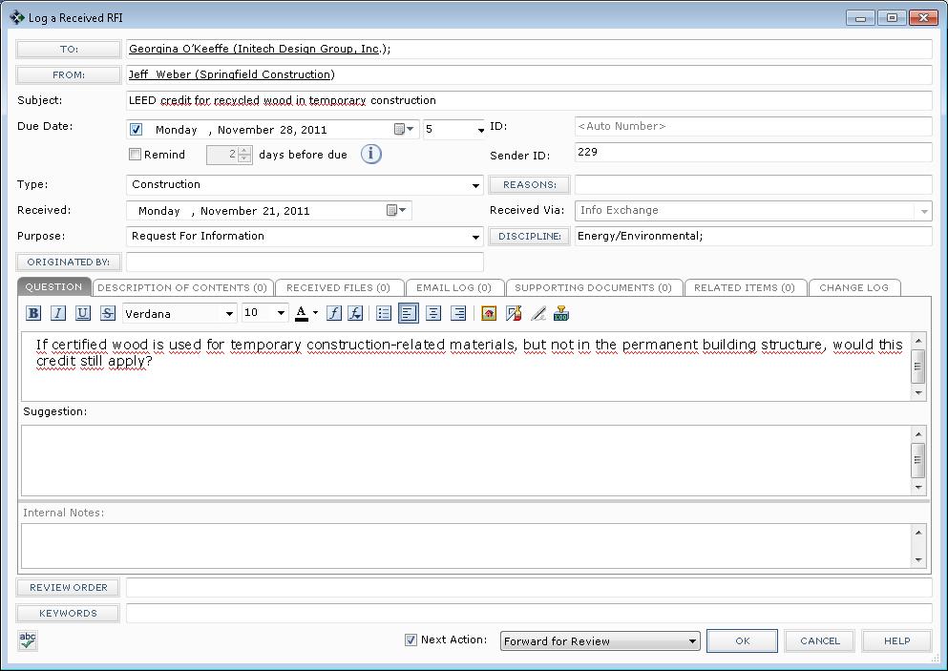

|  |  |
| --- | --- |
| C:\Users\Alison\AppData\Local\Microsoft\Windows\Temporary Internet Files\Content.IE5\3AR54E5N\MC900293188[1].wmf | Connected workflow ensures that the information entered by the sender is available by default when the item is logged by the recipient. However, the recipient can modify or supplement this information without breaking the link to the sender’s version of the item. |

1. At this point, the workflow for the recipient is identical to an “un-connected” RFI until it is time to send a response back to the connected sender.

Responding to a Connected RFI

Responding to a connected RFI is similar to responding to an “un-connected” RFI.

1. In the RFI activity center, highlight the RFI and select **Close, Respond and Close** from the task menu.
2. The **Respond to RFI and Close** dialog appears. Create the content of the response and associate any files as needed on the **Associated Files** tab. Click **Create**.  
   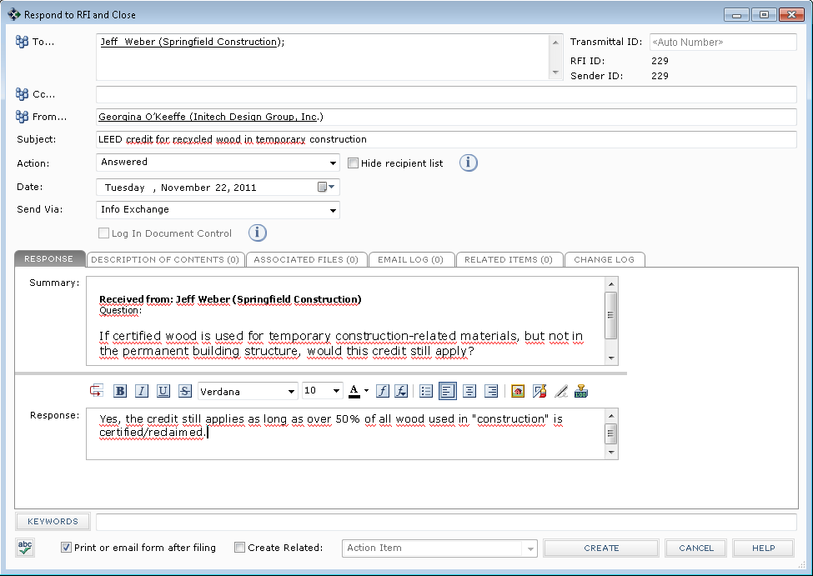
3. If there are files associated with the response, the **Transfer to Info Exchange Options** dialog box appears with the **Enable Connected Project delivery** option enabled. To confirm connected delivery of the RFI and its associated files, make sure the **Enable Connected Project delivery** check box is selected. Click **OK** to complete the transfer.  
   
4. The RFI is posted to the responder’s Info Exchange site and the recipient(s) of the RFI response receives an email notification, just as with an “un-connected” workflow event.
5. The responder’s Newforma server also notifies the recipient’s Newforma server of the connected RFI response, prompting the recipient’s Newforma server to login and download the RFI response as a pending, incoming RFI response.

Receiving a Connected RFI Response

1. The RFI Response is routed directly into the original sender’s RFI log. An email notification is also sent. The answer to the RFI as well as any associated files are automatically logged with the response in the recipient’s RFI log.  
   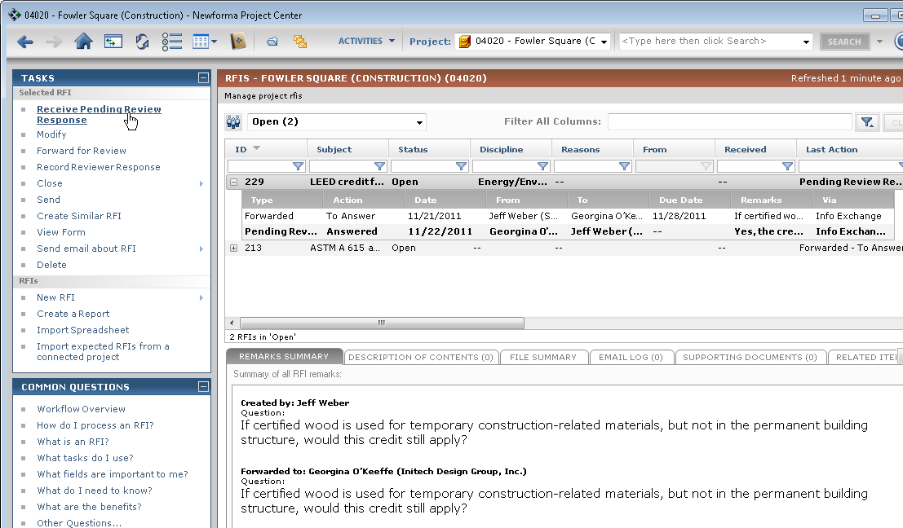
2. The recipient clicks on **Receive Pending Review Response** in the **Tasks** list to launch the **Record Reviewer Response for RFI** dialog and complete the transaction.  
   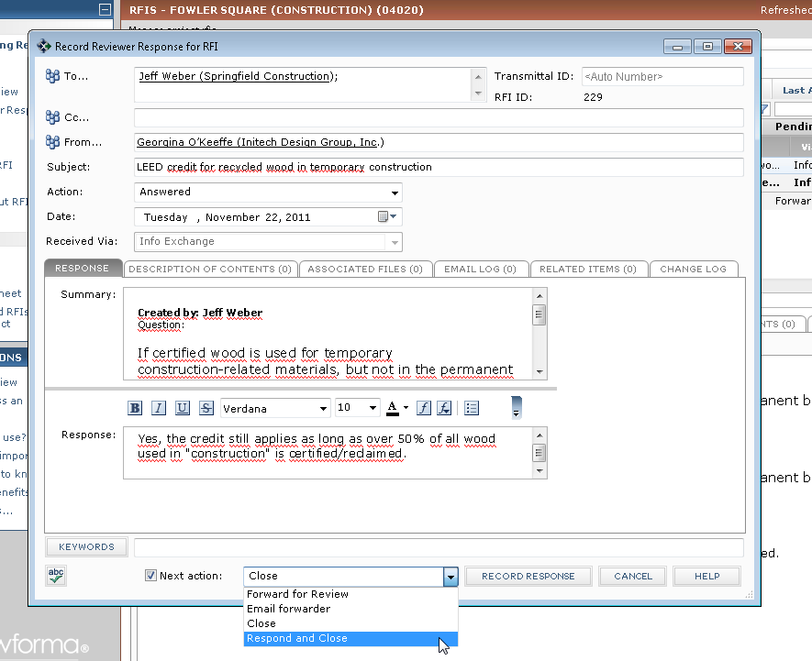
3. From here, the process is similar to any other Newforma workflow item.

Connecting Expected Submittals

Expected items like submittals can also be shared between connected project teams. The process for sharing connected expected submittals starts the same way as for “un-connected” expected submittals.

**Company A Creates an Expected Submittal**

1. To initiate the process, a team member from Company A creates an expected submittal. In the **Create** or Modify **Submittal** dialog, the user clicks on the **Expected…** button and enters the contact at Company B from whom the submittal is expected.  
   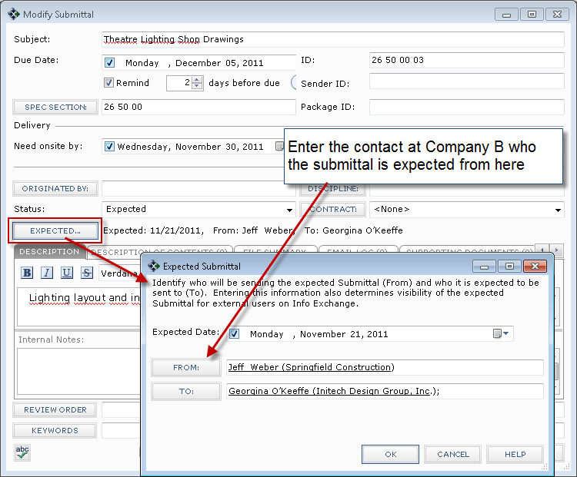
2. After the user creates the expected submittal, the Company A Newforma server uses the underlying N2N connection to notify the Company B Newforma server about the expected submittal.

|  |  |
| --- | --- |
| C:\Users\Alison\AppData\Local\Microsoft\Windows\Temporary Internet Files\Content.IE5\3AR54E5N\MC900293188[1].wmf | In practice, the most efficient way to create expected submittals is to import them from a spreadsheet. Please consult the Submittals Users Guide for more information on that process. |

**Company B Imports Expected Submittals**

1. After the Company A server notifies the Company B server of the availability of the expected submittals, the **Import expected Submittals from a connected project** task is available from within the Submittals activity center at Company B.  
   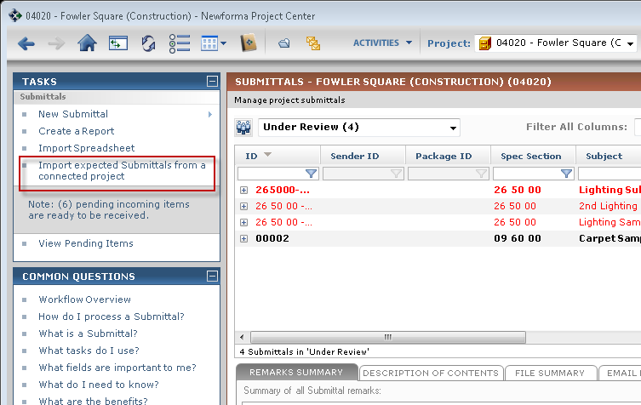
2. Selecting this task creates the corresponding expected submittal in the recipient’s project.  
   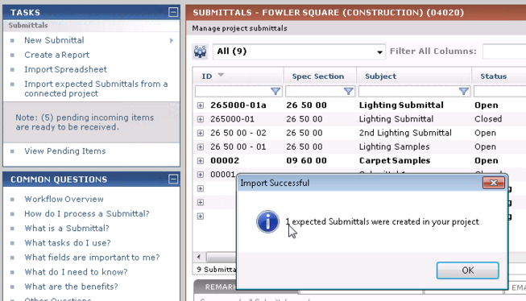

|  |  |
| --- | --- |
| C:\Users\Alison\AppData\Local\Microsoft\Windows\Temporary Internet Files\Content.IE5\3AR54E5N\MC900293188[1].wmf | Note: You can use the expected submittal feature to support submittals at multiple levels. For example, a subcontractor would expect a submittal from the sub and an architect would expect it from the GC. |

Summary

Now that you have completed the Newforma-to-Newforma User Guide, you should understand how to use N2N to:

* Send file transfers directly to the recipient’s incoming Info Exchange log
* Synchronize selected project folders on a scheduled basis
* Seamlessly exchange RFI, submittal and other workflow actions

Additional Information

For additional information on this and other Newforma products, please consult the following resources:

* [Newformant Learn Page](http://www.newformant.com/#4)

Appendix I: Enabling Newforma-to-Newforma

Before anyone can use Newforma to Newforma (N2N), a Newforma administrator at each company must enable it.

|  |  |
| --- | --- |
| C:\Users\Alison\AppData\Local\Microsoft\Windows\Temporary Internet Files\Content.IE5\3AR54E5N\MC900431585[1].png | Check with your Newforma Account Manager to verify that your company is licensed to use this feature. |

1. The Newforma administrator accesses the **Licensing** tab of the Project Center Administration activity center and selects the **Newforma to Newforma** checkbox in the **Add-On Features** section of the tab.  
   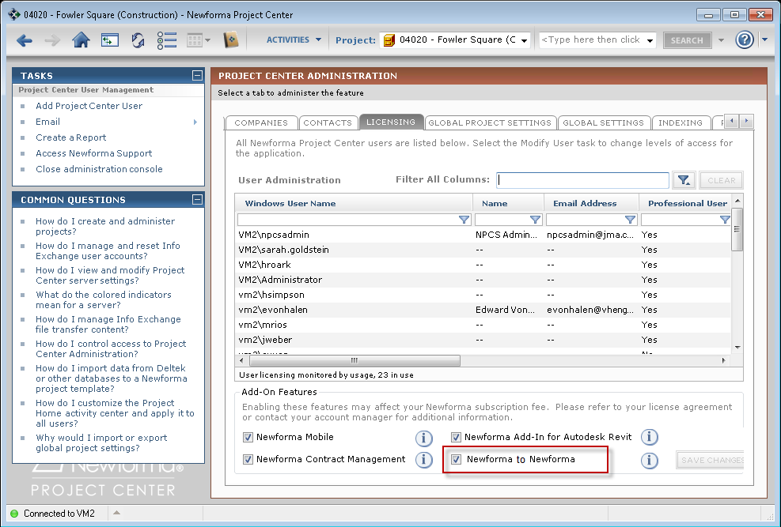
2. Once N2N is enabled in your company, you can establish a connection with other companies by sending an invitation.

Appendix II: Connecting to Another Company

It takes two mutually consenting companies to complete a Newforma-to-Newforma company connection. This section describes the steps required from Project Center administrators for a company (Company A) to initiate a company connection and the corresponding steps that the other company (Company B) must take to confirm the company connection.

|  |  |
| --- | --- |
| C:\Users\Alison\AppData\Local\Microsoft\Windows\Temporary Internet Files\Content.IE5\3AR54E5N\MC900431585[1].png | Attention: Before connecting with Newforma-to-Newforma, partnering companies should consider entering into a trusted business relationship that provides for this level of transparency for the information created and shared for their projects. |
| C:\Users\Alison\AppData\Local\Microsoft\Windows\Temporary Internet Files\Content.IE5\3AR54E5N\MC900293188[1].wmf | Company connections should be done with the Project Center administrators from each company on the phone. |

**Initiating a Connection (Company A)**

**Before initiating a connection, the administrator at Company A needs to know the URL of Company B’s Project Center Server web site and the email address of a Project Center administrator at Company B.**

1. From the Project Center Administration activity center, an administrator from the company initiating the connection selects the other company to connect with from the **Companies** tab. The administrator then selects the **Send Connection Request** task from the **Tasks** pane.  
   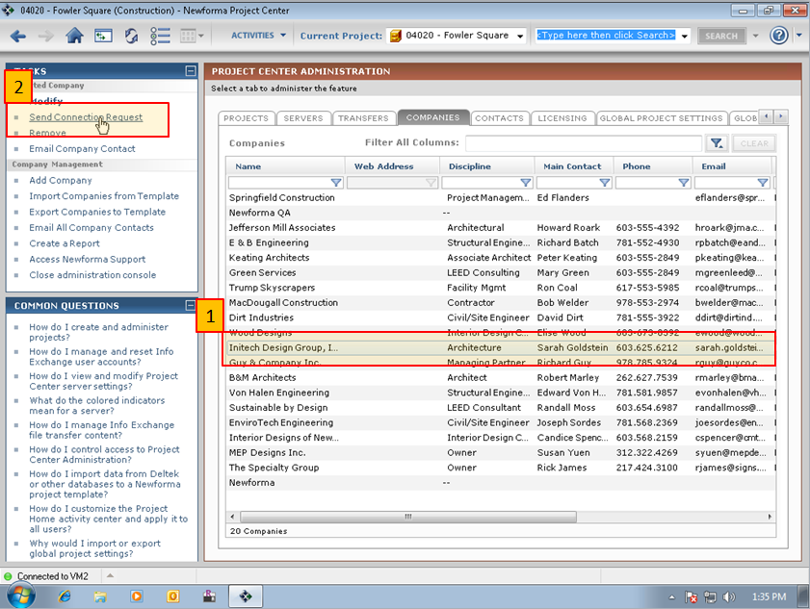
2. The **Send Connection Request** dialog appears. The administrator enters the URL to the company’s Info Exchange web server in the **Info Exchange Server** **address** field and clicks **OK**.  
   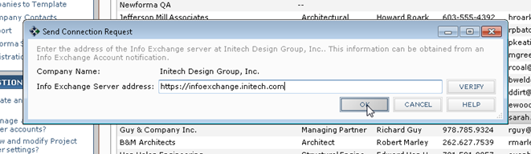

|  |  |
| --- | --- |
| C:\Users\Alison\AppData\Local\Microsoft\Windows\Temporary Internet Files\Content.IE5\3AR54E5N\MC900293188[1].wmf | You can get this URL from the link embedded in an Info Exchange email notification from that company. |

1. An email is generated containing a link that the recipient at the other company can use to confirm the connection.  
   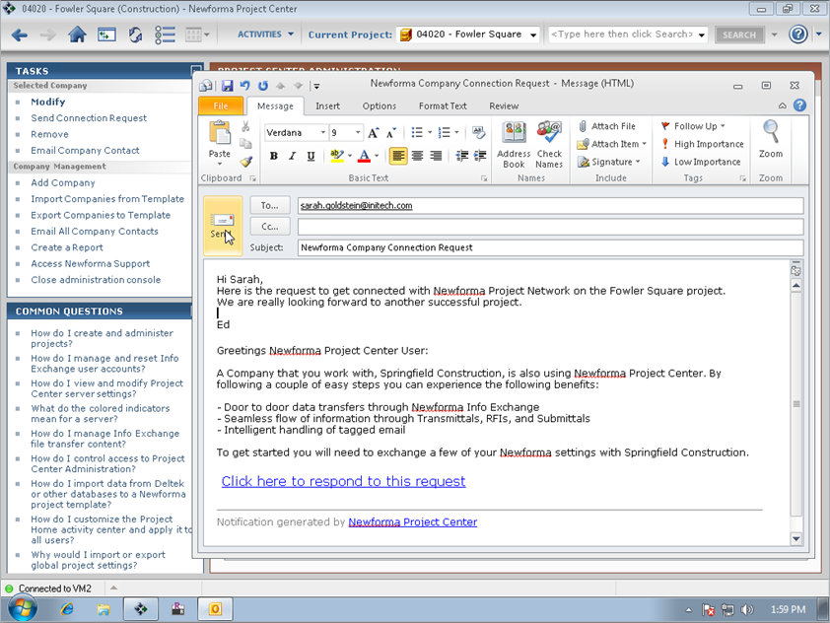

**Confirming a Connection (Company B)**

1. The recipient at Company B clicks on the link embedded in the Connection Request email from Company A and clicks **OK** in the **Confirm Integration Request** dialog to confirm the connection.  
   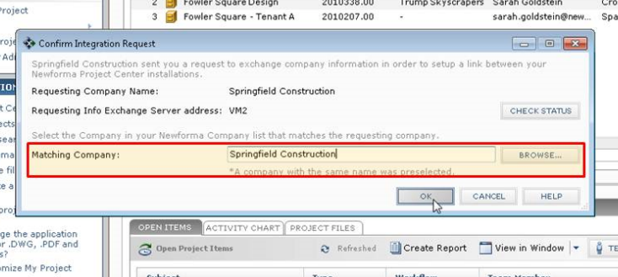
2. If the sender’s company is not automatically selected, the recipient will need to click **Browse** in the **Confirm Integration Request** dialog and select Company A from their contact database. The following message indicates the connection was successful. Click **OK** to acknowledge the message.  
   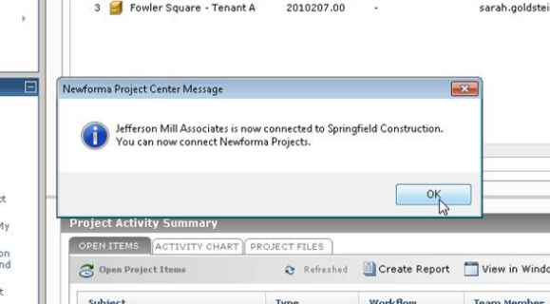
3. The **Connection Status** column of the **Companies** tab in Project Center Administration will also indicate the connection was successful.  
   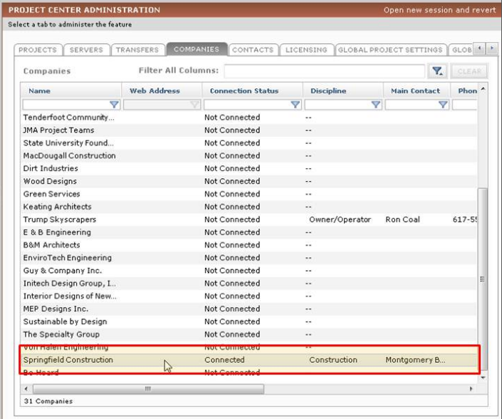

Appendix III: Connecting to a Project

Before connecting projects, the two companies must connect their companies first, using the process described above. Connecting projects using Newforma-to-Newforma also requires two mutually consenting companies. This section describes the steps required by a Project Center administrator for one company (Company A) to initiate a project connection and the corresponding steps that the other company (Company B) must take to confirm the connection.

|  |  |
| --- | --- |
| C:\Users\Alison\AppData\Local\Microsoft\Windows\Temporary Internet Files\Content.IE5\3AR54E5N\MC900431585[1].png | Before connecting with Newforma-to-Newforma, partnering companies should consider entering into a trusted business relationship that provides for this level of transparency of the information created and shared for their projects. |

**Initiating a Connection (Company A)**

|  |  |
| --- | --- |
| C:\Users\Alison\AppData\Local\Microsoft\Windows\Temporary Internet Files\Content.IE5\3AR54E5N\MC900293188[1].wmf | Project connections should be done with the Project Center Administrators from each company on the phone. In fact, they can be done right after the initial company connection. |

1. From the Project Center Administration activity center, an administrator from the company initiating the connection selects the project to connect from the **Projects** tab, then selects the **Connect with another Company’s project** task in the **Tasks** pane.  
   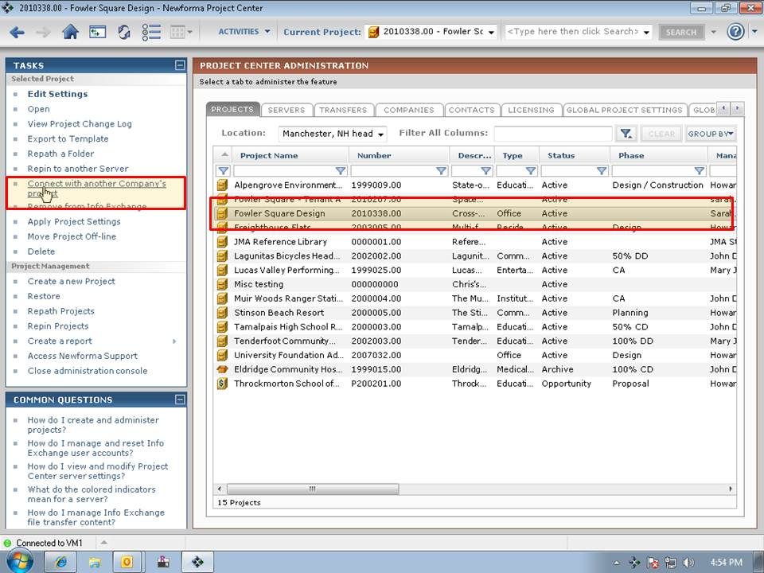
2. The **Select Connected Company** dialog appears. The user selects the appropriate company from the list of connected companies and clicks **OK**.  
   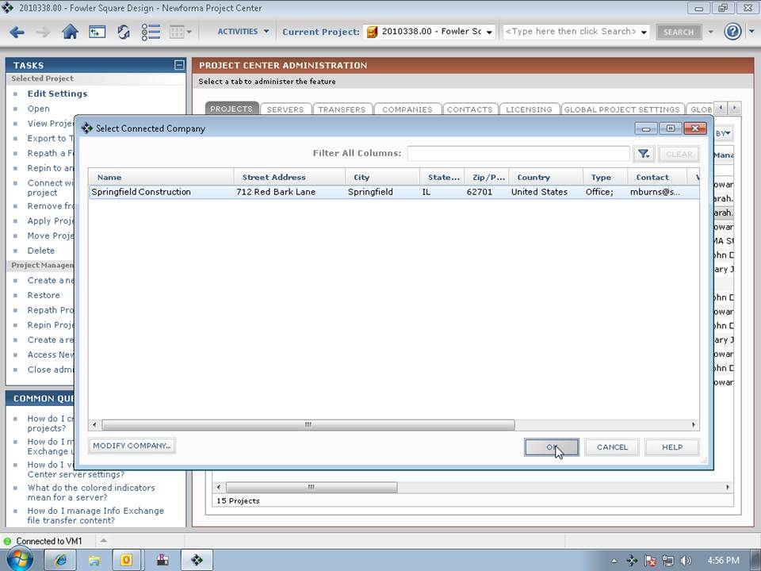
3. An email is generated containing a link that the recipient at the other company can use to confirm the connection.  
   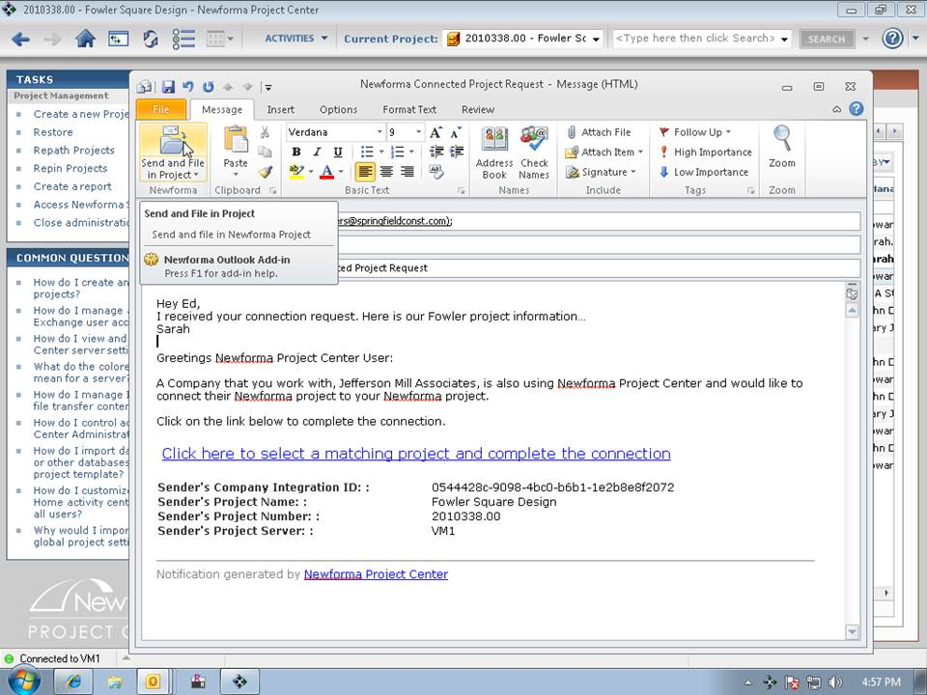

**Confirming a Connection (Company B)**

1. The recipient of the project connection request clicks on the link in the connection confirmation email. The **Confirm Project Connect Request** dialog appears. The recipient clicks **Browse** and selects the project at Company B associated with the project connection request from Company A, then clicks **OK** to complete the confirmation.  
   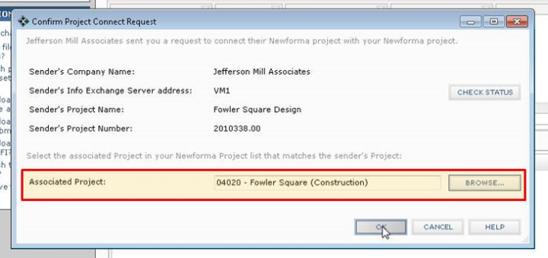
2. The **Connected To** column of the **Projects** tab in Project Center Administration indicates that the project is connected.  
   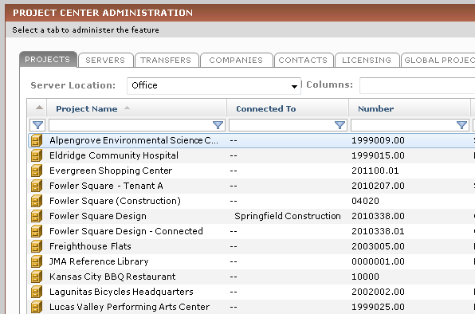

Appendix IV: Troubleshooting

This troubleshooting section focuses on various reasons why connected transactions might fail, as well as providing possible solutions.

**The Sender is not on the Recipient’s Project Team**

For fully connected delivery, the initiator of a connected transfer or workflow action needs to be on the recipient’s project team and needs to have been granted access to the recipient’s Info Exchange server for the connected project.

The reason for this is the sender’s Newforma Project Center server needs to be able to log into the recipient’s Info Exchange server to initiate the connected transaction. The Info Exchange account of the project team member who initiates the connected transaction is used by the sender’s Newforma Project Center server to do this, so if that individual is not on the recipient’s project team, the sender’s Newforma Project Center server cannot initiate the connected transaction.

If the fully connected transaction fails for this reason, the connected item (i.e. file transfer, shared folder or workflow item) is still posted to the sender’s Info Exchange server and an email notification is still sent to the recipient. However, none of the information about the transaction is created or downloaded automatically to the recipient’s project. When the recipient clicks on the link within the email notification, the following dialog appears:  
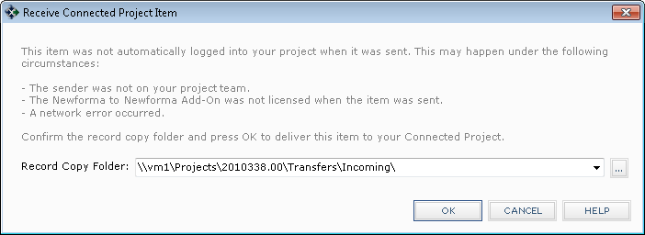

After selecting **OK** above, the project item is downloaded into the recipient’s project and the connected item process continues with the user being prompted to acknowledge receipt of the project item.

**The Sender does not have Sufficient Permission Set Privileges**

In addition to being on the project team, the sender must also have a Permission Set assigned by the recipient that enables the creation of the project item type being sent. For example, if a sender initiates a connected submittal, but the recipient has not assigned a Permission Set that grants the sender the rights to create a submittal on the recipient’s Info Exchange server, the transaction will not be automatically completed.

* *Note:* There are no permission sets necessary for Files Transfers and Shared Folders. These are basic functions provided by having Info Exchange access on the project. For the workflow related items (Submittals, RFIs, etc.) you will need to have one of the available “show” permission sets in order to create the object on the remote server.

As in the situation above, the submittal will be posted to the sender’s Info Exchange server and a notification will be sent to the recipient. The recipient can then click on the embedded link to complete the connected transaction, creating the project item and downloading any associated files directly into their project.

**Automatic Download is not Enabled for the Project**

In order for file contents associated with connected items to be automatically downloaded into the recipient’s project, the recipient’s project must have **Automatically download incoming transfers** enabled in the **Transfer Options** section of the **Info Exchange** tab within the project settings.  
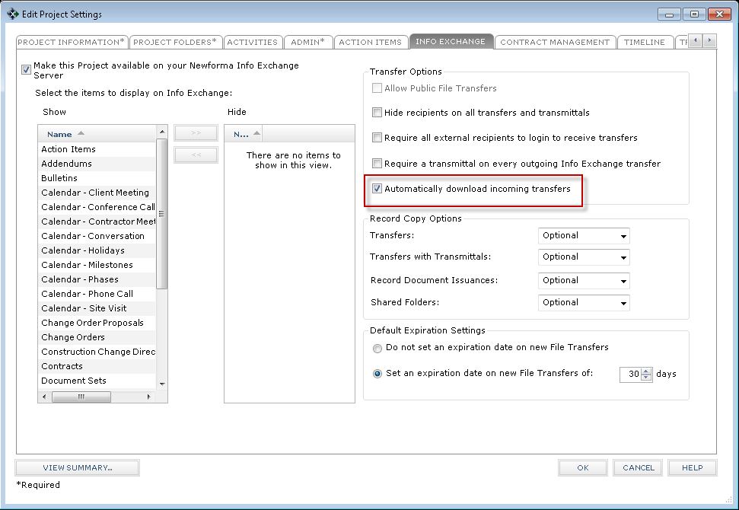

If this option is disabled, the connected item can still be created as a pending item in the recipient’s project. However, the file contents are not automatically downloaded. When the pending item is acknowledged, the user is prompted to download the files from the sender’s Info Exchange server.

**The Connection is No Longer Set Up**

If the following message appears, “There was a problem connecting to the project on the other server. Contact your system administrator.”

It indicates that the remote Info Exchange Server had a problem with the request (i.e. for 2 connected projects, the project that the server is trying to connect to). In this case, check the connection, as it may no longer be set up. Another problem might be that the user doesn’t have Info Exchange access.

**Incorrect Project Association**

A failure could occur when the sender is not associated with the correct company in the recipient’s database. The sender needs to be associated with the company that is sending the connected item.

Appendix V: Connected Workflow Data Mapping

One of the biggest benefits connected workflow provides is the automated, accurate exchange of data fields that are transferred between companies. This eliminates the time-consuming and often error-prone manual copying and pasting of field data from the originating system into the receiving system.

|  |  |
| --- | --- |
| C:\Users\Alison\AppData\Local\Microsoft\Windows\Temporary Internet Files\Content.IE5\3AR54E5N\MC900293188[1].wmf | Fields that are not mentioned below are intentionally excluded. For example, fields like Keywords and Internal Notes are excluded because they are commonly used for private tagging or tracking of internal details. |

In the table below, the left column is the field in the originating system and the right column is the field that the data maps to in the item on the other end of the connected project.

One important coordination step between companies is to synch up the **Purpose** field between company systems. If the **Purpose** field doesn’t have the same value between the two companies, the following dialog will appear each time the receiving company processes a pending workflow item. See the tables below for the default values for the **Purpose** fields for each workflow item.  
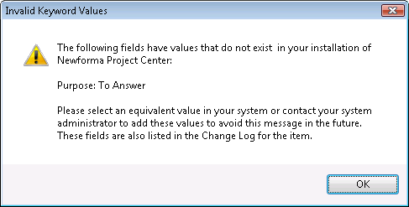

Submittals (Forward For Review – Log a Received)

| **Forwarding Field** | **Receiving Field** |
| --- | --- |
| Subject (Transmittal) | Subject |
| Due Date | Due Date |
| ID | Sender ID |
| Spec Section | Spec Section |
| Package ID | Package ID |
| Need onsite by | Need onsite by |
| Lead Time | Lead Time |
| Originated By | Originated By |
| Discipline | Discipline |
| Remarks (Transmittal) | Remarks |
| To (Transmittal) | To (Transmittal) |
| From (Transmittal) | From (Transmittal) |
| Date (Transmittal) | Received (Transmittal) |
| Description of Contents | Description of Contents (Transmittal) |
| **Purpose (Transmittal)**   * **For Review** * **For Review and Comment** * **No Action Required** | **Purpose (Transmittal)**   * **For Review** * **No Action Required** |

RFIs (Forward For Review – Log a Received)

| **Forwarding Field** | **Receiving Field** |
| --- | --- |
| Subject (Transmittal) | Subject |
| Due Date | Due Date |
| ID | Sender ID |
| Type | Type |
| Originated By | Originated By |
| Discipline | Discipline |
| **Purpose (Transmittal)**   * **To Answer** | **Purpose (Transmittal)**   * **Request for Information** |
| Question (Transmittal) | Question |
| Suggestion (Transmittal) | Suggestion |
| To (Transmittal) | To (Transmittal) |
| From (Transmittal) | From (Transmittal) |
| Date (Transmittal) | Received (Transmittal) |
| Description of Contents | Description of Contents (Transmittal) |

Change Order Proposals (Forward For Review – Log a Received)

| **Forwarding Field** | **Receiving Field** |
| --- | --- |
| Subject (Transmittal) | Subject |
| Due Date | Due Date |
| ID | Sender ID |
| Proposed Total Amount | Proposed Total Amount |
| Proposed Total Days | Proposed Total Days |
| Discipline | Discipline |
| Remarks (Transmittal) | Remarks |
| To (Transmittal) | To (Transmittal) |
| From (Transmittal) | From (Transmittal) |
| Date (Transmittal) | Received (Transmittal) |
| **Purpose (Transmittal)**   * **For Input** * **Request Updated Quotes** | **Purpose (Transmittal)**   * **For Input** * **Request Updated Quotes** |
| Description of Contents | Description of Contents (Transmittal) |

Supplemental Instructions (Forward For Review – Log a Received)

| **Forwarding Field** | **Receiving Field** |
| --- | --- |
| Subject (Transmittal) | Subject |
| ID | Sender ID |
| Initiated By | Initiated By |
| Discipline | Discipline |
| Remarks (Transmittal) | Remarks |
| To (Transmittal) | To (Transmittal) |
| From (Transmittal) | From (Transmittal) |
| Date (Transmittal) | Received (Transmittal) |
| **Purpose (Transmittal)**   * **For Review** * **For Review and Comment** | **Purpose (Transmittal)**   * **No Action Required** |
| Description of Contents | Description of Contents (Transmittal) |

Addendums (Forward For Review – Log a Received)

| **Forwarding Field** | **Receiving Field** |
| --- | --- |
| Subject (Transmittal) | Subject |
| ID | Sender ID |
| Initiated By | Initiated By |
| Discipline | Discipline |
| Remarks (Transmittal) | Remarks |
| To (Transmittal) | To (Transmittal) |
| From (Transmittal) | From (Transmittal) |
| Date (Transmittal) | Received (Transmittal) |
| **Purpose (Transmittal)**   * **For Review** * **For Review and Comment** | **Purpose (Transmittal)**   * **For Bid Package Evaluation** |
| Description of Contents | Description of Contents (Transmittal) |

Change Orders (Forward For Review – Log a Received)

| **Forwarding Field** | **Receiving Field** |
| --- | --- |
| Subject (Transmittal) | Subject |
| ID | Sender ID |
| Date Executed | Date Executed |
| Estimated Amount | Estimated Amount |
| Estimated Days | Estimated Days |
| Actual Amount | Actual Amount |
| Actual Days | Actual Days |
| Initiated By | Initiated By |
| Responsible | Responsible |
| Discipline | Discipline |
| Remarks (Transmittal) | Remarks |
| To (Transmittal) | To (Transmittal) |
| From (Transmittal) | From (Transmittal) |
| Date (Transmittal) | Received (Transmittal) |
| **Purpose (Transmittal)**   * **For Review** * **For Review and Comment** | **Purpose (Transmittal)**   * **For Review** |
| Description of Contents | Description of Contents (Transmittal) |

Proposal Requests (Forward For Review – Log a Received)

| **Forwarding Field** | **Receiving Field** |
| --- | --- |
| Subject (Transmittal) | Subject |
| ID | Sender ID |
| COP Status | COP Status |
| Initiated By | Initiated By |
| Discipline | Discipline |
| Remarks (Transmittal) | Remarks |
| To (Transmittal) | To (Transmittal) |
| From (Transmittal) | From (Transmittal) |
| Date (Transmittal) | Received (Transmittal) |
| **Purpose (Transmittal)**   * **For Review and Comment** * **For Review** * **For Your Information** | **Purpose (Transmittal)**   * **Respond with Proposal** |
| Description of Contents | Description of Contents (Transmittal) |

Construction Change Directives (Forward For Review – Log a Received)

| **Forwarding Field** | **Receiving Field** |
| --- | --- |
| Subject (Transmittal) | Subject |
| ID | Sender ID |
| COP Status | COP Status |
| Initiated By | Initiated By |
| Discipline | Discipline |
| Responsible | Responsible |
| Contract Sum | Contract Sum |
| Sum Description | Sum Description |
| Contract Time | Contract Time |
| Remarks (Transmittal) | Remarks |
| To (Transmittal) | To (Transmittal) |
| From (Transmittal) | From (Transmittal) |
| Date (Transmittal) | Received (Transmittal) |
| **Purpose (Transmittal)**   * **For Review** * **For Review and Comment** | **Purpose (Transmittal)**   * **No Action Required** |
| Description of Contents | Description of Contents (Transmittal) |

Bulletins (Forward For Review – Log a Received)

| **Forwarding Field** | **Receiving Field** |
| --- | --- |
| Subject (Transmittal) | Subject |
| ID | Sender ID |
| Type | Type |
| COP Status | COP Status |
| Initiated By | Initiated By |
| Discipline | Discipline |
| Responsible | Responsible |
| Contract Sum | Contract Sum |
| Sum Description | Sum Description |
| Contract Time | Contract Time |
| Remarks (Transmittal) | Remarks |
| To (Transmittal) | To (Transmittal) |
| From (Transmittal) | From (Transmittal) |
| Date (Transmittal) | Received (Transmittal) |
| **Purpose (Transmittal)**   * **For Review** * **For Review and Comment** | **Purpose (Transmittal)**   * **No Action Required** * **For Construction** * **Respond with Proposal** |
| Description of Contents | Description of Contents (Transmittal) |

Respond and Close and Record Reviewer Response (All CM workflow activity centers)

Company A responds to and closes an item sent to them for review and Company B records their response.

| **Respond and Close Field** | **Record Reviewer Response Field** |
| --- | --- |
| Subject (Transmittal) | Subject(Transmittal) |
| Response (Transmittal) | Response(Transmittal) |
| To (Transmittal) | To (Transmittal) |
| **Action (Transmittal)** | **Action (Transmittal)** |
| From (Transmittal) | From (Transmittal) |
| Date (Transmittal) | Received (Transmittal) |
| Description of Contents(Transmittal) | Description of Contents (Transmittal) |

Action Values for CM Respond and Close and Record Reviewer Response Activities

| CM Activity Center | Respond and Close Field | Record Reviewer Response Field |
| --- | --- | --- |
| Submittals | Approved  Approved as Noted  No Exceptions  No Action Taken  Revise and Resubmit  Partial Resubmittal  Rejected | No Action Taken  Approved  Approved as Noted  No Exceptions  Rejected  Revise and Resubmit |
| RFIs | Answered  Additional Information Needed | Answered  Not Answered |
| Addendums | Approved  Approved as Noted  No Exceptions  Revise and Resubmit  Rejected | No Action Taken  Approved  Approved as Noted  No Exceptions  Rejected  Revise and Resubmit |
| Bulletins | Approved  Approved as Noted  No Exceptions  Revise and Resubmit  Rejected | Approved  Approved as Noted  No Exceptions  Rejected  Revise and Resubmit |
| Supplemental Instructions | Approved  Approved as Noted  No Exceptions  Revise and Resubmit  Rejected | No Action Taken  Approved  Approved as Noted  No Exceptions  Rejected  Revise and Resubmit |
| Proposal Request | Approved  Approved as Noted  No Exceptions  Revise and Resubmit  Rejected | Approved  Approved as Noted  No Exceptions  Rejected  Revise and Resubmit |
| Construction Change Directive | Approved  Approved as Noted  No Exceptions  Revise and Resubmit  Rejected | Approved  Approved as Noted  No Exceptions  Rejected  Revise and Resubmit |
| Change Order Proposal | No Action Taken  Changes Recommended  Rejected  Revise and Resubmit | No Changes  Changes Recommended  Rejected  Revise and Resubmit |
| Change Order | Recommendation (from Send and Close) | Approved  Approved as Noted  No Exceptions  Rejected  Revise and Resubmit |