Form Template Basics

|  |  |  |  |
| --- | --- | --- | --- |
| C:\Users\Alison\AppData\Local\Microsoft\Windows\Temporary Internet Files\Content.IE5\3AR54E5N\MC900431585[1].png | | Make backup copies of templates before modifying them.  Most modified templates must be saved in the same folder under their original names for Project Center to be able to use them. Please refer to the Form Template Style Sub Folder Organization section of this document for more information. | |
| C:\Users\Alison\AppData\Local\Microsoft\Windows\Temporary Internet Files\Content.IE5\3AR54E5N\MC900293188[1].wmf | | Either Word 2007 or 2010 can be used to modify Word Templates. Prior versions of Word are not supported.  Templates must be saved in the .docx format. The .doc format is not supported, nor are .dot and dotx variations. | |

* You can modify templates either from a workstation or from the Newforma Project Center server. Making changes to templates stored on the Newforma Project Center server remotely from a workstation requires permissions adjustments. Contact your IT Team or Newforma Services for assistance with this change.

Building your forms in Word is similar to building templates that employees fill out manually. Here are some of the features you may choose to use within Word for building your templates:

* Headers and Footers (including 2nd page headers and footers) to show logos, address tags and other firm-identifying information.
* Tables for positioning information in compliance with firm graphic standards.
* Adjusting page margins, orientation and size (including international A4/A5 sizes) according to firm graphic standards.
* Word Styles for ensuring maximum graphics compliance.

Some features, such as headers and footers, are not rendered in HTML Previews on Info Exchange. Customers with external and/or internal users that will be using InfoExchange extensively to participate in Contract Management or Commitment workflows may wish to test Form Templates on Info Exchange previews to ensure maximum compatibility.

There are 3 ways to get started:

* Modify an existing Newforma provided Form Template (recommended for beginners).
* Start from scratch with a new, blank template.
* Use an existing manual Form Template created in Word as a starting point.

Field Reference Guides

In the event that you require fields that are not already placed in the Form Template Library provided by Newforma, each form category type has a corresponding reference guide that contains all possible fields that can be placed in a template.

The reference guides contain a list of suggested sections and all available fields that can be used to drag and drop fields directly into your forms.

It is recommended when customizing form templates to start with the Form Templates contained within the library.

If you are unable to locate a field you require, please contact [services@newforma.com](mailto:services@newforma.com) for assistance.

Inserting Fields and Sections into Templates

You can drag and drop fields from the reference guides for the various Form Views directly into your Form Templates. It’s is recommended that you open the reference document side by side with your form template on your screen, like this:

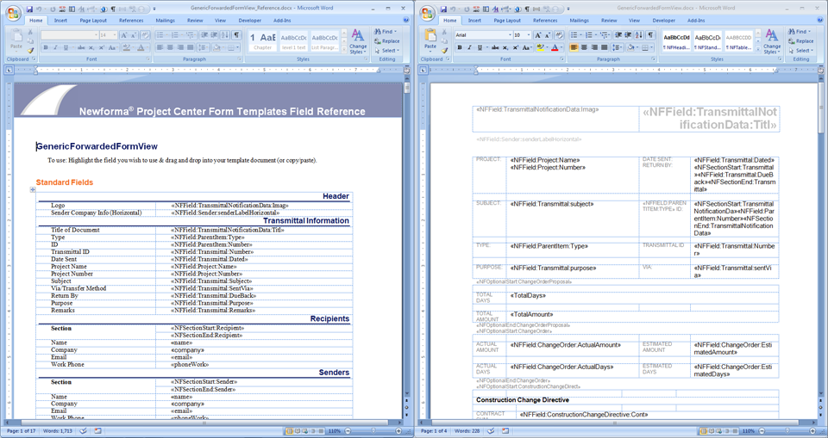

Highlight the field on the reference guide.

Drag and drop (or copy/paste) the field in the desired location in your template.

It is also possible to manually insert fields. The Advanced Form Template Modification section of this document covers advanced topics.