

AECO PROJECT INFORMATION MANAGEMENT

Newforma-to-Newforma® Getting Started Guide

Tenth Edition

Table of Contents

Overview 1

Connecting to Another Company 2

Initiating a Connection (Company A) 2

Confirming a Connection (Company B) 4

Connecting to a Project 6

Initiating a Connection (Company A) 6

Confirming a Connection (Company B) 8

Troubleshooting 9

The Sender is not on the Recipient’s Project Team 9

The Sender does not have Sufficient Permission Set Privileges 9

The Connection is No Longer Set Up 10

Incorrect Project Association 10

Items Created Prior to the Connection Being Established 10

Connected Workflow Data Mapping 11

Submittals (Forward For Review – Log a Received) 11

RFIs (Forward For Review – Log a Received) 12

Change Order Proposals (Forward For Review – Log a Received) 13

Supplemental Instructions (Forward For Review – Log a Received) 14

Addendums (Forward For Review – Log a Received) 14

Change Orders (Forward For Review – Log a Received) 15

Proposal Requests (Forward For Review – Log a Received) 15

Construction Change Directives (Forward For Review – Log a Received) 16

Bulletins (Forward For Review – Log a Received) 17

Respond and Close and Record Reviewer Response (All CM workflow activity centers) 18

Action Values for CM Respond and Close and Record Reviewer Response Activities 18

Newforma-to-Newforma® User Guide

Overview

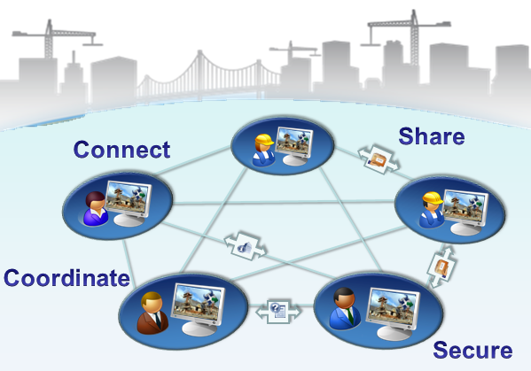Newforma-to-Newforma® (N2N) seamlessly connects companies using Newforma® Project Center to streamline the coordination and exchange of critical project information. By utilizing a direct, secure communication channel between servers within each company’s corporate firewall, Newforma-to-Newforma enables a fully integrated and transparent mode of project delivery without compromising control of proprietary project information.

This user’s guide describes the setup and recommended best practice use cases associated with Newforma-to-Newforma. The appendices of this user guide walk Project Center administrators through the one-time connection process that allows mutually consenting Newforma customers to securely connect their Newforma® Info Exchange servers. With this background server-to-server connection in place, the guide describes the following three use cases enabled by Newforma-to-Newforma:

* Send file transfers directly to the recipient’s incoming Info Exchange log, completely eliminating download delays.
* Synchronize selected project folders on a scheduled basis, ensuring that distributed design and construction teams remain coordinated.
* Seamlessly exchange RFI, Submittal and other workflow actions, eliminating the need to copy and paste meta-data or download related files.

|  |  |
| --- | --- |
| C:\Users\Alison\AppData\Local\Microsoft\Windows\Temporary Internet Files\Content.IE5\3AR54E5N\MC900293188[1].wmf | Note: There are certain pre-conditions in the setup of the project and configuration of project team members that must be met in order for connected delivery of project items to work. Project Center administrators should consult the Troubleshooting appendix of this manual for more details. |

Connecting to Another Company

It takes two mutually consenting companies to complete a Newforma-to-Newforma company connection. This section describes the steps required from Project Center administrators for a company (Company A) to initiate a company connection and the corresponding steps that the other company (Company B) must take to confirm the company connection.

|  |  |
| --- | --- |
| C:\Users\Alison\AppData\Local\Microsoft\Windows\Temporary Internet Files\Content.IE5\3AR54E5N\MC900431585[1].png | Attention: Before connecting with Newforma-to-Newforma, partnering companies should consider entering into a trusted business relationship that provides for this level of transparency for the information created and shared for their projects. |
| C:\Users\Alison\AppData\Local\Microsoft\Windows\Temporary Internet Files\Content.IE5\3AR54E5N\MC900293188[1].wmf | Company connections should be done with the Project Center administrators from each company on the phone. |
|  |  |

**Initiating a Connection (Company A)**

**Before initiating a connection, the administrator at Company A needs to know the URL of Company B’s Project Center Server web site and the email address of a Project Center administrator at Company B.**

1. In Project Center Administration, a global administrator from the company initiating the connection selects the other company to connect with from the **Companies** tab.
2. The administrator then selects the **Newforma to Newforma**, **Send Connection Request** task from the **Tasks** pane.  
   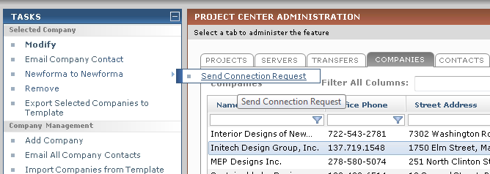
3. The **Send Connection Request** dialog appears. The administrator enters the URL to the company’s Info Exchange web server in the **Info Exchange Server** **address** field and clicks **OK**.  
   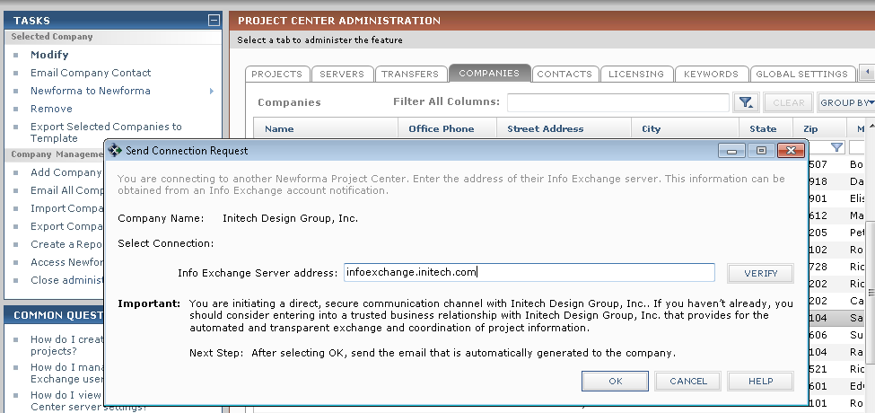

|  |  |
| --- | --- |
| C:\Users\Alison\AppData\Local\Microsoft\Windows\Temporary Internet Files\Content.IE5\3AR54E5N\MC900293188[1].wmf | **Do not type enter the "https:\\" when entering the Info Exchange website name.** |

1. An email is generated containing a link that the recipient at the other company can use to confirm the connection.  
   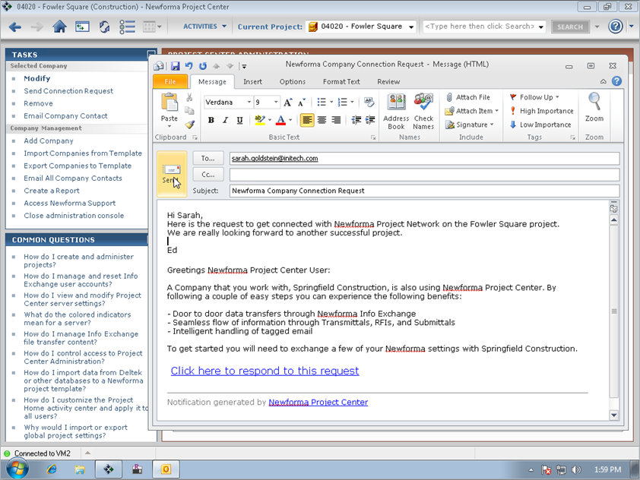

**Confirming a Connection (Company B)**

1. The recipient at Company B clicks on the link embedded in the Connection Request email from Company A and clicks **OK** in the **Confirm Integration Request** dialog to confirm the connection.  
   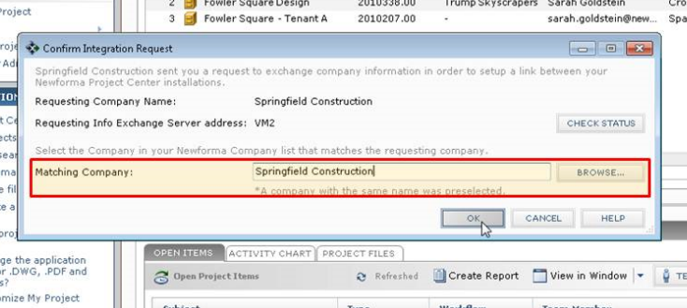
2. If the sender’s company is not automatically selected, the recipient will need to click **Browse** in the **Confirm Integration Request** dialog and select Company A from their contact database. The following message indicates the connection was successful. Click **OK** to acknowledge the message.  
   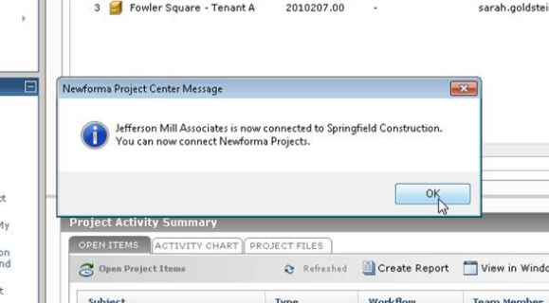
3. The **Connection Status** column of the **Companies** tab in Project Center Administration will also indicate the connection was successful.  
   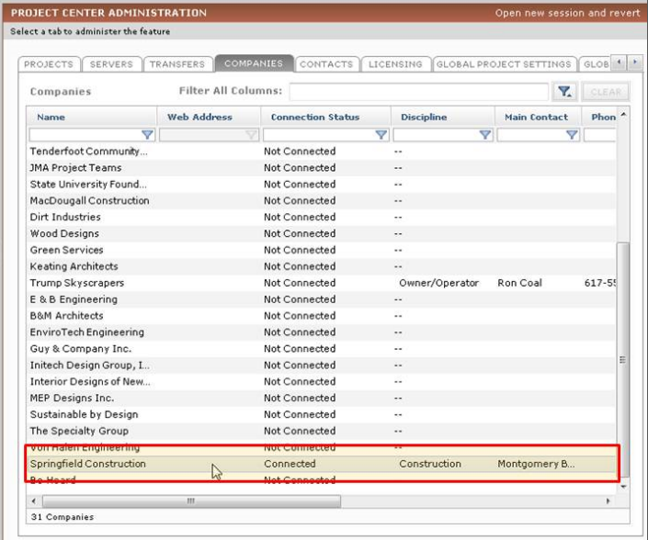

Connecting to a Project

Before connecting projects, the two companies must connect their companies first, using the process described above. Connecting projects using Newforma-to-Newforma also requires two mutually consenting companies. This section describes the steps required by a Project Center administrator for one company (Company A) to initiate a project connection and the corresponding steps that the other company (Company B) must take to confirm the connection.

|  |  |
| --- | --- |
| C:\Users\Alison\AppData\Local\Microsoft\Windows\Temporary Internet Files\Content.IE5\3AR54E5N\MC900431585[1].png | Project Center administrators from each company making this connection need to be on each other's **Project Teams** of the projects that are being connected with Info Exchange access. |

**Initiating a Connection (Company A)**

|  |  |
| --- | --- |
| C:\Users\Alison\AppData\Local\Microsoft\Windows\Temporary Internet Files\Content.IE5\3AR54E5N\MC900293188[1].wmf | Project connections should be done with the Project Center Administrators from each company on the phone. In fact, they can be done right after the initial company connection. |

1. In Project Center Administration, an administrator from the company initiating the connection selects the project to connect from the **Projects** tab, then selects the **Connect with another Company’s project** task in the **Tasks** pane.  
   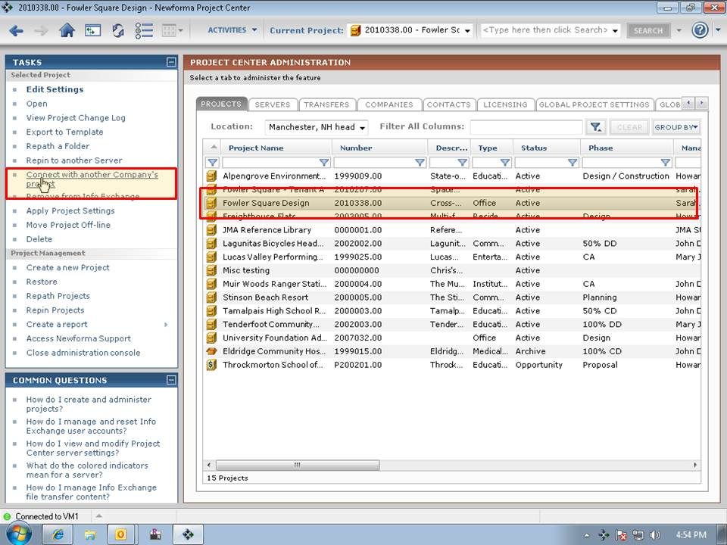
2. The **Select Connected Company** dialog appears. The user selects the appropriate company from the list of connected companies and clicks **OK**.  
   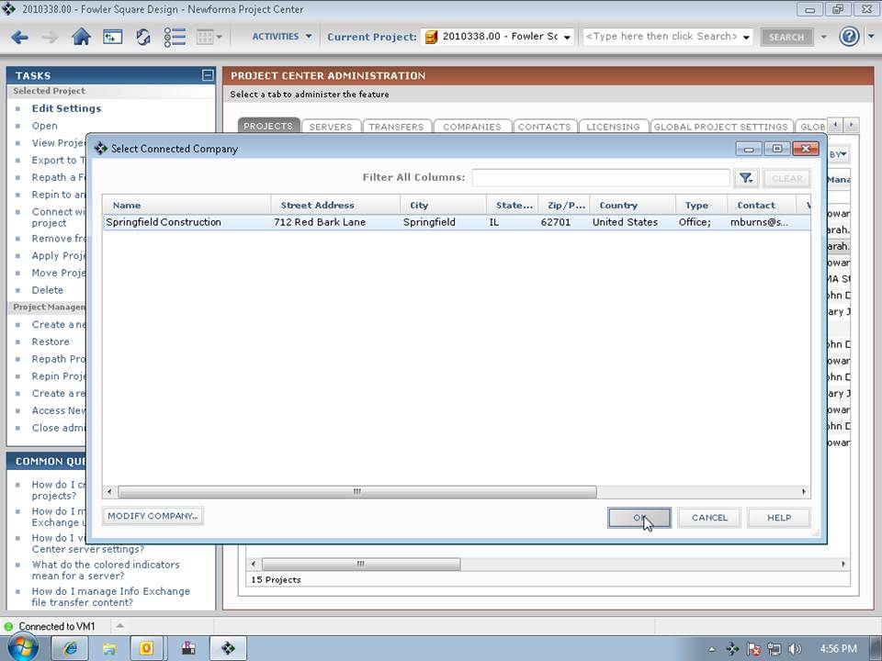
3. An email is generated containing a link that the recipient at the other company can use to confirm the connection.  
   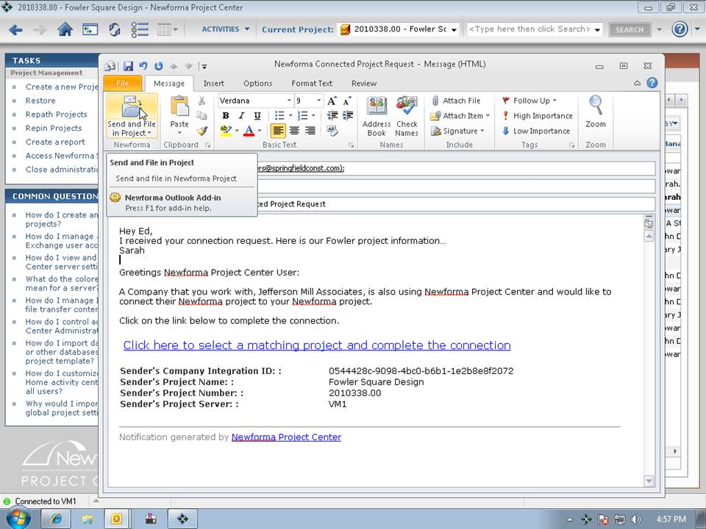

**Confirming a Connection (Company B)**

1. The recipient of the project connection request clicks on the link in the connection confirmation email. The **Confirm Project Connect Request** dialog appears. The recipient clicks **Browse** and selects the project at Company B associated with the project connection request from Company A, then clicks **OK** to complete the confirmation.  
   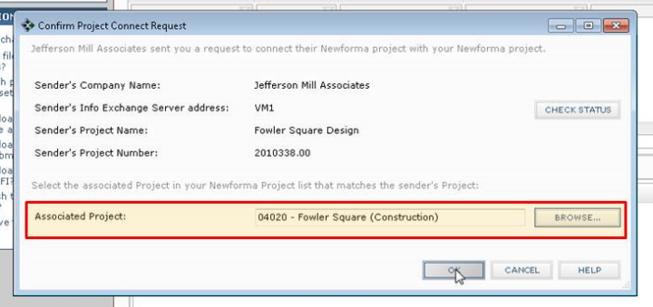
2. The **Connected To** column of the **Projects** tab in Project Center Administration indicates that the project is connected.  
   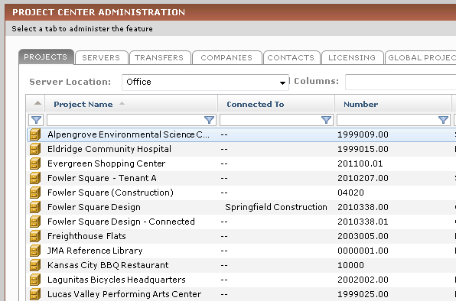

Troubleshooting

This troubleshooting section focuses on various reasons why connected transactions might fail, as well as providing possible solutions.

**The Sender is not on the Recipient’s Project Team**

For fully connected delivery, the initiator of a connected transfer or workflow action needs to be on the recipient’s project team and needs to have been granted access to the recipient’s Info Exchange server for the connected project.

The reason for this is the sender’s Newforma Project Center server needs to be able to log into the recipient’s Info Exchange server to initiate the connected transaction. The Info Exchange account of the project team member who initiates the connected transaction is used by the sender’s Newforma Project Center server to do this, so if that individual is not on the recipient’s project team, the sender’s Newforma Project Center server cannot initiate the connected transaction.

If the fully connected transaction fails for this reason, the connected item (i.e. file transfer, shared folder or workflow item) is still posted to the sender’s Info Exchange server and an email notification is still sent to the recipient. However, none of the information about the transaction is created or downloaded automatically to the recipient’s project. When the recipient clicks on the link within the email notification, the following dialog appears:  
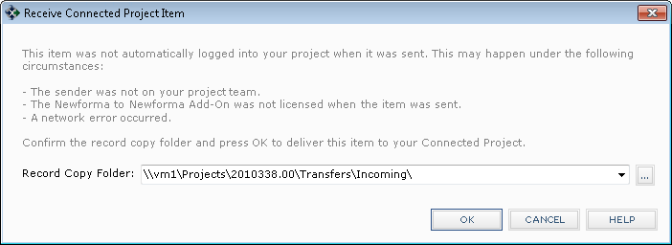

After selecting **OK** above, the project item is downloaded into the recipient’s project and the connected item process continues with the user being prompted to acknowledge receipt of the project item.

**The Sender does not have Sufficient Permission Set Privileges**

In addition to being on the project team, the sender must also have a Permission Set assigned by the recipient that enables the creation of the project item type being sent. For example, if a sender initiates a connected submittal, but the recipient has not assigned a Permission Set that grants the sender the rights to create a submittal on the recipient’s Info Exchange server, the transaction will not be automatically completed.

* *Note:* There are no permission sets necessary for Files Transfers and Shared Folders. These are basic functions provided by having Info Exchange access on the project. For the workflow related items (Submittals, RFIs, etc.) you will need to have one of the available “show” permission sets in order to create the object on the remote server.

As in the situation above, the submittal will be posted to the sender’s Info Exchange server and a notification will be sent to the recipient. The recipient can then click on the embedded link to complete the connected transaction, creating the project item and downloading any associated files directly into their project.

**The Connection is No Longer Set Up**

If the following message appears, “There was a problem connecting to the project on the other server. Contact your system administrator.”

It indicates that the remote Info Exchange Server had a problem with the request (i.e. for 2 connected projects, the project that the server is trying to connect to). In this case, check the connection, as it may no longer be set up. Another problem might be that the user doesn’t have Info Exchange access.

**Incorrect Project Association**

A failure could occur when the sender is not associated with the correct company in the recipient’s database. The sender needs to be associated with the company that is sending the connected item.

**Items Created Prior to the Connection Being Established**

Submittals, RFIs or other NCM items created before the N2N connection is established can no longer be used with the “Respond and Close” task if sent via Info Exchange. These items must be sent via Email and the responses manually logged. If the item is sent via Info Exchange a “remote workflow” error will be returned to the sender. Items created and forwarded after the connection has been established should continue to use Info Exchange as the transfer method.

Connected Workflow Data Mapping

One of the biggest benefits connected workflow provides is the automated, accurate exchange of data fields that are transferred between companies. This eliminates the time-consuming and often error-prone manual copying and pasting of field data from the originating system into the receiving system.

|  |  |
| --- | --- |
| C:\Users\Alison\AppData\Local\Microsoft\Windows\Temporary Internet Files\Content.IE5\3AR54E5N\MC900293188[1].wmf | Fields that are not mentioned below are intentionally excluded. For example, fields like Keywords and Internal Notes are excluded because they are commonly used for private tagging or tracking of internal details. |

In the table below, the left column is the field in the originating system and the right column is the field that the data maps to in the item on the other end of the connected project.

One important coordination step between companies is to synch up the **Purpose** field between company systems. If the **Purpose** field doesn’t have the same value between the two companies, the following dialog will appear each time the receiving company processes a pending workflow item. See the tables below for the default values for the **Purpose** fields for each workflow item.  
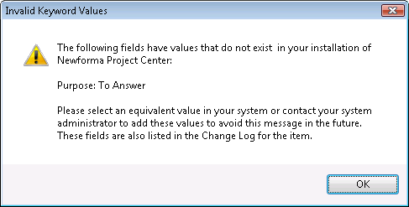

Submittals (Forward For Review – Log a Received)

| **Forwarding Field** | **Receiving Field** |
| --- | --- |
| Subject (Transmittal) | Subject |
| Due Date | Due Date |
| ID | Sender ID |
| Spec Section | Spec Section |
| Package ID | Package ID |
| Need onsite by | Need onsite by |
| Lead Time | Lead Time |
| Originated By | Originated By |
| Discipline | Discipline |
| Remarks (Transmittal) | Remarks |
| To (Transmittal) | To (Transmittal) |
| From (Transmittal) | From (Transmittal) |
| Date (Transmittal) | Received (Transmittal) |
| Description of Contents | Description of Contents (Transmittal) |
| **Purpose (Transmittal)**   * **For Review** * **For Review and Comment** * **No Action Required** | **Purpose (Transmittal)**   * **For Review** * **No Action Required** |

RFIs (Forward For Review – Log a Received)

| **Forwarding Field** | **Receiving Field** |
| --- | --- |
| Subject (Transmittal) | Subject |
| Due Date | Due Date |
| ID | Sender ID |
| Type | Type |
| Originated By | Originated By |
| Discipline | Discipline |
| **Purpose (Transmittal)**   * **To Answer** | **Purpose (Transmittal)**   * **Request for Information** |
| Question (Transmittal) | Question |
| Suggestion (Transmittal) | Suggestion |
| To (Transmittal) | To (Transmittal) |
| From (Transmittal) | From (Transmittal) |
| Date (Transmittal) | Received (Transmittal) |
| Description of Contents | Description of Contents (Transmittal) |

Change Order Proposals (Forward For Review – Log a Received)

| **Forwarding Field** | **Receiving Field** |
| --- | --- |
| Subject (Transmittal) | Subject |
| Due Date | Due Date |
| ID | Sender ID |
| Proposed Total Amount | Proposed Total Amount |
| Proposed Total Days | Proposed Total Days |
| Discipline | Discipline |
| Remarks (Transmittal) | Remarks |
| To (Transmittal) | To (Transmittal) |
| From (Transmittal) | From (Transmittal) |
| Date (Transmittal) | Received (Transmittal) |
| **Purpose (Transmittal)**   * **For Input** * **Request Updated Quotes** | **Purpose (Transmittal)**   * **For Input** * **Request Updated Quotes** |
| Description of Contents | Description of Contents (Transmittal) |

Supplemental Instructions (Forward For Review – Log a Received)

| **Forwarding Field** | **Receiving Field** |
| --- | --- |
| Subject (Transmittal) | Subject |
| ID | Sender ID |
| Initiated By | Initiated By |
| Discipline | Discipline |
| Remarks (Transmittal) | Remarks |
| To (Transmittal) | To (Transmittal) |
| From (Transmittal) | From (Transmittal) |
| Date (Transmittal) | Received (Transmittal) |
| **Purpose (Transmittal)**   * **For Review** * **For Review and Comment** | **Purpose (Transmittal)**   * **No Action Required** |
| Description of Contents | Description of Contents (Transmittal) |

Addendums (Forward For Review – Log a Received)

| **Forwarding Field** | **Receiving Field** |
| --- | --- |
| Subject (Transmittal) | Subject |
| ID | Sender ID |
| Initiated By | Initiated By |
| Discipline | Discipline |
| Remarks (Transmittal) | Remarks |
| To (Transmittal) | To (Transmittal) |
| From (Transmittal) | From (Transmittal) |
| Date (Transmittal) | Received (Transmittal) |
| **Purpose (Transmittal)**   * **For Review** * **For Review and Comment** | **Purpose (Transmittal)**   * **For Bid Package Evaluation** |
| Description of Contents | Description of Contents (Transmittal) |

Change Orders (Forward For Review – Log a Received)

| **Forwarding Field** | **Receiving Field** |
| --- | --- |
| Subject (Transmittal) | Subject |
| ID | Sender ID |
| Date Executed | Date Executed |
| Estimated Amount | Estimated Amount |
| Estimated Days | Estimated Days |
| Actual Amount | Actual Amount |
| Actual Days | Actual Days |
| Initiated By | Initiated By |
| Responsible | Responsible |
| Discipline | Discipline |
| Remarks (Transmittal) | Remarks |
| To (Transmittal) | To (Transmittal) |
| From (Transmittal) | From (Transmittal) |
| Date (Transmittal) | Received (Transmittal) |
| **Purpose (Transmittal)**   * **For Review** * **For Review and Comment** | **Purpose (Transmittal)**   * **For Review** |
| Description of Contents | Description of Contents (Transmittal) |

Proposal Requests (Forward For Review – Log a Received)

| **Forwarding Field** | **Receiving Field** |
| --- | --- |
| Subject (Transmittal) | Subject |
| ID | Sender ID |
| COP Status | COP Status |
| Initiated By | Initiated By |
| Discipline | Discipline |
| Remarks (Transmittal) | Remarks |
| To (Transmittal) | To (Transmittal) |
| From (Transmittal) | From (Transmittal) |
| Date (Transmittal) | Received (Transmittal) |
| **Purpose (Transmittal)**   * **For Review and Comment** * **For Review** * **For Your Information** | **Purpose (Transmittal)**   * **Respond with Proposal** |
| Description of Contents | Description of Contents (Transmittal) |

Construction Change Directives (Forward For Review – Log a Received)

| **Forwarding Field** | **Receiving Field** |
| --- | --- |
| Subject (Transmittal) | Subject |
| ID | Sender ID |
| COP Status | COP Status |
| Initiated By | Initiated By |
| Discipline | Discipline |
| Responsible | Responsible |
| Contract Sum | Contract Sum |
| Sum Description | Sum Description |
| Contract Time | Contract Time |
| Remarks (Transmittal) | Remarks |
| To (Transmittal) | To (Transmittal) |
| From (Transmittal) | From (Transmittal) |
| Date (Transmittal) | Received (Transmittal) |
| **Purpose (Transmittal)**   * **For Review** * **For Review and Comment** | **Purpose (Transmittal)**   * **No Action Required** |
| Description of Contents | Description of Contents (Transmittal) |

Bulletins (Forward For Review – Log a Received)

| **Forwarding Field** | **Receiving Field** |
| --- | --- |
| Subject (Transmittal) | Subject |
| ID | Sender ID |
| Type | Type |
| COP Status | COP Status |
| Initiated By | Initiated By |
| Discipline | Discipline |
| Responsible | Responsible |
| Contract Sum | Contract Sum |
| Sum Description | Sum Description |
| Contract Time | Contract Time |
| Remarks (Transmittal) | Remarks |
| To (Transmittal) | To (Transmittal) |
| From (Transmittal) | From (Transmittal) |
| Date (Transmittal) | Received (Transmittal) |
| **Purpose (Transmittal)**   * **For Review** * **For Review and Comment** | **Purpose (Transmittal)**   * **No Action Required** * **For Construction** * **Respond with Proposal** |
| Description of Contents | Description of Contents (Transmittal) |

Respond and Close and Record Reviewer Response (All CM workflow activity centers)

Company A responds to and closes an item sent to them for review and Company B records their response.

| **Respond and Close Field** | **Record Reviewer Response Field** |
| --- | --- |
| Subject (Transmittal) | Subject(Transmittal) |
| Response (Transmittal) | Response(Transmittal) |
| To (Transmittal) | To (Transmittal) |
| **Action (Transmittal)** | **Action (Transmittal)** |
| From (Transmittal) | From (Transmittal) |
| Date (Transmittal) | Received (Transmittal) |
| Description of Contents(Transmittal) | Description of Contents (Transmittal) |

Action Values for CM Respond and Close and Record Reviewer Response Activities

| CM Activity Center | Respond and Close Field | Record Reviewer Response Field |
| --- | --- | --- |
| Submittals | Approved  Approved as Noted  No Exceptions  No Action Taken  Revise and Resubmit  Partial Resubmittal  Rejected | No Action Taken  Approved  Approved as Noted  No Exceptions  Rejected  Revise and Resubmit |
| RFIs | Answered  Additional Information Needed | Answered  Not Answered |
| Addendums | Approved  Approved as Noted  No Exceptions  Revise and Resubmit  Rejected | No Action Taken  Approved  Approved as Noted  No Exceptions  Rejected  Revise and Resubmit |
| Bulletins | Approved  Approved as Noted  No Exceptions  Revise and Resubmit  Rejected | Approved  Approved as Noted  No Exceptions  Rejected  Revise and Resubmit |
| Supplemental Instructions | Approved  Approved as Noted  No Exceptions  Revise and Resubmit  Rejected | No Action Taken  Approved  Approved as Noted  No Exceptions  Rejected  Revise and Resubmit |
| Proposal Request | Approved  Approved as Noted  No Exceptions  Revise and Resubmit  Rejected | Approved  Approved as Noted  No Exceptions  Rejected  Revise and Resubmit |
| Construction Change Directive | Approved  Approved as Noted  No Exceptions  Revise and Resubmit  Rejected | Approved  Approved as Noted  No Exceptions  Rejected  Revise and Resubmit |
| Change Order Proposal | No Action Taken  Changes Recommended  Rejected  Revise and Resubmit | No Changes  Changes Recommended  Rejected  Revise and Resubmit |
| Change Order | Recommendation (from Send and Close) | Approved  Approved as Noted  No Exceptions  Rejected  Revise and Resubmit |